SDU University

UDС 621.397:004.932.72’1(043) On manuscript rights

SADYK UALIKHAN ERKINULY

A Hybrid Deep Feature Extraction-Traditional Machine Learning Ensemble Model for Robust Banknote Recognition Under Various Conditions

8D06102 – Computer Science

Thesis for the degree of
doctor of philosophy (PhD)

Scientific supervisors
doctor PhD,
assoc. professor
C. Turan

Foreign scientific supervisor
doctor PhD,
assist. professor
H. Wang

Republic of Kazakhstan
Kaskelen, 2026
CONTENTS

NORMATIVE REFERENCES....................................................................... | 4
DESIGNATIONS AND ABBREVIATIONS…............................................. | 5
INTRODUCTION............................................................................................ | 8
1 LITERATURE REVIEW............................................................................. | 14
1.1 Challenges in banknote recognition under real-world conditions................ | 16
1.2 Traditional Computer Vision Techniques for Banknote Recognition.......... | 18
1.3 Traditional machine learning approaches for banknote recognition............. | 22
1.4 Deep learning approaches for banknote recognition..................................... | 25
1.5 Publicly available datasets for banknote recognition.................................... | 29
Chapter summary................................................................................................ | 32
2 METHODOLOGY........................................................................................ | 34
2.1 Research design............................................................................................ | 36
2.2 Datasets and task definitions........................................................................ | 39
2.2.1 Dataset resources.................................................................................. | 39
2.2.2 Task definitions used in this dissertation............................................... | 41
2.2.3 Dataset use in this dissertation.............................................................. | 41
2.3 Preprocessing and region extraction............................................................. | 43
2.3.1 Image standardisation and preprocessing (prior to embedding extraction) .......................................................................................................... | 43
2.3.2 ROI extraction (KZ-BD) ....................................................................... | 43
2.3.3 Data augmentation................................................................................ | 46
2.4 Deep feature extraction with ResNet-18...................................................... | 47
2.4.1 Motivation and design choice............................................................... | 47
2.4.2 Truncated backbone and embedding definition.................................... | 48
2.4.3 Embedding extraction protocol............................................................. | 49
2.5 Classical learners and stacking ensemble...................................................... | 50
2.5.1 Base learners......................................................................................... | 50
2.5.2 Hyperparameter selection..................................................................... | 52
2.5.3 Leakage-safe stacking and meta-learner............................................... | 53
2.6 Experimental protocol.................................................................................. | 57
2.6.1 Splits and evaluation sets...................................................................... | 57
2.6.2 Comparative baselines.......................................................................... | 59
2.6.3 Ablation studies.................................................................................... | 60
2.7 Evaluation metrics and efficiency analysis.................................................. | 61
2.7.1 Recognition performance metrics........................................................ | 61
2.7.2 Latency and memory footprint............................................................. | 63
2.8 Implementation details and reproducibility.................................................. | 64
Chapter summary............................................................................................... | 65
3 EXPERIMENTAL RESULTS AND DISCUSSION.................................. | 68
3.1 Chapter objectives and evaluation logic....................................................... | 68
3.2 Experimental Setup...................................................................................... | 69
3.2.1 Dataset and class selection.................................................................... | 69
3.2.2 Preprocessing and feature extraction pipelines..................................... | 70
3.2.3 Train-test split and evaluation metrics.................................................. | 71
3.2.4 Classifiers and optimization procedure................................................ | 71
3.2.5 Experimental scope for subsequent sections......................................... | 71
3.3 Results on Kazakh banknotes....................................................................... | 72
3.3.1 Traditional baseline results with RGB features..................................... | 73
3.3.2 Optimized traditional results with HSV histograms.............................. | 74
3.3.3 Hybrid baseline results with ResNet-18 features.................................. | 75
3.3.4 Optimized hybrid results ...................................................................... | 76
3.3.5 Comparative interpretation for the chapter............................................ | 77
3.4 Model stacking ensemble and efficiency trade-off....................................... | 79
3.5 Transferability experiments on other datasets............................................... | 82
3.5.1 Transferability to Thai banknotes.......................................................... | 83
3.5.2 Transferability to coffee bean roasting-level classification................... | 85
3.5.3 Cross-dataset interpretation and implications........................................ | 87
3.6 Discussion.................................................................................................... | 87
3.6.1 Feature representation explains most of the performance gap............... | 87
3.6.2 Why the hybrid pipeline is stronger on Kazakh banknotes.................... | 88
3.6.3 Optimization and stacking improve results............................................ | 88
3.6.4 Robustness across metrics, not just accuracy......................................... | 91
3.6.5 Accuracy-efficiency trade-off is central to the chapter......................... | 91
3.6.6 What transferability reveals about domain dependence.........................  3.6.7 Comparison with prior published results……………………………...  3.6.8 Summary of all reported results………………………………………. | 92  92  94
Chapter Summary............................................................................................... | 96
4 EXTENDED ANALYSIS, PRACTICAL DEPLOYMENT, AND FUTURE DIRECTIONS................................................................................. | 98
4.1 Photometric robustness and the role of colour features in real-world capture................................................................................................................ | 99
4.2 Comparison with vision-transformer baselines............................................. | 101
4.3 Training-time strategies for small and class-imbalanced data....................... | 103
4.4 Deployment efficiency on mobile and edge devices...................................... | 105
4.5 Interpretability and trust in assistive recognition systems............................. | 107
4.6 Synthesis and future research agenda……………………………………… | 109
Chapter summary................................................................................................ | 112
CONCLUSION................................................................................................. | 114
REFERENCES................................................................................................ | 116

NORMATIVE REFERENCES

This thesis uses references to the following standards:
These instructions are based on interstate standards GOST 7.1-2003. Bibliographic record. Bibliographic description. General requirements and rules of compilation.
Rules for awarding degrees, approved by Order of the Minister of Education and Science of the Republic of Kazakhstan dated September 28, 2018 No. 512.

DESIGNATIONS AND ABBREVIATIONS

AUC | – Area Under the Curve
AWB | – Automatic White Balance
BoW | – Bag of Words
BoVW | – Bag of Visual Words
CBAM | – Convolutional Block Attention Module
CC | – Connected Components
CLAHE | – Contrast Limited Adaptive Histogram Equalization
CM | – Co-occurrence Matrix (as in GLCM)
CNN | – Convolutional Neural Network
CV | – Computer Vision
ECA | – Efficient Channel Attention
ECE | – Expected Calibration Error
EUR | – Euro (currency code)
FC | – Fully Connected (layer)
FPR | – False Positive Rate
FPS | – Frames Per Second
GC3558 | – Ghana currency dataset identifier (dataset name as written)
GLCM | – Gray Level Co-occurrence Matrix
GNB | – Gaussian Naïve Bayes
GOST | – GOST bibliographic/formatting standards (state standard)
HOG | – Histogram of Oriented Gradients
HSV | – Hue, Saturation, Value (colour space)
ICECCO | – International Conference on Electronics Computer and Computation
IEEE | – Institute of Electrical and Electronics Engineers
INR | – Indian Rupee (currency code)
ISP | – Image-Signal Processor
JOD | – Jordanian Dinar (currency code)
k-NN | – k-Nearest Neighbours
KRW | – South Korean Won (currency code)
KZ-BD | – Kazakh Banknote Dataset
KZT | – Kazakhstani Tenge (currency code)
LBP | – Local Binary Patterns
LDA | – Linear Discriminant Analysis
MB | – Megabyte(s)
MBDM | – Multinational Banknote Detecting Model
MCC | – Matthews Correlation Coefficient
ML | – Machine Learning
NCC | – Normalised Cross-Correlation
NN | – Neural Network
NR | – Not Reported
NSTU-BDTAKA | – Bangladeshi banknote dataset name (as written)
OCR | – Optical Character Recognition
OvR | – One-versus-Rest
PCA | – Principal Component Analysis
PMC | – PubMed Central
RANSAC | – Random Sample Consensus
RBF | – Radial Basis Function
RBF-SVM | – Support Vector Machine with RBF kernel
RF | – Random Forest
RGB | – Red, Green, Blue (colour space)
RMB | – Renminbi (informal name often used for CNY)
ROC | – Receiver Operating Characteristic
ROC-AUC | – Receiver Operating Characteristic – Area Under Curve
ROI | – Region of Interest
SE | – Squeeze-and-Excitation (attention)
SHAP | – SHapley Additive exPlanations
SIFT | – Scale-Invariant Feature Transform
SNR | – Serial Number Recognition
SSD | – Single Shot Detector
SVC | – Support Vector Classifier
SVM | – Support Vector Machine
THB | – Thai Baht (currency code)
TPR | – True Positive Rate
UCI | – University of California, Irvine (as in UCI dataset)
UDC/УДК | – Universal Decimal Classification
USD | – US Dollar (currency code)
VGG | – Visual Geometry Group (model family name)
VGG-16 | – 16-layer VGG network
ViT | – Vision Transformer
VLAD | – Vector of Locally Aggregated Descriptors
XAI | – Explainable Artificial Intelligence
YOLO | – You Only Look Once

INTRODUCTION

General characteristics of the work. This dissertation presents a hybrid computational framework for the automatic recognition of Kazakh banknotes acquired under heterogeneous real-world conditions. The proposed method combines deep feature extraction via a convolutional neural network (CNN) with conventional machine-learning classifiers integrated through a stacking ensemble [1]. The overarching objective is to achieve high recognition accuracy, robustness to environmental variability, and computational efficiency suitable for embedded and mobile deployment [2].
A ResNet-18 backbone is used exclusively as a feature extractor rather than as an end-to-end classifier. The terminal fully connected layer is removed, and activations from the penultimate layer are used as compact yet highly discriminative embedding vectors. These representations encode salient structural and spectral characteristics of Kazakh banknotes, including security features (e.g., holographic elements), micro-patterns, and denomination-specific textures [3].
The extracted embeddings are provided to a stacking ensemble comprising five heterogeneous base learners: k-nearest neighbours (kNN), which captures local neighbourhood structure through instance-based similarity; a kernelized support vector classifier (SVC), which supports non-linear separation in high-dimensional feature spaces; random forests (RF), which improve generalization via ensemble decision trees and are robust to noise; Gaussian naïve Bayes (GNB), a computationally lightweight probabilistic baseline that can be effective in limited-data settings; and a ridge classifier, a linear model with L2 regularization that stabilises estimation under correlated features.
Each base classifier is independently optimised using cross-validation and grid search. Their outputs are subsequently combined by a meta-learner that estimates an optimal fusion strategy across the base models, thereby increasing ensemble diversity and improving predictive reliability. This hierarchical decision process enhances robustness to factors commonly encountered in operational settings, including illumination changes, background clutter, and physical deformation or wear of banknotes.
The experimental workflow is organized into three stages. First, dataset construction is carried out by assembling a custom Kazakh Banknote Dataset (KZ-BD) containing more than 4,000 high-resolution images spanning fourteen denominations, collected under diverse real-world conditions (variation in illumination, rotation, occlusion, and wear). Second, model development and analysis integrates ResNet-18 embeddings with the individual base classifiers, followed by stacking design and systematic ablation experiments to quantify the contribution of each learner. Third, evaluation is performed using standard recognition metrics, including accuracy, macro-averaged F1 score, Matthews correlation coefficient (MCC), and ROC-AUC, complemented by latency and memory-footprint measurements to assess suitability for lightweight deployment.
The proposed hybrid ensemble attains strong recognition performance relative to the traditional baseline established in this dissertation, while maintaining low computational overhead; this comparison is internal to the study, as no directly comparable published benchmark currently exists for Kazakh banknotes. The results demonstrate that deep learned representations, when fused with complementary classical classifiers in a stacked architecture, can yield a robust, interpretable, and practically deployable solution for banknote recognition in unconstrained environments.
The aim of the research is to design, implement, and rigorously evaluate a hybrid recognition framework that fuses ResNet-18-derived deep feature embeddings with a stacking ensemble of classical machine-learning classifiers, in order to achieve accurate, robust, and computationally efficient denomination recognition for Kazakh banknotes under heterogeneous, unconstrained real-world acquisition conditions. This aim is pursued by constructing a purpose-built, rigorously annotated benchmark dataset (KZ-BD) and by systematically comparing traditional and hybrid feature representations, culminating in a deployment-ready model whose accuracy, robustness, and computational footprint are all explicitly quantified.
Relevance of the work. Reliable banknote recognition is a foundational capability for secure financial transactions, automated cash-handling systems, and assistive technologies that support independent use of cash by visually impaired individuals [4]. However, most academic and industrial solutions have been developed and validated primarily on major currencies such as USD, EUR, and RMB, for which large public datasets and standardised evaluation practices are widely available [5]. In contrast, Kazakh banknotes remain underrepresented in the international literature, despite their complex security elements, evolving design series, and distinctive colour–texture characteristics. This gap limits reproducibility, hinders fair comparison of methods, and slows the development of robust recognition systems tailored to Kazakhstan’s currency.
In practical deployments, banknote images are typically acquired using cameras or mobile devices under unconstrained conditions [6]. Such settings introduce substantial variability in illumination, viewpoint, scale, background clutter, partial occlusion, and physical degradation due to wear or deformation [2, p. 165-175]. These factors can degrade performance and reduce generalization, particularly for approaches relying solely on hand-crafted features or end-to-end deep classifiers trained under narrowly controlled conditions [3, p. 1392]. Consequently, there is a clear need for recognition methods that remain accurate under heterogeneous visual conditions while meeting the computational constraints of embedded and mobile platforms [1, p. 5-7].
The relevance of the present research is therefore twofold. First, it provides the first rigorously specified dataset and benchmarking protocol for Kazakh banknote recognition, enabling reproducible evaluation and facilitating future comparative studies. Second, it demonstrates that a hybrid pipeline combining ResNet-18 feature embeddings with a classical stacking ensemble can achieve high recognition accuracy together with low inference latency, thereby supporting practical deployment in local fintech applications and accessibility systems consistent with Kazakhstan’s digital-transformation agenda.
The Objectives of Research. To achieve this aim, the study pursues six specific objectives, each targeting a distinct stage of the proposed hybrid pipeline, from dataset construction through to deployment-oriented evaluation:
- Construct and annotate a comprehensive Kazakh Banknote Dataset (KZ-BD) spanning multiple denominations and diverse acquisition conditions, including variations in illumination, rotation, occlusion, wear, and background.
- Use ResNet-18 as a fixed feature extractor to produce compact, discriminative embedding vectors for each banknote image.
- Train and tune kNN, SVC, RF, GNB, and Ridge classifiers on the extracted embeddings using systematic model-selection procedures (e.g., cross-validation and grid search).
- Implement a stacking strategy in which a meta-learner fuses the probabilistic outputs of the base classifiers to improve generalization across heterogeneous capture conditions.
- Perform controlled ablation and comparative experiments to quantify the contribution of each base learner and to demonstrate the performance gains of the stacked ensemble over individual classifiers.
- Evaluate recognition performance using accuracy, macro-F1, Matthews correlation coefficient (MCC), and ROC-AUC, and assess deployment suitability via parameter efficiency, inference latency, and memory-footprint measurements for real-time and resource-constrained applications.
Methods of Research. This study adopted an experimental, quantitative research design that integrates deep learning with traditional machine-learning techniques to develop a hybrid system for automatic recognition of Kazakh banknotes. The methodological workflow began with the construction of a dedicated dataset, the Kazakh Banknote Dataset (KZ-BD), comprising more than 4,000 high-resolution images spanning fourteen denominations. Images were collected under diverse real-world acquisition conditions, including variations in illumination, rotation, partial occlusion, physical wear, and background clutter (see figure 1). Prior to modelling, all samples were preprocessed using resizing and colour normalization, and augmented to improve generalization and robustness to environmental variability.
A ResNet-18 convolutional neural network was employed as a fixed feature extractor rather than as an end-to-end classifier. The final fully connected classification layer was removed, and activations from the penultimate layer were extracted as compact, high-dimensional embedding vectors representing each image. These embeddings encode discriminative structural and textural cues associated with denomination-specific design patterns and security elements. The resulting feature vectors were subsequently used to train a stacking ensemble comprising five complementary base learners: k-nearest neighbours (kNN), kernelized support vector classifier (SVC), random forest (RF), Gaussian naïve Bayes (GNB), and ridge classifier. Each base model was tuned independently via cross-validation, and a meta-learner was trained to fuse the probabilistic outputs of the base learners into a final prediction, thereby improving predictive reliability and generalization.
Model development and evaluation followed dataset-appropriate train/test protocols detailed in Chapters 2 and 3, including the KZ-BD dataset’s published 70:30 training/validation split, with cross-validation used for hyperparameter selection within the training partition, and, for the classifier-comparison experiments in Chapter 3, a fixed-seed 75%/25% train/test split. Performance was quantified using multiple metrics, including accuracy, macro-averaged F1 score, Matthews correlation coefficient (MCC), and ROC-AUC. To assess deployment feasibility, additional analyses measured inference latency and memory footprint, with emphasis on constraints typical of mobile and embedded platforms. Comparative baselines and ablation experiments were conducted to isolate the contribution of each component and to evaluate the advantage of the stacked configuration. The results indicate that the proposed hybrid ensemble consistently outperforms individual classifiers, delivering strong recognition accuracy, improved robustness to heterogeneous capture conditions, and computational efficiency appropriate for real-time banknote recognition applications.
The novelty of the research is twofold. First, this dissertation delivers the first hybrid ResNet-18-plus-stacking-ensemble framework for Kazakh banknote recognition, validated under real, unconstrained capture conditions rather than a controlled laboratory setting [1, p. 6-8]. Second, it introduces KZ-BD, the first comprehensive, openly available, and richly annotated dataset of Kazakh banknotes [7], closing a data gap that had previously blocked reproducible benchmarking for this currency.
The research’s significance is reflected in its theoretical, technological, and societal contributions, each substantiated by and extending an identifiable strand of the cited literature. From a methodological standpoint, the study advances understanding of how deep and classical learners can be integrated synergistically within an ensemble framework, building on prior evidence that combining engineered and learned representations, or classical and deep classifiers, improves banknote-recognition robustness [1, p. 5-7; 4, h. 2121-2130; 6, p, 60-65; 8]. In particular, it shows that ResNet-18 embeddings preserve sufficient discriminative information to function as a general-purpose representation layer for multiple lightweight classifiers, improving generalization across heterogeneous visual domains and acquisition conditions.
From a technological perspective, the proposed hybrid ensemble delivers a high-accuracy, low-latency recognition solution suitable for real-time deployment in financial and retail infrastructure, including ATMs, vending machines, and mobile payment applications, consistent with the deployment orientation of prior banknote-classification and detection systems [3, p. 1392; 5, p. 243-246; 6, p. 60-65]. Because the architecture is modular, it can be updated incrementally as new banknote series are introduced, reducing the need for full end-to-end retraining and lowering maintenance costs.
From a societal perspective, the research supports the digitalization of Kazakhstan’s financial ecosystem and contributes to inclusive assistive technologies for visually impaired users, directly in line with the growing body of work on mobile and embedded currency-identification aids for this population [2, p. 165-175; 3, p. 1392; 9]. The dataset and methodological pipeline also provide a reproducible educational and research resource for universities and laboratories working in computer vision, artificial intelligence, and fintech-oriented innovation.
The dissertation offers a reproducible methodological framework and a deployable recognition model that help narrow the gap between academic research and practical currency-recognition systems, delivering both scientific insight and real-world impact.
Alignment with the UN Sustainable Development Goals and national development priorities. The research reported in this dissertation is aligned with several United Nations Sustainable Development Goals (SDGs) and with the current national development framework of the Republic of Kazakhstan. At the level of the SDGs, the work principally supports SDG 8 (Decent Work and Economic Growth), through its contribution to a more resilient and technologically advanced national cash-handling and fintech infrastructure; SDG 9 (Industry, Innovation and Infrastructure), through the development and public release of a benchmark dataset and a hybrid deep-learning/classical-ensemble methodology that can be reused by other researchers working on under-represented currencies; and SDG 10 (Reduced Inequalities), through its explicit focus on assistive recognition for visually impaired users, supporting their equal and independent access to cash-based financial transactions.
At the national level, the Decree of the President of the Republic of Kazakhstan No. 611 dated 30 July 2024, “On Approval of the National Development Plan of the Republic of Kazakhstan until 2029,” frames the country’s medium-term development around seventeen thematic areas that closely mirror the structure of the SDGs, with explicit emphasis on the modernisation and digitalisation of industries, the expansion of innovation activity, and ensuring equal opportunities for all citizens. The present research contributes to this agenda by providing a reproducible, technologically grounded case study of applied artificial intelligence for a domestically relevant problem, and is consistent with the direction set out in the President’s Address “Kazakhstan in the Age of Artificial Intelligence: Current Challenges and Their Solutions Through Digital Transformation,” which initiated the ongoing development of the “Digital Qazaqstan” strategy for large-scale digitalisation and artificial-intelligence adoption.
The dissertation’s emphasis on assistive recognition for visually impaired users is further consistent with Kazakhstan’s recent strengthening of its national and international commitments to the rights of persons with disabilities, including the January 2025 ratification of the Marrakesh Treaty to Facilitate Access to Published Works for Persons Who Are Blind, Visually Impaired, or Otherwise Print Disabled, and the provisions of the Social Code of the Republic of Kazakhstan concerning access to information and technology for persons with disabilities. With approximately 700,000–750,000 persons with disabilities currently living in Kazakhstan, technological solutions that support independent financial transactions represent a concrete and measurable contribution to this national commitment.
Statements for defense. The following statements are put forward for defense, each directly supported by the experimental evidence presented in Chapter 3:
1. A hybrid pipeline combining frozen ResNet-18 embeddings with a stacked classical-learner ensemble achieves the highest recognition accuracy on the KZ-BD benchmark (99.11% single-model, 99.55% stacked), exceeding the optimised traditional colour-feature pipeline by a substantial margin (tables 9, 11, and §3.4).
2. For the traditional pipeline, improving the feature representation alone (RGB channel averages → HSV histograms) yields a larger accuracy gain (71.00% → 94.67% best single-model) than either classifier selection or subsequent stacking, establishing feature representation as the dominant driver of performance for this task (§3.6.3).
3. The relative advantage of the hybrid pipeline over the optimised traditional pipeline is domain-dependent rather than universal: it is large on the primary Kazakh-banknote task, small on a related transfer task (Thai banknotes, +0.55 percentage points), and reverses on a task with near-complete colour separability (coffee-bean roast classification, −1.00 percentage points), indicating that the choice between hybrid and traditional pipelines should be conditioned on a domain’s colour-separability properties (§3.5, §3.6.6, table 16).
4. KZ-BD, a purpose-built dataset of 4,200 annotated Kazakh banknote images captured under real, unconstrained acquisition conditions, constitutes the first openly available recognition benchmark for this currency, closing a data gap identified in Chapter 1 (§2.2.1).
5. The best-found hyperparameters of distance-based and tree-based classifiers (kNN, Random Forest) remain stable across feature representations, whereas kernel-based and density-based classifiers (SVC-RBF, Gaussian NB) require representation-specific re-tuning, a distinction with direct implications for adapting the pipeline to future encoders (§3.6.3, §4.2); as this pattern is observed across a single representation change per classifier, it is presented as a hypothesis motivating future work rather than an established mechanism.
The results of research were published in following:
Research publications:
- Kazakh banknote image dataset // Data in Brief. – 2026. – №65. – Р. 112634.
- Comparative analysis of machine learning approaches in Kazakh banknote classification // Bulletin of Electrical Engineering and Informatics. – 2024. – №13(5). – P. 3552-3567.
- KZ-BD: Dataset of Kazakhstan banknotes with annotations // Data in Brief. – 2024. – №53. – P. 110076.
- State-of-the-Art Review of Deep Learning Methods in Fake Banknote Recognition Problem // International Journal of Advanced Computer Science & Applications. – 2024. – №15(1).
- Overview of deep learning models for banknote recognition // In 17th international conference on Electronics Computer and Computation (ICECCO). – 2023. – P. 1-5.
- Benchmarking Deep Transfer Learning for Banknote Recognition: Vision Transformers Vs. CNNs on the KZ-BD Dataset // In 18th international conference on Electronics, Computer, and Computation (ICECCO). – 2026. – P. 01-06.
Structure and scope of the dissertation. The thesis consists of four chapters. It contains 38 figures and 17 tables, The list of used literature consists of 83 sources. The dissertation includes 120 pages.

1 LITERATURE REVIEW

Banknote recognition lies at the intersection of computer vision and pattern recognition, supporting applications such as assistive tools for individuals with visual impairments, automated fare and vending systems, ATMs and cash recyclers, and retail checkout platforms [8, p. 3552-3566]. Recent smartphone-based systems combine mobile imaging with deep networks to assist visually impaired users in real time [7, p. 110076]. In real deployments, banknote-processing systems are commonly described in terms of four core functions: i) denomination recognition; ii) counterfeit detection; iii) serial-number reading via optical character recognition (OCR), and iv) fitness assessment (i.e., classification of physical condition) [9, p. 16901]. A widely cited survey systematizes these tasks and emphasises that practical systems must balance accuracy, throughput, and hardware cost, often by selecting different sensing modalities and computational pipelines depending on the operational constraints of the machine or device [10].


a b c
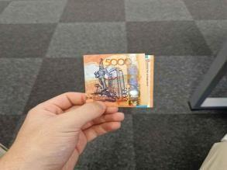
d e f

a – rotated 500 KZT with a cluttered background; b – flipped 1,000 KZT with a partly shadowed background; c – crumpled 2000 KZT in the hand; d – folded 5,000 KZT in the hand; e – clearly visible 10,000 KZT in a noisy background; f – darkened 20,000 KZT in a patterned background

Figure 1 – Examples of Kazakh banknote images of each denomination under diverse conditions

Historically, recognition systems relied on template matching and hand-crafted descriptors (e.g., colour statistics, gradient-based features such as HOG, and keypoint descriptors such as SIFT/SURF), combined with classical classifiers including support vector machines (SVM), k-nearest neighbours (kNN), and Random Forests [11]. These pipelines remain attractive because they are computationally lightweight and can be reliable in controlled settings [12]. However, they are typically sensitive to nuisance factors common in real-world capture: non-uniform illumination, pose and scale variation, cluttered backgrounds, partial occlusion by hands, and physical deformation (folds, wrinkles, tears) or heavy wear. The consequence is a measurable generalization gap between laboratory conditions and operational environments, particularly for mobile camera acquisition where lighting and background cannot be controlled [13].
Over the past decade, deep learning has become the dominant approach for banknote recognition and related tasks [14]. Convolutional neural networks (CNNs) are widely used for denomination classification, while modern object detectors enable joint localization and classification in complex scenes [15]. In assistive settings and mobile capture, detection-centric pipelines are often preferable because they explicitly localise the banknote before classification, reducing background interference and improving robustness to clutter and partial views [16]. Recent work on multinational banknote detection has shown that training strategies such as mosaic augmentation can improve robustness under occlusion and viewpoint variation by increasing the diversity of composite training examples. For instance, the Multinational Banknote Detecting Model (MBDM) uses mosaic-based augmentation across multiple currencies (including USD, EUR, KRW, and JOD) to strengthen detection performance under heterogeneous conditions [17].
In parallel, recent evaluations of state-of-the-art YOLO variants illustrate the continued emphasis on real-time performance for assistive deployment. A Scientific Reports study on Egyptian currency recognition evaluates YOLOv8–YOLOv10 and reports both strong detection performance and real-time throughput, highlighting the practical importance of latency and on-device feasibility in accessibility-oriented applications [18].
A major catalyst for progress has been the emergence of larger and more realistic datasets. BankNote-Net is a prominent resource designed around assistive use cases: it reports 24,826 banknote images across 17 currencies and 112 denominations, and releases a “universal” representation in the form of compact embeddings learned via supervised contrastive learning, supporting downstream training and few-shot adaptation to currencies not present in the original dataset. This direction reflects an increasing focus on generalization beyond a single currency and on portability across domains [19].
For Kazakhstan specifically, KZ-BD addresses a long-standing underrepresentation of Kazakhstani banknotes in the international literature. The dataset provides 4,200 mobile-acquired images across 14 denominations (1–20,000 KZT), captured under varied real-world conditions (different lighting, cluttered backgrounds, and folded notes) and annotated in YOLO format, enabling reproducible benchmarking for both detection and recognition.
Within this landscape, hybrid recognition pipelines offer a principled compromise between representational power and deployment efficiency [20]. The key idea is to treat a pre-trained CNN as a transferable representation module and to perform classification using lightweight learners whose decision boundaries can be tuned efficiently and combined to reduce correlated errors. This motivation is consistent with empirical findings in the Kazakh setting, where hybrid feature-based approaches and stacking strategies outperform purely traditional baselines and can approach near-ceiling performance on realistic datasets. Accordingly, this dissertation focuses on a hybrid framework that (i) leverages deep embeddings for robust, discriminative representation under real-world variability and (ii) employs an ensemble of classical classifiers fused via stacking to achieve reliable and computationally efficient recognition suitable for mobile and embedded deployment.

1.1 Challenges in banknote recognition under real-world conditions
Real-world deployment of banknote-recognition systems remains challenging because both the acquisition conditions and the operational requirements vary substantially across use cases. Unlike controlled, scanner-based imagery, camera captures collected in everyday contexts exhibit photometric variability (uneven illumination, shadows, colour casts, low contrast), geometric variability (rotation, perspective distortion, scale changes), and scene-level variability (background clutter, partial occlusion by hands or holders) [21]. In addition, banknotes often present material degradation (folds, wrinkles, tears, soiling, fading) and design-related difficulty, including fine-grained similarities between denominations and design drift across series and re-editions [22]. These factors can degrade the reliability of both handcrafted-feature pipelines and end-to-end deep models unless they are explicitly addressed through dataset construction, architectural choices, and targeted training strategies [23]. Classical machine-learning classifiers remain competitive in this setting, particularly for lightweight on-device counterfeit screening where inference speed and storage footprint are critical [24]. Support-vector machines, in particular, continue to provide strong results for banknote-authentication tasks on resource-constrained platforms [25]. To synthesise these considerations, the following discussion summarises the dominant challenges encountered in practice, the associated failure modes, and representative mitigation strategies across traditional machine learning, deep learning, and hybrid/ensemble approaches.
Illumination imbalance and colour shift alter pixel statistics and suppress contrast, weakening the stability of colour- and texture-dependent cues [26]. Classical systems often rely on photometric normalisation (e.g., colour-space transforms, contrast enhancement such as CLAHE, or colour-constancy heuristics), whereas modern CNN-based models typically benefit from strong photometric augmentation (brightness/contrast jitter, colour jitter, gamma changes) and the invariances learned through large-scale pretraining [27]. In unconstrained settings, detect-then-classify designs can further stabilise downstream classification by isolating the note region before feature extraction [28].
Background clutter (textured surfaces, patterned fabrics, printed materials) introduces spurious edges, false keypoints, and false positives. Traditional methods mitigate this via geometric consistency checks, template correlation thresholds, and carefully engineered region-of-interest (ROI) constraints, but these heuristics tend to be brittle across diverse environments. Detection-first pipelines (YOLO, Faster R-CNN) explicitly localise the banknote and reduce the contribution of background pixels; training strategies such as mosaic augmentation further improve robustness by exposing the model to composited backgrounds and partial views during training [29].
Occlusion and folds are particularly problematic because they remove or distort discriminative regions (denomination numerals, portraits, emblems, and fine security patterns). Keypoint-based descriptors can fail when salient keypoints disappear, and deep models trained predominantly on pristine images can overfit to idealised cues. Augmentations such as Cutout/random erasing, Copy-Paste, Mosaic/CutMix-style compositions, and multi-view training can improve robustness by simulating realistic obstruction patterns; again, detection-first pipelines reduce the impact of occlusion by focusing the model on the most informative visible regions [30].
Pose, perspective, and scale variation challenge template-based matching and patch-based comparisons. While SIFT/SURF provide partial invariance to rotation and scale, their effectiveness decreases under clutter and severe projective distortion. Modern detectors and CNN classifiers trained with multi-scale and multi-view augmentation generally tolerate a broader range of camera viewpoints and distances, especially when combined with explicit geometric normalization (cropping, rectification, or perspective-aware augmentation) [31].
Wear, soiling, and aging reduce contrast and attenuate micro-textures; they may also corrupt security cues that rely on fine detail. Additionally, banknote redesigns introduce domain shift over time. Practical mitigation includes balanced sampling across “new” and “worn” conditions, curricula that mix easy and difficult cases, and robustness-oriented preprocessing (e.g., denoising or Retinex-like illumination correction where appropriate) [32]. Transfer learning from large corpora generally improves tolerance to appearance variability compared with training from scratch [33].
Fine-grained similarity between denominations is common when multiple values share similar colour palettes, layout structures, or macro-level motifs, and classification hinges on small localised differences. Deep models often address this via higher-resolution inputs, ROI-focused crops around denomination numerals, attention mechanisms, or part-based representations [34]. Hybrid systems can benefit from feature fusion, where deep embeddings are complemented with low-level colour statistics (HSV histograms) or layout priors that provide additional discriminative evidence in borderline cases.
Device heterogeneity and domain shift further complicate deployment: sensor characteristics, optics, sharpening, denoising, and compression pipelines can shift the image distribution between training and target environments [35]. Broader multi-device datasets and augmentation that simulates blur, noise, and compression artefacts can improve generalisation [20]; universal encoders and few-shot adaptation strategies reduce the cost of accommodating new devices or currencies without full retraining [36].
Many target applications impose strict constraints on latency, memory footprint, and energy consumption, particularly in mobile assistive scenarios. Real-time performance typically requires lightweight backbones, efficient detection-first pipelines, and compression methods such as quantisation, pruning, and knowledge distillation [37]. Hybrid designs, in which compact deep embeddings are classified by lightweight models (or stacked ensembles with shallow meta-learners), can provide a favourable trade-off between accuracy and compute cost.
Although recent methods address many of these issues, a common limitation is that evaluation is often conducted under relatively controlled or semi-structured conditions, with limited condition-specific analysis of robustness (e.g., separate reporting under low light, heavy occlusion, or device shift) [38]. For Kazakhstani banknotes, publicly available benchmarks and rigorous analyses remain especially limited, and hybrid architectures have not been comprehensively studied under heterogeneous real-world variation. These gaps motivate a methodological framework that: i) explicitly incorporates realistic data diversity; ii) leverages deep encoders that learn robust invariances; iii) combines them with classical ensemble classifiers to achieve stable decision-making under deployment constraints (figure 2).

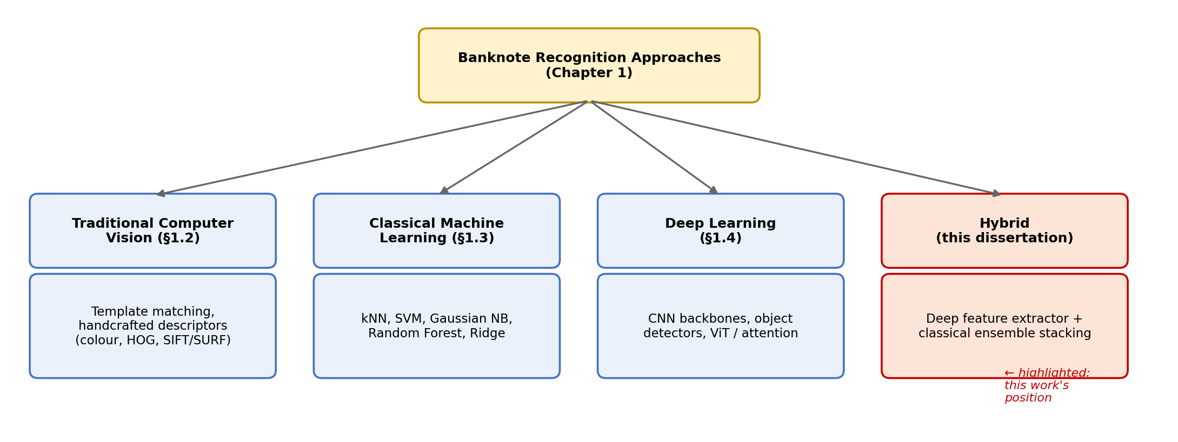

Figure 2 – Taxonomy of banknote-recognition approaches surveyed in this chapter, positioning the hybrid deep-feature and classical-ensemble framework proposed in this dissertation relative to traditional computer-vision, classical machine-learning, and deep-learning alternatives

1.2 Traditional computer vision techniques for banknote recognition
Before the widespread adoption of deep learning, banknote-recognition systems were dominated by classical computer-vision methods. These systems typically employed deterministic image-processing pipelines and hand-engineered descriptors designed to capture colour, texture, edges, and local keypoints. In many practical contexts they offered important advantages: they were lightweight, interpretable, and compatible with low-cost hardware. However, their reliance on manually designed features and carefully tuned preprocessing also made them sensitive to distribution shifts and unconstrained acquisition conditions [39].
The development of classical banknote-recognition methods can be broadly described in three overlapping phases. Early work (late 1990s to early 2000s) was largely template- and rule-based, using direct correlation against reference images, strict geometric constraints, and palette-based heuristics. These approaches were computationally efficient, but they were fragile under rotation, illumination changes, and physical degradation [40]. As feature engineering matured (mid-2000s to mid-2010s), descriptors such as SIFT, SURF, HOG, and LBP became central because they captured more informative structural cues, including gradient structure, micro-texture patterns, and rotation/scale-invariant keypoints. This era enabled recognition under moderate viewpoint variation and more diverse capture settings [41]. Later classical systems increasingly combined multiple complementary descriptors, introduced compact encodings (e.g., PCA, BoVW/VLAD), and adopted machine-learning classifiers and simple ensembles, reaching substantial accuracy in controlled or semi-controlled setups and establishing a strong pre-deep-learning baseline.
A typical classical pipeline is front-loaded with preprocessing because handcrafted descriptors do not learn invariances automatically. Most systems apply denoising and contrast enhancement (often CLAHE), followed by white-balance correction or colour-constancy operations [42]. Conversion from RGB to HSV (or related colour spaces) is frequently used to separate chromatic content from intensity, improving stability under photometric changes [43]. These steps can markedly improve downstream feature consistency, but they also highlight a structural weakness of classical pipelines: errors in preprocessing propagate directly into the feature stage, often causing overall failure.
After photometric normalization, the banknote must be separated from the background. Classical systems commonly use colour thresholding (often in HSV), edge detection and contour extraction, connected-component filtering, and aspect-ratio checks that exploit the near-rectangular geometry of banknotes [44]. Many systems further incorporate size and layout priors, such as expected aspect ratios, approximate positions of portraits or denomination numerals, and border consistency constraints. These priors are powerful for reducing false positives, but they are typically currency- and series-specific and therefore require maintenance when designs change.
Perspective rectification is often a critical intermediate step. Using corner detection and homography estimation (frequently with RANSAC), the detected note region is transformed to a canonical, top-down view. Rectification improves the reliability of subsequent template correlation and region-based comparisons, and it reduces intra-class variability caused by viewpoint. In controlled imaging environments, pipelines combining strong layout priors and rectification have been reported to achieve near-ceiling performance; however, their robustness depends on the reliability of the localisation and corner-detection stage, which can degrade under occlusion, clutter, or heavy wear [45].
Once a canonical ROI is obtained, the system extracts descriptors. Several families of handcrafted features have been widely used:
1. Colour features: Global or regional colour histograms (RGB/HSV) provide a fast summary of palette information. They can be highly discriminative when denominations differ strongly in colour, but they are vulnerable to illumination changes and background bleed if segmentation is imperfect [46].
2. Texture descriptors: LBP and GLCM encode local texture regularities and have been used to capture print micro-patterns and paper-related texture cues. They can perform well on clean ROIs but degrade when the ROI includes clutter, shadows, or severe wear [47].
3. Gradient/shape descriptors: HOG captures edge-orientation distributions associated with portraits, numerals, guilloché patterns, and design contours. It is often effective when contrast is sufficient, but it is less robust under strong viewpoint changes unless paired with rectification [48].
4. Local keypoints: SIFT and SURF introduced rotation- and scale-invariant local matching and are frequently combined with RANSAC-based geometric verification. In practice, these methods can be effective under moderate geometric variation, but they can also generate many spurious matches in textured backgrounds [49].
5. Transform-domain features: Fourier- and wavelet-domain descriptors (including Fourier–Mellin variants) provide global cues and are often used in authenticity-related tasks because they can capture periodic or global structural signatures. They are typically too coarse for fine-grained denomination discrimination unless fused with local features [50].
Because handcrafted descriptors can be high dimensional, classical pipelines often include PCA/LDA for dimensionality reduction or aggregate local features via BoVW/VLAD encodings to obtain compact classifier-friendly vectors. These representations are then classified using SVM, kNN, Random Forests, or lightweight ensemble schemes (e.g., voting or boosting), particularly in counterfeit detection settings where carefully curated features may separate genuine vs counterfeit classes effectively [51].
Classical computer vision remains valuable for its transparency, low compute requirements, and the ability to embed domain knowledge (geometry, layout rules, known aspect ratios) directly into the pipeline. Nonetheless, its limitations in unconstrained environments are well established. Because descriptors are fixed rather than learned, classical methods can be brittle under photometric disturbances (shadows, glare, colour casts), cluttered or textured backgrounds (false edges and keypoints), and partial occlusions or folds that remove critical regions. Large pose variation can introduce geometric inconsistencies that even keypoint-based matching may not fully resolve in complex scenes. Wear and soiling alter micro-textures and contrast patterns, confusing descriptors that assume stable local structure. Finally, device/domain shift (sensor differences, compression artefacts, denoising pipelines) can substantially reduce performance because handcrafted features often capture dataset-specific statistics rather than transferable invariances [52].
Experiments on Kazakh banknotes illustrate this trade-off. Classical baselines (e.g., HSV-histogram-based pipelines) can provide strong and computationally efficient benchmarks on realistic datasets such as KZ-BD, especially when combined with robust localisation and rectification. However, they are typically surpassed by hybrid approaches that retain useful classical components (geometric constraints and efficient decision layers) while replacing brittle handcrafted descriptors with deep, transferable embeddings. This observation motivates the methodological direction of the thesis: classical computer vision provides essential tools for photometric stabilisation, geometric normalisation, and interpretability, but its limited capacity to learn invariances makes it insufficient for robust deployment under heterogeneous real-world capture.

Table 1 – Traditional computer-vision techniques used in banknote recognition (with roles, strengths, and caveats)

Technique / cue | Core idea | Typical operations | Strengths | Limitations / failure modes | Typical role
1 | 2 | 3 | 4 | 5 | 6
Photometric normalisation (HSV, CLAHE, white balance) | Stabilise colour/contrast before feature extraction | Denoising → CLAHE → colour constancy/white balance → RGB→HSV | Low cost; improves stability of downstream features | Over/under-correction can amplify noise or distort colour cues | Common pre-processing for camera-captured images
ROI localisation by geometry | Isolate the note from background | Colour thres holding, edges/contours, CC filte ring, aspect-ratio checks | Removes clutter; redu ces search space; speeds later stages | Brittle under heavy occlusion/clutter; depends on thresholds | Front-end for most classical pipelines
Size/layout priors | Use known bill geometry and layout | Candidate filtering; border checks; re gion-specific constraints | Strong false-positive suppression | Currency/series-specific; needs upda tes across redesigns | Rule layer for kiosks/ATMs; stabiliser for ROI
Template matching (NCC) | Direct match to per-class templates | Normalised cross-correlation; best-match selection | Very fast; strong in controlled settings | Sensitive unless recti fied; brittle to wear/illu mination | Scanner/kiosk settings; post-rectification verification
Colour histograms (RGB/HSV) | Global or regional palette signature | Histogram binning; often per-region | Extremely fast; useful when palettes differ | Sensitive to lighting and background bleed | Baseline descriptor; complements texture/shape
Texture descriptors (LBP/GLCM) | Encode micro-texture statistics | LBP coding; co-occurrence matrices; ROI pooling | Captures print/texture regularities | Degrades with clutter, blur, and heavy wear | Complementary cue for denomination/authentication
HOG (gradient/shape) | Encode edge-orientation structure | Dense gradients + block normalisation | Strong for numerals/portraits/guilloché | Needs cont rast; limited to moderate pose unless rectified | Common classical descriptor for classification
SIFT/SURF keypoints + RANSAC | Local invariant matching with geometric verification | Detect → describe → match → RANSAC filtering | Rotation/scale tolerance; supports geometric consistency | Spurious matches in textured scenes; slower than hist/HOG | Robust matching, localisation support, verification
Continuation of the table 1

1 | 2 | 3 | 4 | 5 | 6
Fourier/Wavelet (incl. Fourier–Mellin) | Transform-domain global cues | Transform coefficients → summary statistics | Useful for global structure; often strong for authenti city cues | Coarse for fine-grained denomination; benefits from fusion | Counterfeit detection and auxiliary features
PCA/LDA, BoVW/VLAD | Compact, classifier-friendly encodings | Dimensionality reduc tion or code book pooling | Low memory; fast inference | Sensitive to codebook/embedding choices | Bridge from CV descriptors to ML classifiers
Boosting & voting (authenticity) | Combine weak learners/features | AdaBoost, weighted voting | High accuracy with curated features | Requires careful feature/label design | Often used in counterfeit screening
CV + geometric rules combined | Post-hoc validation of CV/ML outputs | Aspect/size gates; re gion consis tency checks | High precision in practice | Maintenance burden across new series | Safety net in production systems
Note – Table 1 continues onto the next page

Table 1 makes visible a recurring pattern: each traditional technique trades robustness for a specific limitation – illumination sensitivity, geometric fragility, or computational cost – and no single descriptor dominates across all real-world failure modes. This motivates combining several such descriptors through the classical classifiers reviewed next, and ultimately motivates the shift toward learned representations that avoid hand-designing this trade-off altogether (§1.4).

1.3 Traditional machine learning approaches for banknote recognition
Prior to the dominance of deep learning, most banknote-recognition systems followed a feature-engineering pipeline in which images were first normalised, optionally segmented to a region of interest (ROI), and then mapped into compact descriptors designed to capture the colour, texture, and structural cues that distinguish denominations [53]. As summarised in table 2, widely used handcrafted descriptors include global colour histograms (RGB/HSV), micro-texture descriptors (LBP, GLCM), gradient-based representations (HOG), rotation- and scale-invariant local keypoints (SIFT/SURF), and frequency-domain signatures (Fourier-, wavelet-, and Fourier–Mellin-based features) [54]. These descriptors were explicitly constructed to reflect visually salient properties of banknotes and can perform strongly under controlled or semi-controlled acquisition settings where photometric and geometric variation is limited and ROI extraction is reliable.
After descriptor extraction, recognition was typically performed using lightweight and well-understood machine-learning classifiers. k-nearest neighbours (kNN) is frequently used as a baseline because it requires minimal model fitting and classifies by comparing a query descriptor to stored examples. Its effectiveness depends critically on the geometry of the feature space: when descriptors yield compact, well-separated clusters, kNN can be competitive. However, kNN is sensitive to noise, feature scaling, and irrelevant dimensions, and its computational cost grows with dataset size. These limitations are more pronounced under unconstrained mobile capture (illumination changes, clutter, occlusion), where handcrafted descriptors may not remain stable [55].
To obtain stronger decision boundaries, many classical systems adopted support vector machines (SVMs), often with RBF kernels. SVMs are well suited to high-dimensional descriptors and frequently provide strong performance on HOG, fused colour–texture features, and aggregated local descriptors (e.g., BoW/VLAD). Their performance, however, depends on careful hyperparameter selection and can degrade under domain shift (e.g., when camera sensors or illumination conditions differ from those in training). Notably, in hybrid settings where features are produced by a CNN encoder, SVMs often remain highly competitive because deep embeddings tend to be more discriminative and better behaved than handcrafted descriptors [56].
A complementary probabilistic perspective is provided by Gaussian naïve Bayes (GNB), which models each class using a Gaussian distribution under a conditional independence assumption. GNB can be effective on descriptors that are statistical in nature (e.g., pooled texture statistics or transform coefficients) and offers extremely low computational overhead. Nevertheless, its simplifying assumptions are often violated in practice because engineered descriptors frequently contain correlated dimensions. Despite this, GNB can contribute meaningfully in ensembles because its error patterns differ from those of margin-based or tree-based methods [57].
Random forests (RF) became popular due to their robustness to noise and their ability to model non-linear interactions among heterogeneous features (colour + texture + shape). RFs can perform well on mixed descriptor families and provide a form of built-in feature selection. However, they may overfit when training data are limited, and they can struggle when class distinctions are extremely fine-grained unless the feature representation is highly discriminative [58].
The ridge classifier provides a fast linear baseline with ℓ2 regularisation, which stabilises estimation in the presence of correlated features (common in histogram-based representations) and reduces variance relative to unregularised linear models. While linear decision functions cannot capture complex non-linear boundaries in challenging handcrafted feature spaces, ridge classification can be surprisingly effective when applied to feature representations that are close to linearly separable, a property that is often observed in well-trained deep embedding spaces [59].
Taken together, these five models (kNN, SVM, GNB, RF, and ridge) represent distinct decision paradigms: instance-based, margin-based, probabilistic, ensemble-based, and regularised linear learning [60]. This algorithmic diversity is a key reason stacking and other ensemble strategies can improve robustness: different classifiers exploit different geometric and statistical properties of the feature space, reducing correlated errors and increasing reliability under adverse acquisition conditions. Table 3 summarises how their complementary strengths can be leveraged in stacked hybrid ensembles.
Read alongside table 1, table 2 clarifies that classifier choice cannot compensate for a poorly matched descriptor: each classifier column is only as robust as the invariances the underlying feature already encodes. The table 2 below turns to the complementary question of which classifiers to combine once a descriptor has been fixed.

Table 2 – Handcrafted descriptors used in traditional banknote-recognition pipelines

Typical invarian ces (approx.) | Strengths | Limitations | Commonly paired classifiers
Limited photo metric robust ness (HSV mo re stable than RGB) | Simple and fast; discriminative when denominations differ in palette; easy to fuse | Sensitive to illumination, shadows, and background contamination if ROI is imperfect | SVM, RF, GNB
Small local shifts; local micro-texture stability | Captures print texture and micro-pattern statistics; useful in clean ROIs | Degrades with blur, heavy wear, or clutter; depends on accurate ROI | SVM, RF, (sometimes) GNB
Partial robust ness to small transla tions and local deformation | Strong for edges, numerals, portraits, and guilloché structu res | Requires sufficient con trast; weaker under large pose/perspective changes without rectification | Linear SVM, RBF-SVM
Rotation and scale (local), partial viewpoint tolerance | Supports geometric verification (e.g., RANSAC); effective under moderate geometric variation | Computationally heavier; false matches in textured clutter; sensitive to severe occlusion | BoW/VLAD + SVM; keypoint matching with RANSAC

Table 3 showcases complementarity of classical classifiers commonly used in hybrid stacking

Table 3 – Complementarity of classical classifiers commonly used in hybrid stacking

Classifier | Decision behaviour | Key strengths | Known weaknesses | Contribution to stac king (why it helps)
1 | 2 | 3 | 4 | 5
kNN | Instance-based, local voting | Minimal training; effective when classes form compact clusters | Sensitive to noise/scale; expensive at inference for large datasets; suffers with many irrelevant dimensions | Adds local neighbourhood decisions that can correct global-boundary errors
SVM (RBF) | Margin-based, non-linear separation | Strong global deci sion boundary in high-dimensional spaces; often top performer | Hyperparameter sensitive; can degrade under domain shift | Provides a high-accuracy “anchor” model with strong global separation
GNB | Probabilistic, class-condi | Extremely fast; works well with statistical/pooled | Independence assumption; limited | Adds a distinct probabilistic view; contributes comple
Continuation of the table 3

1 | 2 | 3 | 4 | 5
 | tional Gaussian | features; low variance | modelling of complex dependencies | mentary errors and calibrated tendencies
RF | Non-linear ensemble of trees | Robust to noise; models feature interactions; handles mixed features | Can overfit on small datasets; may struggle with subtle class diffe rences if features are weak | Captures irregular boundaries and inte ractions missed by linear or margin-based models
Ridge | Regularised linear (ℓ2) | Fast and stable; handles correlated features; interpre table coefficients | Limited expressive ness for strongly non-linear boundaries | Provides a stable linear baseline that can perform well when embeddings are near-linearly separable
Note – Table 3 continues onto the next page

Table 3 establishes the rationale that underlies this dissertation’s own stacking design (§2.5.3): because kNN, SVM, Gaussian NB, Random Forest, and Ridge fail in different, largely uncorrelated ways, combining them offers genuine complementary value rather than redundant capacity. Section 1.4 now turns to a different route to robustness: learning the representation itself rather than hand-designing it.

1.4 Deep learning approaches for banknote recognition
Deep learning has become the prevailing paradigm for banknote recognition because convolutional models can learn robust visual representations from data, rather than relying on fixed hand-engineered descriptors [61]. When trained with appropriate supervision and augmentation, CNNs are substantially more resilient to real acquisition variability, including illumination changes, background clutter, viewpoint and scale variation, partial occlusion, and physical wear, compared with classical feature pipelines. In contemporary systems, two architectural families dominate:
- Image classification backbones (e.g., VGG, ResNet, DenseNet, Inception, MobileNet, EfficientNet) applied to a cropped and approximately aligned banknote ROI [62].
- Object detectors (e.g., Faster R-CNN, SSD, YOLO families) that localise and classify banknotes directly within full-scene images [63].
For real-world mobile and assistive scenarios, a detect-then-classify pattern is now widely adopted: a detector isolates the banknote (or proposes candidate regions), after which a compact classifier refines the denomination using the cropped ROI. This decomposition reduces background interference and concentrates the classifier’s capacity on banknote-specific cues, improving reliability under heterogeneous capture conditions [64]. Recent work has extended this pattern with attention-enhanced CNN backbones that further improve denomination separation under challenging acquisition conditions [65]. Table 4 provides a structured comparison of these approaches, including attention-enhanced variants, universal encoders, and robustness-oriented training strategies.
When a reasonably clean crop is available (scanner input, kiosk capture, or a detector’s ROI), transfer learning from large-scale pretraining remains a strong baseline [66]. Fine-tuning established backbones such as ResNet, DenseNet, MobileNet, and EfficientNet on currency-specific datasets frequently yields high accuracy even when training data are modest, provided that augmentation and regularisation are used appropriately. A practical and reproducible baseline in this setting is: (i) resize the ROI to a fixed resolution, (ii) apply normalisation and moderate photometric augmentation, and (iii) fine-tune a compact backbone (e.g., ResNet-18 or MobileNetV2) with early stopping and weight decay [67].
Beyond single-currency training, multi-currency datasets and universal encoders reduce the per-currency data requirement and can improve cross-domain robustness. BankNote-Net, for example, aggregates banknote imagery across many currencies and provides an embedding model designed to support adaptation to unseen currencies and device domains with limited additional data. Table 3 summarises commonly used pre-trained model families and the typical contexts in which they are most effective.
Scene-level recognition, where users capture banknotes in everyday environments, places stronger demands on localisation and latency. One-stage detectors (notably YOLO variants) have become common because they provide an attractive speed–accuracy trade-off on edge hardware [68], whereas two-stage detectors such as Faster R-CNN are used primarily when latency constraints are looser or when the priority is high-quality localisation [69]. Recent work on assistive recognition reports strong performance for modern YOLO variants under real-time requirements, reinforcing their suitability for on-device deployment [70]. Earlier systems combining detection with a downstream classifier similarly showed that explicit localisation stabilises recognition under cluttered backgrounds and variable illumination [71]. For multi-national detection, multinational training strategies such as mosaic-based augmentation have been used to improve robustness to partial notes, overlaps, and diverse backgrounds across currencies [72].
In practice, training strategy is at least as important as architecture choice. In addition to standard geometric and photometric augmentation (flips, rotations, colour jitter), more aggressive techniques are frequently applied to simulate realistic failures: random erasing (Cutout), occlusion-like masks, and composition-based augmentations such as Copy-Paste or mosaic schemes. These techniques encourage the model to rely on stable denomination cues rather than brittle background correlations, and they can improve performance under occlusion and clutter. Where note condition varies strongly (new vs worn/soiled), balanced sampling and curricula that explicitly include degraded samples reduce bias toward pristine notes and improve performance under operational conditions [73].
Deep learning has also moved banknote processing closer to integrated multi-function pipelines. For counterfeit detection, CNN-based models (sometimes augmented with attention blocks) increasingly replace handcrafted checks and can exploit subtle discriminative cues when representative counterfeit data are available. For serial-number recognition (SNR), systems typically detect the serial-number region and apply a specialised OCR head; multi-currency designs demonstrate that a single architecture can support serial-number reading across several currencies under consistent capture conditions. Integrating denomination recognition, authenticity verification, and OCR within a staged or multi-task architecture aligns naturally with the standard four-function taxonomy of banknote processing and remains an important direction for practical systems [74].
Attention mechanisms are particularly valuable when denominations share similar layouts or colour palettes, because they encourage the model to emphasise discriminative micro-regions such as denomination numerals, portraits, micro-printing, and security patches. Lightweight attention modules (e.g., SE, ECA, CBAM) have been reported to provide consistent improvements in fine-grained classification with modest parameter overhead [75]. Vision Transformers and hybrid CNN–Transformer architectures offer an alternative by modelling long-range dependencies across the full banknote surface via self-attention, and are especially promising when large, diverse datasets are available and cross-currency generalisation is the objective. However, their compute and data demands, as well as deployment complexity on edge devices, mean that compact CNN backbones (optionally with lightweight attention) remain the most practical default in many banknote systems. In this thesis, attention and transformer components are therefore treated as complementary extensions, while the core experimental focus remains on CNN-based feature extractors whose embeddings are subsequently processed by traditional machine-learning ensembles.
Mobile and embedded deployment imposes strict constraints on model size, latency, and energy consumption. For assistive applications on mid-range smartphones, systems are typically designed around real-time throughput targets and compact memory footprints. Common strategies include selecting lightweight backbones (e.g., MobileNet or EfficientNet-B0/B1), tuning detector input resolution, and applying compression techniques such as post-training quantisation, pruning, and knowledge distillation [76]. Empirical studies on detector-based banknote recognition indicate that these approaches can preserve strong accuracy while meeting real-time requirements. Within the methodological framework of this dissertation, deep learning serves primarily as a robust representation module that supplies compact embeddings for the hybrid deep-feature and traditional-ensemble pipeline described in the methodology chapter.

Table 4 – Deep-learning approaches for banknote recognition

Approach | Typical role | Strengths | Limitations/when to avoid
1 | 2 | 3 | 4
CNN classifier (transfer learning: ResNet, Mobi leNet, EfficientNet, DenseNet, Inception) | Denomination classification from cropped ROIs | High accuracy with modest data; simple training and deployment; strong baselines | Requires reliable ROI cropping; sensitive to mislocalisation and heavy scene clutter
Two-stage detector (Faster R-CNN) | Scene-level detec tion+classifica tion | High-quality localisa tion; strong detection in complex scenes | Often too heavy for real-time mobile inferen ce; higher latency
One-stage detector (YOLO family, SSD) | Real-time scene-level detection + classification | Strong speed–accuracy trade-off; suitable for | May underperform two-stage detectors on
Continuation of the table 4

1 | 2 | 3 | 4
 |  | assistive mobile and embedded settings | localisation-heavy tasks without careful tuning
Detect-then-classify | Detector produ ces ROI → com pact CNN refines denomination | Reduces background influence; modular; often improves robustness in the wild | Two-stage maintenance and tuning; end-to-end latency depends on both stages
Attention-augmented CNN (SE/ECA/CBAM; task-specific attention) | Fine-grained denomination or counterfeit recognition | Emphasises discriminative micro-regions; modest overhead | Added complexity; overfitting risk on small datasets without regularisation
Vision Transformers / hybrid CNN–Transformer | Global modelling of banknote sur face; cross-curren cy generalisation | Captures long-range dependencies; promising at scale | Higher compute/data demands; less convenient for edge deployment
Universal encoder/ mul ti-currency pretraining (e.g., BankNote-Net) | Reusable embeddings; few-shot adaptation | Reduces per-currency da ta needs; supports adap tation to new domains | Still requires adapta tion; residual domain shift can persist
Note – Table 4 continues onto the next page

Table 4 shows that the deep-learning literature has converged on the same underlying trade-off already seen in table 1, now expressed at the architecture level: higher representational capacity consistently comes at the cost of data, compute, or both. Table 5, below, examines the specific encoder families available to resolve this trade-off in practice.
Table 5 shows common pre-trained model families used in banknote recognition.

Table 5 – Common pre-trained model families used in banknote recognition

Model family | Practical footprint (relative) | Why it fits banknote imagery | Pitfalls / cautions | Typical use
1 | 2 | 3 | 4 | 5
MobileNetV2/V3 | Small | Strong speed on phones; good transfer on limited data | Sensitive to in put resolution and augmenta tion choices | ROI classifier; lightweight backbones in mobile systems
ResNet-18 | Small to medium | Strong general features; com pact embed dings useful for hybrids | Lower capacity than larger ResNets for extremely fine-grained cues | ROI classifier; feature extractor for hybrid heads
ResNet-50 | Medium to large | Higher accura cy ceiling; robust transfer | Heavier; may need compres sion for edge deployment | Server/desktop classifier; teacher for distillation
Continuation of the table 5

1 | 2 | 3 | 4 | 5
EfficientNet-B0/B1 | Small to medium | Strong accuracy per parameter; effective with good augmen tation | Training can be sensitive; larger variants become heavy | Compact high-accuracy ROI classifier
DenseNet (e.g., 121) | Medium | Good detail/tex ture modelling (micro-patterns, portraits) | Memory heavier; slower on low-end devices | ROI classifier where throughput is moderate
VGG-16 | Large | Stable reference baseline in older literature | Inefficient by modern standards; not edge-friendly | Historical baseline comparisons
Note – Table 5 continues onto the next page

Table 5 provides the direct justification for this dissertation’s own encoder choice: ResNet-18 occupies the practical middle ground between the smallest mobile-oriented backbones, which sacrifice accuracy, and larger networks, which sacrifice deployability (§2.4.1). Having reviewed both the descriptor-level (§1.2-1.3) and architecture-level (§1.4) sources of the accuracy-efficiency trade-off, the chapter now turns to the data resources needed to evaluate it.

1.5 Publicly available datasets for banknote recognition
Data are a primary driver of reliability in banknote recognition. Regardless of whether a system is traditional, deep, or hybrid, it can only learn (or be tuned to) the invariances that are represented in the training distribution. If the training set under-represents the factors that occur in practice such as illumination imbalance, background clutter, occlusion and folds, physical wear and soiling, pose variation, and device heterogeneity, then models tend to overfit to “clean” conditions and fail under real-world capture. For this reason, improvements in dataset quality, diversity, and annotation fidelity often yield larger practical gains than incremental architectural modifications.
In this dissertation, datasets serve three distinct methodological roles:
- Learning nuisance invariances: They expose models to variability that should be ignored for correct recognition (illumination, pose, clutter, blur, partial occlusion).
- Defining the recognition scope: They formalise the label schema and task definition (denomination granularity, series, obverse/reverse, and whether coins are included).
- Enabling rigorous evaluation: They support transparent and condition-aware assessment through well-defined train/validation/test splits, and, where possible, cross-dataset generalisation tests.
A consolidated overview of the principal public datasets referenced in this thesis is provided in table 6. These corpora are complementary: some prioritise realism under unconstrained capture (e.g., camera-based datasets with clutter and occlusion), others prioritise breadth across currencies and denominations for generalisation research, and some provide specialised stressors such as design-series shift or separate partitions for detection and recognition.
Concretely, KZ-BD is valuable because it was captured “in the wild” and includes YOLO-format annotations under varied backgrounds, illumination, and occlusion, supporting evaluation under realistic operating conditions [77]. BankNote-Net contributes breadth, spanning multiple currencies and denominations and enabling evaluation of cross-currency generalisation and adaptation scenarios [78]. The Peruvian dataset is important for analysing series shift because it spans two banknote series (e.g., older vs newer designs), which mirrors real conditions when central banks update artwork and security elements [79]. NSTU-BDTAKA and BanglaTaka add different scripts, palettes, and capture styles; in particular, NSTU-BDTAKA provides separate subsets for detection and recognition, which is useful for benchmarking detection-first pipelines and then evaluating downstream recognition behaviour [80]. Finally, the UCI Banknote Authentication dataset remains useful as a rapid baseline for validating authenticity-oriented models on wavelet-derived statistics; however, it is a tabular dataset rather than image data and should be treated as a complementary sanity check, not a substitute for image-level counterfeit evaluation [81].
High-quality data are also essential for reproducible and fair science. Best practice includes publishing fixed train/validation/test splits; stratifying evaluation by acquisition conditions (illumination, clutter, occlusion/folds, pose/tilt, wear, device); reporting per-class metrics (macro-F1 for classification and mAP for detection); and including cross-dataset tests when feasible (e.g., training on one dataset and evaluating on another dataset’s compatible subset). Hybrid pipelines particularly benefit from dataset diversity: a compact deep encoder can learn robust features from heterogeneous and multi-currency data, while classical learners and stacked ensembles can provide controllable decision layers that adapt efficiently when new data arrive (new denominations, new series, or new capture devices). In short, dataset breadth (currencies/series), condition diversity, annotation fidelity, and transparent splits are the factors that convert high laboratory accuracy into dependable real-world banknote recognition [82]. Table 6 shows public datasets.

Table 6 – Public datasets for banknote recognition

Dataset | Year | Country/scope | Size | Classes | Source
1 | 2 | 3 | 4 | 5 | 6
KZ-BD | 2024 | Kazakhstan (notes + coins) | 4,200 images | 14 | Data in Brief (Elsevier)
BankNote-Net | 2022 | 17 currencies | 24,826 images | 112 denomi nations | arXiv+GitHub (Microsoft)
Peruvian Banknotes | 2023 | Peru (2011 & 2019 series) | 9,315 images | 16 | Data in Brief
NSTU-BDTAKA | 2024 | Bangladesh | 3,111 (detec tion) + 28,875 (recognition) | - | Data in Brief + Mendeley Data
Continuation of the table 6

1 | 2 | 3 | 4 | 5 | 6
BanglaTaka | 2025 | Bangladesh | 5,073 images | 9 | Data in Brief + PMC
AlFloos | 2024 | Saudi Arabia (6th issue) | 1,330 images | 7 | Springer artic le + Kaggle
GC3558 (Ghana) | 2022 | Ghana (coins + notes) | 3,558 images | 13 | Data in Brief + PMC
Indian & Thai | 2021–22 | India + Thailand | 3,000 images | 15 (10 INR + 5 THB) | Mendeley  Data+Data in Brief

Notes. NR = not reported. “Tasks/annotations” indicates whether detection labels (e.g., bounding boxes) are provided, which is critical for scene-level recognition pipelines (figure 3).

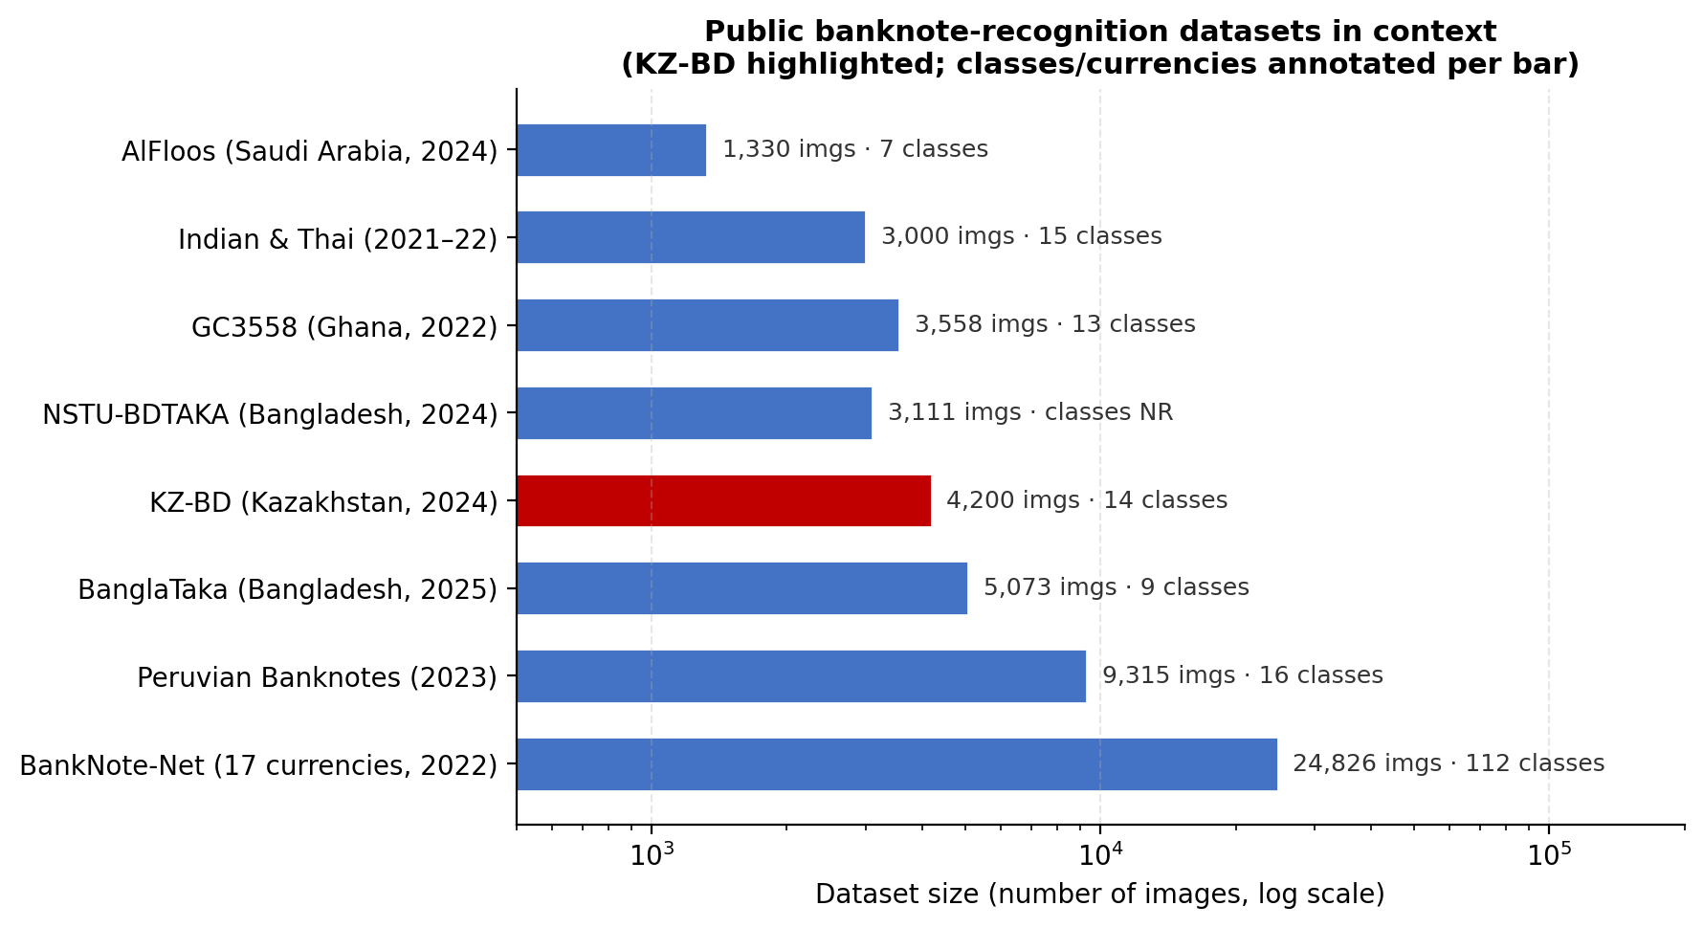

Figure 3 – Public banknote-recognition datasets in context (data from table 6), with KZ-BD highlighted

Note – Dataset size is shown on a log scale because individual datasets range from roughly 1,300 to nearly 25,000 images

To situate the above resources within the broader field, the following discussion summarises representative studies by national currency and reports the dataset identifiers (where provided), approximate image counts, denomination coverage, and availability. The table distinguishes single-currency recognition from multi-currency recognition, which is particularly relevant for assistive and general-purpose systems that must handle diverse currencies in unconstrained capture conditions.
This synthesis also illustrates a persistent limitation in the literature: many datasets remain proprietary or are insufficiently described, restricting reproducibility and limiting meaningful cross-dataset benchmarking. Counts and denomination totals should be interpreted cautiously because studies differ in capture protocol (scanner vs camera), image type (cropped ROI vs in-scene), and whether reported totals include augmentation.

Chapter summary
This chapter positions banknote recognition as a practical computer-vision problem shaped primarily by real-world deployment constraints. It frames modern banknote-processing systems around four core functions: denomination recognition, counterfeit detection, serial-number recognition, and fitness or condition assessment. A central theme is that effective systems must balance recognition accuracy, computational efficiency, and hardware cost. These constraints strongly influence both the sensing modality and the structure of the recognition pipeline, particularly in mobile and assistive scenarios.
The chapter traces the evolution of banknote recognition from classical computer-vision pipelines to modern deep-learning-based approaches. Early systems relied on template matching and hand-crafted descriptors such as colour statistics, HOG, and SIFT/SURF, combined with classifiers including SVMs, kNN, and Random Forests. While these approaches remain attractive for low-cost and controlled environments, they are highly sensitive to real-world nuisance factors such as illumination variation, cluttered backgrounds, viewpoint changes, occlusion, and physical degradation of banknotes. This sensitivity leads to a persistent gap between laboratory performance and real deployment behaviour.
Deep learning is presented as the dominant contemporary paradigm due to its ability to learn robust feature representations from data. The chapter emphasises that detection-centric or detect-then-classify pipelines are especially effective for unconstrained scenes, as explicit localization reduces background interference and improves robustness to partial visibility. Recent training strategies, including mosaic-based augmentation and aggressive photometric transformations, are highlighted as important tools for improving performance under occlusion and viewpoint variation. At the same time, real-time performance remains a key requirement for assistive systems, motivating continued evaluation of lightweight detectors such as modern YOLO variants.
A central motivation of the dissertation is the use of hybrid recognition pipelines. Rather than relying solely on end-to-end deep models, the chapter argues for combining deep feature extractors with lightweight classical classifiers. In this framework, a CNN provides a robust embedding, while multiple classical learners are stacked to exploit complementary decision behaviours and reduce correlated errors. This approach aligns with the thesis objective of achieving strong performance under real-world constraints while remaining suitable for mobile and embedded deployment, particularly for Kazakhstani banknotes.
Section 1.1 systematically outlines the dominant challenges in real-world banknote recognition, including illumination and colour shift, background clutter, occlusion and folds, pose and scale variation, physical wear, fine-grained inter-denomination similarity, device-dependent domain shift, and edge-computing limitations. For each challenge, the chapter links observed failure modes to corresponding mitigation strategies across traditional computer vision, deep learning, and hybrid systems. A key conclusion is that robustness depends not only on model architecture but also on dataset diversity, augmentation strategy, and evaluation methodology.
Section 1.2 reviews traditional computer-vision pipelines in detail, describing preprocessing steps such as contrast enhancement and colour normalization, ROI localization using geometric constraints, perspective rectification, and feature extraction using colour, texture, gradient, and frequency-based descriptors. These features are typically combined with dimensionality reduction and classical classifiers. While such pipelines are efficient and interpretable, they are highly sensitive to errors in segmentation and normalization, which limits their reliability in unconstrained environments.
Section 1.3 focuses on classical machine-learning classifiers and their role in hybrid systems. Models such as kNN, SVM, Gaussian Naïve Bayes, Random Forests, and ridge regression are reviewed in terms of their decision characteristics and complementary strengths. The key insight is that these classifiers exhibit different error patterns, and when combined through stacking, they can improve robustness and stability relative to any single model.
Section 1.4 surveys deep learning approaches for banknote recognition, distinguishing between ROI-based CNN classifiers and scene-level object detectors. Detect-then-classify pipelines are emphasised as particularly effective for real-world capture scenarios. The section also discusses robustness-oriented training strategies, attention mechanisms for fine-grained discrimination, and deployment considerations such as model compression, quantization, and latency constraints. Multi-task systems integrating denomination recognition, counterfeit detection, and OCR are presented as an important direction toward operational banknote-processing systems, albeit with increased training complexity.
Section 1.5 highlights the critical role of datasets in driving progress. It emphasises that dataset realism and diversity largely determine generalization performance. Modern datasets increasingly focus on multi-currency coverage, in-the-wild acquisition, and detailed annotation to support detection and recognition tasks. The chapter identifies three key trends: the rise of multi-currency datasets enabling cross-domain learning, the importance of realistic mobile-captured data, and growing attention to underrepresented currencies. Within this context, the KZ-BD dataset is positioned as an important contribution, providing realistic Kazakhstani banknote images with detection annotations suitable for reproducible evaluation.
Overall, the chapter establishes that robust banknote recognition is fundamentally a deployment-driven problem. Purely classical approaches lack robustness under real-world variability, while fully end-to-end deep models can be computationally heavy and difficult to control. These observations motivate the dissertation’s hybrid strategy: combining deep feature extraction with lightweight, stacked classical classifiers to achieve a practical balance between accuracy, efficiency, and generalization, validated using realistic datasets and condition-aware evaluation protocols.

2 METHODOLOGY

This chapter provides a comprehensive description of the experimental methodology adopted to develop and evaluate a hybrid recognition framework for Kazakh banknotes acquired under heterogeneous real-world imaging conditions. The classifier-comparison methodology and the KZ-BD baseline results reported in this chapter and in Sections 3.1–3.4 extend and consolidate the author’s own prior publication, Sadyk et al. [8, p. 3552-3566], which first reported the traditional-versus-hybrid classifier comparison on Kazakh banknotes. The original contributions of this dissertation beyond that publication are: the construction and documentation of the KZ-BD dataset itself, the cross-dataset transferability experiments in Section 3.5, and the extended analysis and deployment discussion in Chapter 4. Where the text below refers to configuration choices, splits, or hyperparameters “reported in the experimental study,” this refers to [8, p. 3552-3566] specifically. The methodological aim extends beyond maximising denomination-recognition accuracy under controlled evaluation; it is to define a reproducible and deployment-oriented protocol that reflects the variability encountered in operational environments, including retail transactions, automated cash-handling infrastructure, and mobile assistive applications. In this dissertation, heterogeneous conditions are understood as systematic sources of distributional variation that can substantially degrade recognition performance, including non-uniform illumination and colour casts, motion blur and sensor noise, background clutter, changes in viewpoint and scale, partial occlusion by hands or other objects, folds and wrinkles, and the progressive deterioration of banknotes through wear, soiling, and series-level design changes. The methodological choices described in this chapter therefore prioritise robustness, maintainability, and computational efficiency in addition to predictive accuracy.
The proposed approach is grounded in a hybrid modelling principle: deep neural networks are effective at learning transferable and invariant visual representations, while classical machine-learning models can provide efficient, controllable, and complementary decision functions when operating on stable embeddings. To exploit these respective strengths, the pipeline is deliberately decomposed into two stages. In the first stage, a compact convolutional encoder performs representation learning. A ResNet-18 backbone is selected due to its favourable accuracy–efficiency trade-off, which is compatible with resource-constrained deployment. Importantly, ResNet-18 is not used as an end-to-end denomination classifier. Instead, the terminal classification layer is removed and activations from the penultimate layer are used as fixed-length embeddings. This design reduces the complexity of the decision layer while retaining discriminative information associated with denomination-specific textures, spatial layout cues, and fine-grained security-related patterns. Treating ResNet-18 as a feature extractor therefore leverages the invariances captured by convolutional representations while preserving modularity at the classification stage.
In the second stage, the extracted embeddings are mapped to denomination labels using a stacking ensemble of traditional machine-learning classifiers. The rationale for stacking is that no single shallow classifier is uniformly optimal across the full range of nuisance factors present in real-world capture. Instance-based learners can exploit local neighbourhood structure in embedding space; margin-based classifiers can provide strong global separation; probabilistic models offer efficient, low-variance baselines; tree ensembles can capture non-linear interactions and irregular boundaries; and regularised linear models provide stable solutions that are often competitive when embeddings exhibit approximate linear separability. Rather than selecting a single decision mechanism a priori, stacking learns how to combine multiple complementary learners by training a meta-model on their probabilistic outputs. This strategy aims to improve reliability under distribution shift by reducing correlated errors and exploiting diversity in inductive bias. A practical benefit of this modular formulation is maintainability: when new series are introduced or label sets evolve, the representation stage can often be reused, while only the lightweight classification layer requires retraining or incremental updating.
The chapter is organised to maximise methodological transparency and reproducibility. It begins by specifying the dataset resources used in the dissertation and clarifying how each dataset supports distinct aspects of robustness evaluation (for example, YOLO-annotated imagery enabling consistent ROI extraction versus series-specific partitions enabling design-drift analysis). It then formalises the task formulations considered, the label schema, and the evaluation assumptions, including single-note ROI classification, scene-level recognition under clutter and occlusion, and series-aware analysis. Next, it describes the preprocessing pipeline in detail, including image standardisation, colour normalisation consistent with CNN pretraining, and training-only augmentation strategies designed to approximate operational capture variability. Where region extraction is required, the methodology documents the ROI protocol (bounding-box-based crops), background-margin handling, and procedures used to prevent train–test leakage during crop generation and augmentation.
The chapter subsequently formalises the deep embedding stage by documenting the encoder configuration, embedding dimensionality, and the extraction protocol. Operational details that materially affect reproducibility are made explicit, including inference-mode extraction, fixed preprocessing parameters, and caching of embeddings so that all downstream classifiers are trained and evaluated on identical representations. The methodology then details the training and optimisation of each base classifier, including hyperparameter search spaces, the cross-validation strategy used for model selection, and the calibration considerations required to obtain comparable probabilistic outputs across heterogeneous learners. Particular emphasis is placed on the stacking procedure itself: the chapter specifies a leakage-safe protocol in which the meta-learner is trained on out-of-fold predictions, ensuring that fusion weights are learned from base-learner outputs that reflect genuine out-of-sample behaviour.
The evaluation framework is defined with two complementary objectives. First, recognition effectiveness is quantified using standard multi-class metrics, including accuracy, macro-averaged F1 (to ensure class-balanced reporting), Matthews correlation coefficient (MCC) as a robust summary statistic under imbalance, and ROC-AUC under a one-vs-rest formulation where appropriate. Second, deployment feasibility is assessed through efficiency metrics, including end-to-end inference latency (with the contributions of feature extraction and classification reported separately), memory footprint, and model-storage requirements. These measures are essential because practical banknote-recognition systems are frequently deployed on resource-constrained platforms, where usability depends on throughput and responsiveness as much as on accuracy.
The chapter specifies the comparative and ablation experiments used to support methodological claims. Comparative experiments benchmark the proposed stacked hybrid framework against individual base learners and representative baselines (including single classical learners on embeddings and, where relevant, end-to-end CNN classification). Ablation studies isolate the contribution of key components by removing base learners, modifying the meta-learner, or altering ROI and augmentation protocols, thereby identifying which design choices drive performance improvements. Where dataset structure permits, condition-aware analyses further examine robustness by stratifying results across nuisance factors (e.g., low-light versus normal-light capture, occluded versus non-occluded notes, clean versus worn notes). Collectively, these procedures provide a rigorous methodological foundation for evaluating banknote recognition not only as a classification problem, but as a deployable system operating under real-world variability and computational constraints.

2.1 Research design
The study adopts an experimental, quantitative research design in which alternative modelling strategies are systematically implemented and evaluated under controlled conditions. The principal independent variable is the recognition architecture, operationalised through two orthogonal design choices: i) the representation strategy (handcrafted descriptors versus deep CNN embeddings) and ii) the decision mechanism (a single classifier versus a stacked ensemble). Additional controllable factors include the choice of CNN backbone configuration for embedding extraction, the composition of the base-learner set, the fusion rule and meta-learner specification used for stacking, and the hyperparameter-optimisation strategy. To ensure internal validity, all comparative experiments hold constant the preprocessing pipeline, region-extraction procedure, data partitions, and evaluation criteria, so that observed performance differences can be attributed to the modelling strategy rather than to confounding changes in data handling or measurement.
The dependent variables are defined along two complementary axes. The first axis captures recognition effectiveness, quantified using standard multi-class metrics: overall accuracy; macro-averaged F1 score to ensure class-balanced reporting; Matthews correlation coefficient (MCC) as a robust single-number summary that remains informative under imbalance; and ROC-AUC under a one-vs-rest formulation where probability outputs permit meaningful ranking analysis. The second axis captures deployment feasibility, assessed via inference latency and memory footprint, which are essential constraints for embedded and mobile operation. Latency is measured both end-to-end and per pipeline stage (feature extraction versus classifier inference) to identify computational bottlenecks and to separate representational cost from decision-layer cost. Memory analysis includes both persistent storage requirements (e.g., encoder weights and learned classifier parameters) and runtime overhead during inference.
Experiments are conducted using dataset-provided fixed splits when available to preserve reproducibility and comparability with published benchmarks. Hyperparameter tuning and model selection are performed exclusively on training data through cross-validation (or training-plus-validation, where the dataset protocol specifies such use), while the held-out test set is reserved strictly for final performance reporting. Comparative experiments benchmark the proposed hybrid framework against representative baselines, including single classical learners and non-stacked alternatives, as well as end-to-end deep classifiers where appropriate. Ablation studies are then used to isolate the contribution of individual components by systematically removing or altering them (e.g., excluding one base learner at a time, changing the meta-learner, or replacing deep embeddings with handcrafted descriptors). Where dataset structure permits, additional stratified analyses examine robustness across capture conditions (e.g., cluttered versus clean backgrounds, folded versus unfolded notes), thereby supporting stronger claims about generalisation. Collectively, this experimental design enables methodologically grounded conclusions regarding both predictive performance and practical efficiency, and it provides a transparent basis for replication and future extension.
To make these design choices concrete, figure 4 traces the end-to-end research and experimental workflow followed throughout the dissertation, from problem definition through to deployment analysis.

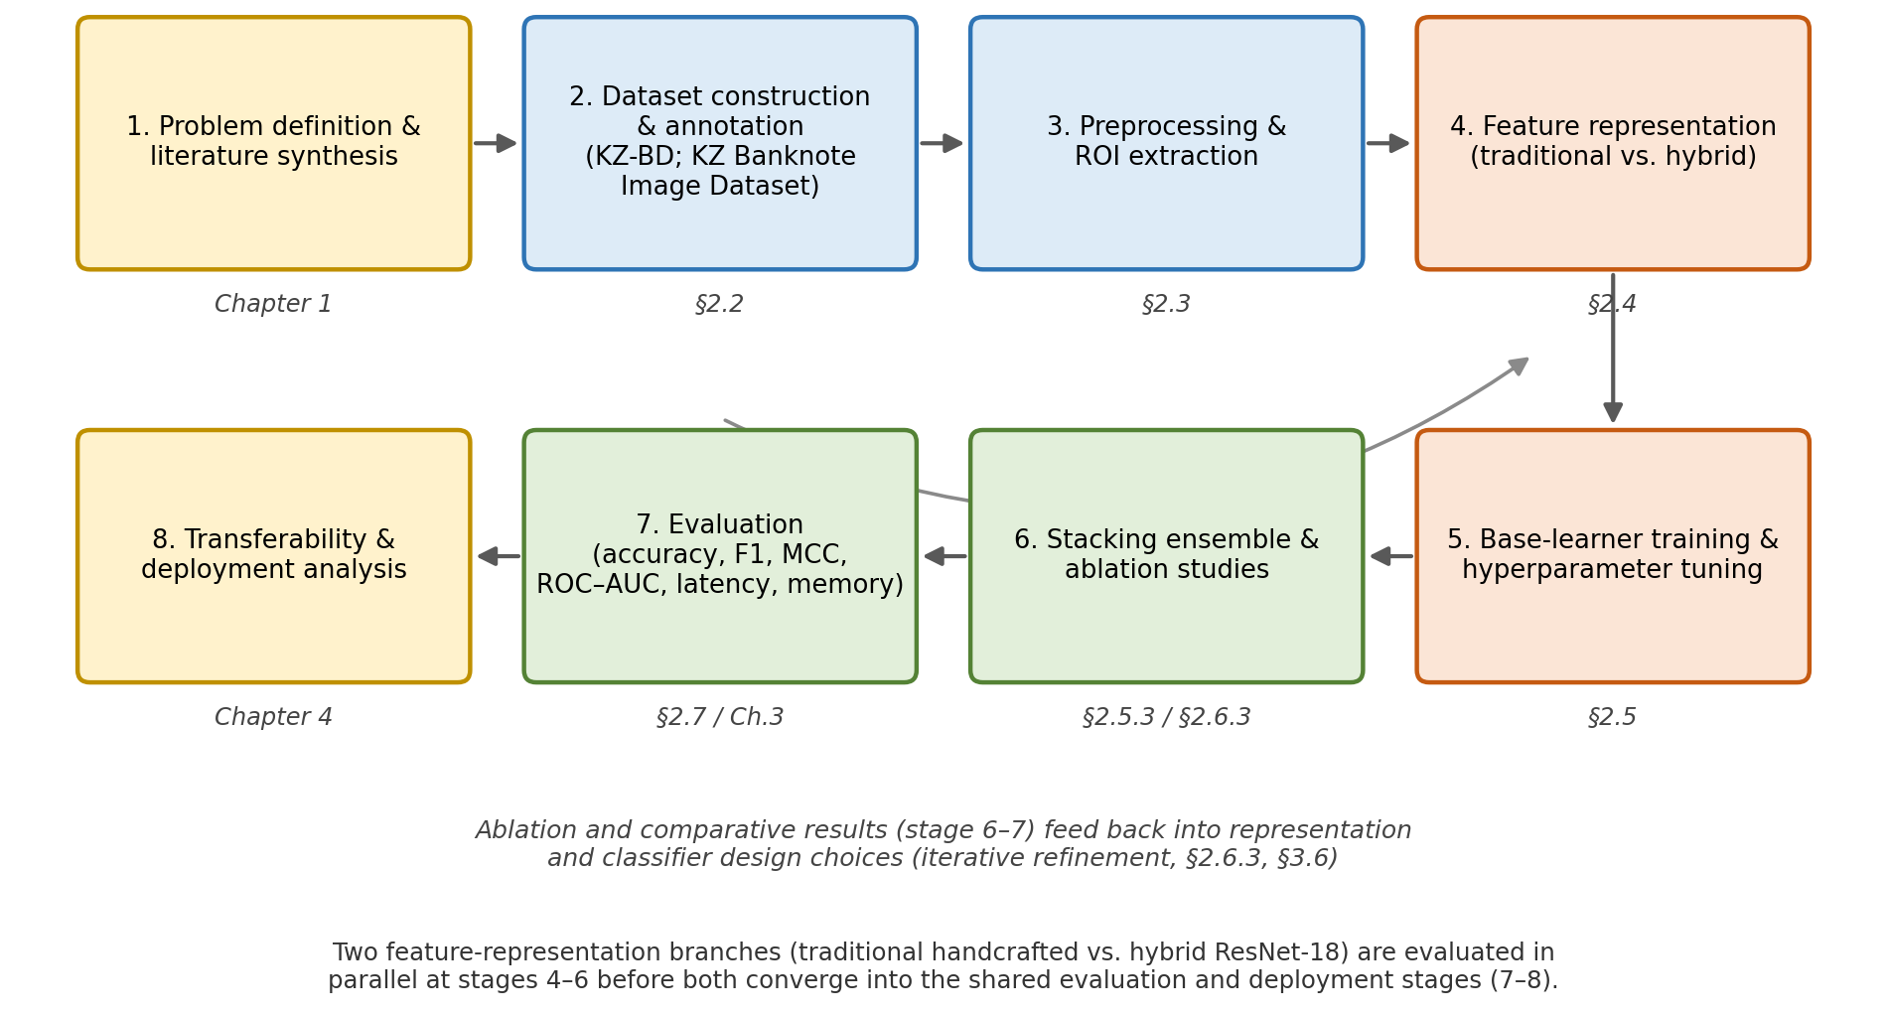

Figure 4 – Research and experimental workflow followed in this study, from problem definition and dataset construction (Chapter 1-2) through feature representation, classifier training, and ensemble stacking, to evaluation and deployment analysis (Chapter 3-4)

The workflow diagram summarises, at the level of the whole study, how the research-design choices described above are executed in practice. Stages 1-3 establish the empirical foundation: synthesising the literature gap identified in Chapter 1 [1, p. 5-7], constructing and annotating the KZ-BD and Kazakh Banknote Image Dataset resources, and extracting clean regions of interest. Stages 4-6 implement the two parallel representation strategies (handcrafted colour features versus ResNet-18 embeddings) that are compared throughout Chapter 3, culminating in the leakage-safe stacking ensemble described in §2.5.3. Stages 7-8 close the loop by quantifying recognition performance and deployment feasibility and by testing whether the resulting pipeline transfers to unrelated datasets (§3.5), consistent with the dissertation’s stated aim of delivering an accurate, robust, and computationally efficient recognition framework (figure 5).

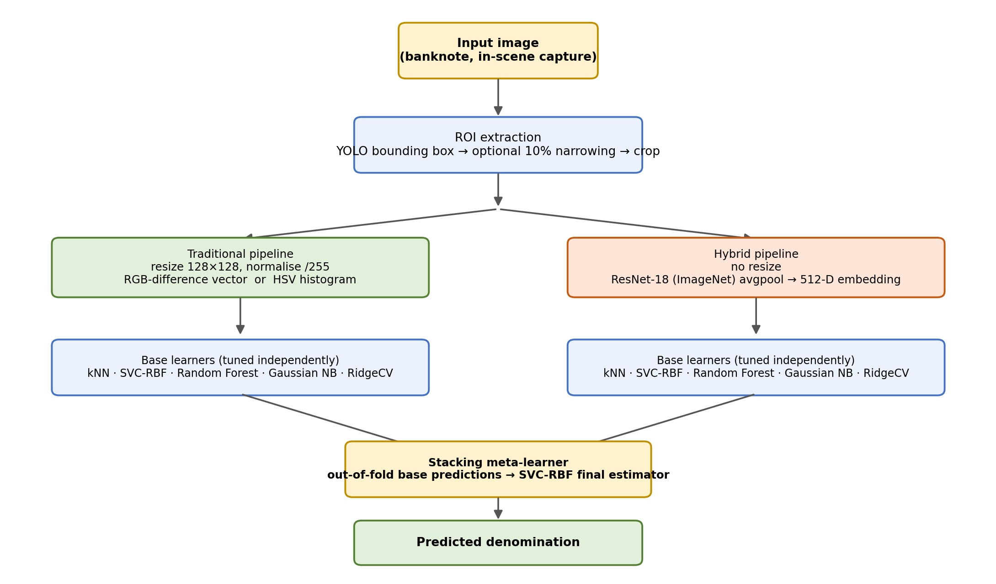

Figure 5 – Unified end-to-end pipeline: ROI extraction, the traditional and hybrid feature-representation branches, the five shared base learners, and the stacking meta-learner that produces the final denomination prediction

Figure 6 complements the pipeline view above with a UML-style class diagram of the system’s software architecture, making explicit the modular decomposition into encoder, base-learner, and ensemble components referenced throughout §2.4-2.5.

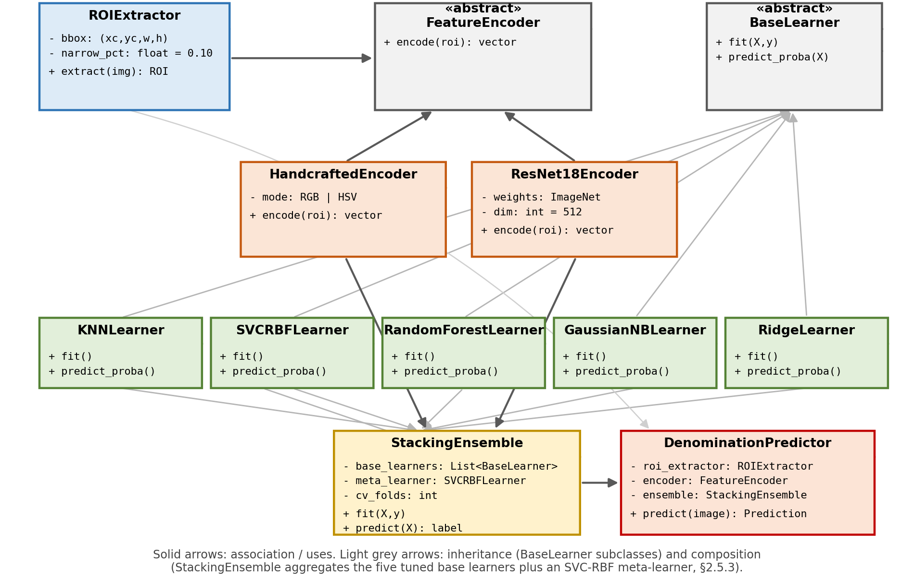

Figure 6 – UML-style class diagram of the recognition system’s software architecture: an abstract FeatureEncoder implemented by handcrafted and ResNet-18 encoders, five BaseLearner implementations, and a StackingEnsemble composed within a DenominationPredictor facade

This class-level view formalises the modularity argument made in §2.4.1: because FeatureEncoder and BaseLearner are treated as interchangeable components behind stable interfaces, the encoder can be replaced (e.g., with a lightweight backbone, §4.4) or a base learner substituted without altering the surrounding system. The StackingEnsemble class composes the five tuned base learners together with an SVC-RBF meta-learner, mirroring the leakage-safe out-of-fold stacking protocol implemented in §2.5.3, consistent with the classifier set and implementation logic reported in [8], while the DenominationPredictor facade exposes a single predict() entry point that hides this internal composition from downstream deployment code.

2.2 Datasets and task definitions

2.2.1 Dataset resources
This dissertation uses two publicly available datasets created and released by the author team. The first dataset, KZ-BD (“Dataset of Kazakhstan Banknotes with Annotations”), comprises 4,200 high-quality images organised into 14 denomination classes spanning 1–20,000 KZT. The images were captured using the rear camera of a single mobile-phone device (a 12-megapixel Apple iPhone 11) [7, p. 110076] under heterogeneous real-world conditions, including illumination variation, cluttered backgrounds, occlusion, and folded banknotes. The dataset is annotated in YOLO format, enabling detection-ready workflows and region-based recognition pipelines, and it is distributed with a stated 70:30 training/validation split under a CC BY 4.0 license to support reproducible benchmarking. The accompanying Data in Brief publication formally documents KZ-BD, noting that it includes authentic Kazakhstan tenge in both coin and paper-note forms and describing dataset curation practices, including de-identification and validation procedures implemented to ensure data integrity and responsible reuse (figure 5).

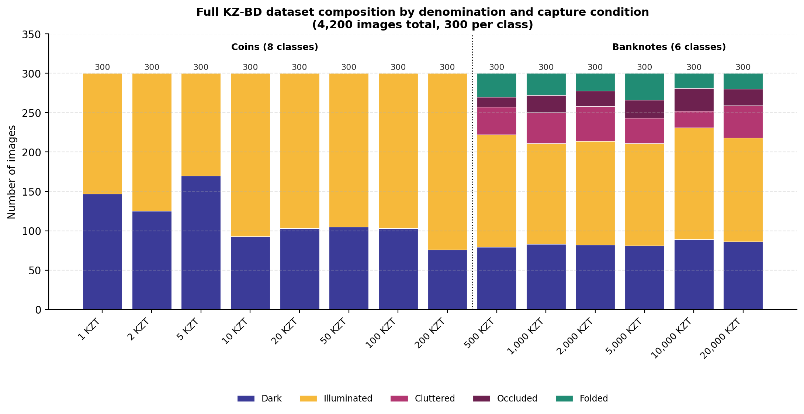

Figure 7 – Full KZ-BD dataset composition by denomination and capture condition (4,200 images, 300 per class), reproduced from the dataset’s Data in Brief documentation, distinguishing coin and banknote classes and their distribution across dark, illuminated, cluttered, occluded, and folded capture conditions

Note – Compiled from the source [7, p. 110076]

The second dataset, the Kazakh Banknote Image Dataset [83], provides banknote imagery organised into six denomination folders (500–20,000 KZT) together with a Mix category containing images with multiple denominations present in the same frame (seven top-level folders in total, 1,846 images overall), thereby supporting evaluation under multi-object scene conditions. It explicitly incorporates variation in background and lighting; the Mix subset contains more than 1,000 images, and each denomination folder contains at least 100 images, ensuring minimum per-class coverage. To enable controlled analysis of design-series variation and capture complexity, the 5,000 KZT denomination is subdivided into 5000_new_single, 5000_new, and 5000_old, allowing systematic comparison between old and new series as well as single-note versus multi-note scenes. The dataset includes a manifest.csv metadata file and predefined train/validation/test splits (via the splits/ directory), and it is released under a CC BY 4.0 license. In the experimental design, KZ-BD serves as the primary benchmark for detection-ready, real-world recognition and robustness evaluation, whereas the Kazakh Banknote Image Dataset is used for secondary validation, particularly for assessing generalisation to multi-note scenes and sensitivity to series-level design changes.

2.2.2 Task definitions used in this dissertation
Because the two datasets differ in annotation granularity and scene composition, the dissertation evaluates three closely related tasks that together reflect both controlled recognition and realistic deployment conditions:
Task 1: Denomination classification on single-note crops (primary task).
The primary task is formulated as supervised multi-class classification, where a cropped region of interest (ROI) containing a single banknote is assigned a denomination label. This setting isolates denomination discrimination from localisation errors and enables a clean assessment of representation quality and classifier performance. KZ-BD supports this task directly through its YOLO bounding-box annotations, which provide consistent ROI extraction for each sample.
Task 2: Scene-level recognition under clutter and occlusion (supporting task).
To approximate real-world operation, a supporting task evaluates robustness when banknotes are captured in unconstrained scenes, including textured or visually complex backgrounds, variable lighting, partial occlusion by hands or objects, and folds. This task tests the model’s tolerance to nuisance variation and its ability to preserve accuracy when discriminative regions are partially degraded. KZ-BD explicitly contains such real capture conditions and is therefore used to analyse performance under these stressors.
Task 3: Series and multi-note variability analysis (secondary task).
A secondary set of experiments examines generalisation across more challenging forms of distribution shift. The second dataset enables evaluation on images that contain multiple banknotes within a single frame (the Mix subset), which introduces additional complexity due to overlapping notes and increased background interference. It also supports controlled analysis of design-series variation for the 5,000 KZT denomination through the 5000_old, 5000_new, and 5000_new_single subsets, allowing the dissertation to quantify sensitivity to series changes and to compare single-note versus multi-note conditions within a consistent denomination category.

2.2.3 Dataset use in this dissertation
Table 7 summarises the two datasets and clarifies their distinct methodological roles. KZ-BD serves as the primary benchmark because it provides YOLO-format annotations and realistic mobile-capture variability, enabling consistent ROI extraction and robustness evaluation. The second dataset is used as an external validation resource, with multi-note scenes and series-specific subsets that support generalisation and design-drift analysis.
Figure 8 visualises the roles summarised in table 7 as a dataset-to-task usage flow, showing which experiments draw on each data resource.

Table 7 – Datasets used and their methodological roles

Dataset | What it provides | What this thesis uses it for
KZ-BD (annotated) | 4,200 images; 14 denomination classes (1–20,000 KZT); YOLO-format bounding boxes; mobile captures with varied lighting, clutter, folds; published 70:30 train/validation split | Primary benchmark for ROI-based denomination recognition; robust ness analysis under unconstrained capture; reproducible evaluation based on the released split
Kazakh Banknote Image Dataset | Denomination folders (500–20,000 KZT) plus Mix (multi-note scenes; >1,000 images); 5,000 KZT subsets (5000_old, 5000_new, 5000_new_single); mani fest.csv metadata; predefined train/vali dation/test partitions; no bounding boxes | External validation of generalisa tion; evaluation on multi-note sce nes (Mix); series-variation analysis for the 5,000 KZT denomination; assessment of sensitivity to design changes and scene complexity

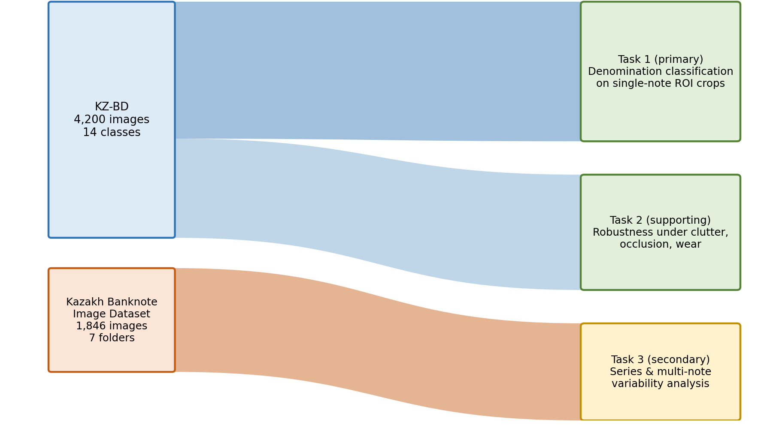

Figure 8 – Dataset-to-task usage flow: KZ-BD (4,200 images, 14 classes) supports Task 1 (primary single-note denomination classification) and Task 2 (robustness under clutter, occlusion, and wear), while the Kazakh Banknote Image Dataset (1,846 images, 7 folders) supports Task 3 (series and multi-note variability analysis)

Note – Compiled from the source [83, p. 112634]

As the diagram makes explicit, KZ-BD is not partitioned between Task 1 and Task 2; rather, the same annotated image set is analysed twice, once under the standard train/test protocol (§2.6.1) and once with an explicit focus on capture-condition stressors, in order to separate robustness effects from raw recognition accuracy. The secondary dataset [83, p. 112634] is used exclusively for Task 3, where its Mix subset and 5,000 KZT design-series folders provide the multi-note and series-variation structure that KZ-BD does not contain. This division of labour between the two data resources is what allows the transferability claims in §3.5 to be interpreted cleanly: any accuracy change observed on Task 3 reflects genuine distribution shift to an unseen data source and scene composition, rather than variation within a single dataset’s split.

2.3 Preprocessing and region extraction

2.3.1 Image standardisation and preprocessing (prior to embedding extraction)
To ensure that subsequent feature extraction and classification are comparable across capture devices and acquisition conditions, all images are converted into a consistent computational format prior to training and evaluation. Preprocessing is designed to be minimal but principled: it removes nuisance variation that is irrelevant to denomination identity while preserving fine-grained discriminative cues (e.g., micro-textures, guilloché structures, denomination numerals, and security-element patterns).
Images are loaded in a consistent colour ordering (RGB) and stored in a standard numeric range. For classical-feature baselines and lightweight models, pixel values are normalised by scaling intensities to [0,1], consistent with the experimental protocol reported in the comparative study. For deep feature extraction, inputs are prepared to remain compatible with ImageNet-pre-trained feature statistics, because the ResNet-18 backbone is reused as a fixed encoder.
For experiments that operate on cropped ROIs (the primary task), resizing is treated as an implementation choice that trades off speed against the preservation of fine detail. In [8, p. 3552-3566], the traditional-feature pipeline explicitly resizes ROI crops to 128×128 prior to feature computation and classification. In contrast, for the hybrid approach, ROI crops are not resized before being passed to the pre-trained ResNet-18 encoder, because the network produces a fixed-length representation via its pooling stage regardless of the spatial resolution of the input ROI. This choice is methodologically important: avoiding aggressive resizing can reduce the risk of eliminating denomination-specific micro-patterns, while the encoder’s pooling operation still yields a compact embedding suitable for efficient downstream learners.
Optional mild denoising may be applied only when strong sensor noise is present (e.g., low-light capture), and is kept conservative to avoid suppressing discriminative texture. In practice, robustness to noise is primarily addressed through (i) dataset diversity (including shadows and low illumination) and (ii) training-time augmentation rather than heavy preprocessing, since the goal is to maintain fidelity to real deployment conditions. KZ-BD explicitly includes lighting variation, cluttered backgrounds, and folded notes captured by mobile devices, supporting this design choice.
Data augmentation is applied exclusively to training samples (Section 3.4.3) to increase invariance to rotation, illumination change, mild blur, and partial occlusion without contaminating validation/test measurements.

2.3.2 ROI extraction (KZ-BD)
Recognition accuracy in banknote classification is highly sensitive to the quality of the region of interest (ROI): when a crop contains excessive background content, both handcrafted descriptors and deep embeddings may encode irrelevant textures and illumination patterns, thereby increasing intra-class variance and reducing class separability. For this reason, ROI construction is treated as a core methodological component of the experimental pipeline. For KZ-BD, ROI extraction is performed deterministically using the dataset’s YOLO-format bounding-box annotations, which were released specifically to support detection and recognition under unconstrained capture conditions.
Each YOLO label specifies a class identifier and a bounding box in normalised form (x_{c},y_{c},w,h), where (x_{c},y_{c}) denotes the box centre and (w,h) denote box width and height, all expressed relative to the image dimensions. Given an image of width W and height H, these values are converted to pixel coordinates as:

x_{min} = W(x_{c} − w/2) (1)

x_{max} = W(x_{c} + w/2) (2)

y_{min} = H(y_{c} − h/2), y_{max} = H(y_{c} + h/2) (3)

y_{max} = H(y_{c} + h/2) (4)

The resulting coordinates are clipped to the valid image range [0,W−1]×[0,H−1] to prevent invalid indexing. The crop defined by [x_{min}⁡,x_{max}⁡]×[y_{min}⁡,y_{max⁡}] yields a rectangular ROI intended to isolate the banknote while retaining only the contextual pixels included by the annotation (1)-(4).
In practice, manually annotated boxes often include a small margin around the target object. The KZ-BD dataset documentation [8, p. 3552-3566] reports that the original annotations “covered slightly extra area around the banknotes,” and therefore applied a 10% narrowing of bounding boxes to reduce background spill and produce tighter ROIs. Figure 9 illustrates this refinement, showing the original bounding box (green) and the narrowed bounding box (red) for a 2,000 KZT banknote. Following this validated protocol, the dissertation adopts the same refinement when ROI purity is critical (particularly for cluttered backgrounds).


Figure 9 – The original bounding box (green) and the narrowed bounding box (red)

Let the original normalised width and height be (w,h). The refined box is defined by (5):

w’ = 0.9w, h’ = 0.9h (5)

with the same centre (x_{c},y_{c}). Equivalently, this removes 5% from each side of the box. This refinement is methodologically non-trivial: it reduces the inclusion of background textures (e.g., table surfaces, textiles, printed patterns) that can bias colour-based baselines and inject irrelevant structure into deep feature embeddings, particularly under hand-held capture and uneven illumination.
To ensure that comparisons across modelling paradigms remain interpretable, ROI handling follows the approach-specific protocols documented in [8, p. 3552-3566].
Traditional-feature baselines: After cropping (with optional 10% narrowing), ROIs are resized to 128×128 and intensity-normalised by scaling pixel values to [0,1] (division by 255) prior to feature computation and classification.
In addition to this shared preprocessing, the two paradigms differ in how the normalised ROI is converted into a feature vector. For the traditional pipeline, two colour-based representations are used across the dissertation’s ablation stages. The baseline representation reduces each ROI to three average-channel-difference features (6):

RB = r̄ − b̄, RG = r̄ − ḡ, GB = ḡ − b̄ (6)

where r̄, ḡ, and b̄ denote the mean red, green, and blue channel intensities over the pixels of the cropped ROI, yielding the three-dimensional descriptor xᵍᵣ = [RB, RG, GB] reported in table 9. The optimised traditional representation instead converts the ROI to HSV colour space and computes a per-channel intensity histogram (7):

h_{ch}(k) = 1/|R| Σ_{p∈R} 𝟙{ch(p) ∈ bin_{k}}, ch ∈ {H, S, V} (7)

where R denotes the set of pixels in the ROI and bin is the k-th intensity bin of channel ch. The three per-channel histograms are each normalised to sum to one and concatenated into a single feature vector (8):

x_{HSV} = [h_{H} || h_{S} || h_{V}] ∈ R_{3B} (8)

with B = 256 bins per channel, giving the 768-dimensional descriptor used in table 10. This representation preserves substantially more of the ROI’s colour distribution than the three-scalar RB/RG/GB baseline, at the cost of a higher-dimensional feature space (§3.3.2).
Hybrid deep-feature pipeline: ROIs are cropped (again with optional 10% narrowing) and passed to the pre-trained ResNet-18 encoder without mandatory resizing, because embeddings are extracted from the network’s global pooling stage, yielding a fixed-length representation (512-dimensional). This preserves fine-grained denomination cues that may be attenuated by aggressive downsampling while maintaining a compact descriptor for efficient classical classification.
This separation aligns with the dissertation’s core methodological premise: deep embeddings function as a universal representation layer, while lightweight classical models provide modular and efficient decision functions that can be strengthened through stacking.
KZ-BD includes denominations from 1 to 20,000 KZT, covering both coins and banknotes. For experiments targeting banknote-only recognition aligned with typical smartphone and assistive scenarios, the classification scope is restricted to paper-note denominations (e.g., 500–20,000 KZT), consistent with the experimental protocol reported in the associated study. Where the research question requires unified currency recognition, the full label space (coins + banknotes) is retained. This design ensures that results are directly interpretable with respect to the intended deployment setting and avoids conflating banknote recognition with coin recognition when the latter is not the target task.

2.3.3 Data augmentation
Data augmentation is incorporated as a training-only mechanism to improve generalisation under heterogeneous real-world capture conditions. Although the collected datasets already exhibit substantial natural variability (e.g., changes in illumination, cluttered backgrounds, folds and partial occlusions), augmentation is introduced in this dissertation as a controlled experimental factor to further increase robustness to rare but operationally critical perturbations. To preserve the validity of evaluation, no augmentation is applied to the validation or test partitions; these sets undergo only deterministic preprocessing. Moreover, the augmentation policy (operators, parameter ranges, and application probabilities) is held constant across all compared models to ensure that observed differences reflect modelling choices rather than differences in data perturbation strength.
The applied augmentations are designed to approximate realistic acquisition variability while preserving denomination identity:
1. Photometric perturbations: random brightness and contrast jitter, together with mild colour jitter, to simulate exposure variation, colour casts, and non-uniform illumination commonly observed in mobile camera capture.
2. Geometric perturbations: random in-plane rotations and small perspective transforms to model changes in camera orientation and mild projective distortion arising from non-frontal viewing angles.
3. Occlusion simulation: random erasing (Cutout-style) to mimic partial obstruction by hands, folds, or overlapping objects, encouraging the model to rely on distributed evidence rather than a single highly localised cue.
Augmentation parameters are fixed across experiments and reported explicitly in the experimental setup to support full reproducibility and fair comparison. Where results are compared to configurations reported in prior work, the dissertation distinguishes baseline experiments from augmentation-enabled extensions to avoid conflating architectural effects with data-driven robustness gains.
In [8, p. 3552-3566], no explicit synthetic augmentation was used. The experiments relied on the inherent diversity of the collected mobile-capture data and evaluated models on dataset-provided partitions after deterministic preprocessing and ROI extraction. Excluding augmentation in the published baseline reduced confounding and ensured that improvements were attributable to the modelling strategy (handcrafted features versus deep embeddings; single learners versus stacking) rather than to additional synthetic perturbations. In this thesis, augmentation-enabled experiments, where included, are therefore treated as a clearly identified extension to the published baseline and are reported separately.

2.4 Deep feature extraction with ResNet-18

2.4.1 Motivation and design choice
ResNet-18 is adopted as a deep feature extractor rather than trained end-to-end as a denomination classifier. The motivation is both methodological and practical. Methodologically, the primary objective of this work is to evaluate whether a hybrid architecture can combine the representational strength of deep convolutional networks with the controllability and efficiency of classical machine-learning decision functions. Using ResNet-18 purely for embedding extraction isolates the contribution of deep representation learning and enables a principled comparison of different shallow classifiers and ensemble fusion strategies on a fixed feature space.
From a representational perspective, ResNet-18 produces compact, high-level descriptors that encode cues relevant to banknote identity, including denomination numerals, portrait and layout structures, and fine-grained texture patterns associated with security printing. These embeddings provide a robust alternative to handcrafted descriptors, which often degrade under illumination changes, cluttered backgrounds, folds, and wear. At the same time, the embedding representation is sufficiently low-dimensional to support efficient training and inference with classical classifiers, including those used in this dissertation’s stacking ensemble.
From a deployment perspective, ResNet-18 offers a favourable accuracy–efficiency trade-off. Compared with larger backbones (e.g., ResNet-50 or DenseNet variants), ResNet-18 substantially reduces computational cost and memory usage while still producing discriminative features suitable for downstream learning. This makes it a practical choice for embedded and mobile deployment, where inference latency, storage footprint, and energy consumption are limiting factors. Finally, treating the CNN as a modular encoder improves maintainability: the feature extractor can be reused across denominations or updated series with minimal architectural changes, while the downstream classical ensemble can be retrained or adapted quickly as label sets evolve.
This design also clarifies why the pipeline does not simply fine-tune a YOLO detector end-to-end to perform denomination classification directly, an alternative worth addressing explicitly since YOLO-format annotations are used throughout this dissertation and YOLO variants are themselves discussed in §1.4 as well suited to on-device deployment. The distinction is one of task decomposition rather than deployment efficiency: YOLO's established strength is localisation, that is, finding where a banknote is in an image, whereas the object of study in this dissertation is denomination classification given a located note, which is a fine-grained recognition problem with considerably less training data available per class (150-300 images, §2.2.1) than a detector's classification head would typically need to discriminate reliably among visually similar denominations. Training a single YOLO model to perform both localisation and fine-grained classification well would require either a substantially larger backbone than the lightweight variants cited as mobile-friendly, or considerably more labelled data than KZ-BD currently provides; it would also couple the two sub-problems together, so that adding a new banknote series would require retraining the detector rather than only the downstream classifier. Using the dataset's YOLO-format bounding boxes directly therefore isolates the classification question that this dissertation investigates from the localisation question that YOLO already answers well, and the two are intended to be complementary at deployment time: a lightweight detector such as those discussed in §1.4 would supply the ROI in practice, feeding into the frozen-encoder-plus-classical-ensemble pipeline evaluated in this dissertation, rather than one approach replacing the other.
One consequence of this design choice is worth stating explicitly: because ResNet-18 is used only in inference mode to produce fixed embeddings, with no backpropagation through its weights, training-specific neural-network concepts such as batch size, dropout rate, learning rate, and number of epochs do not apply anywhere in this pipeline. These hyperparameters would only become relevant if the encoder were fine-tuned or trained end-to-end, which is explicitly outside the scope of this dissertation for the methodological and practical reasons given above. The hyperparameters that do apply throughout this work belong exclusively to the five classical base learners and the meta-learner (§2.5.1-2.5.3), all of which are tuned via grid search rather than gradient descent.

2.4.2 Truncated backbone and embedding definition
Residual networks (ResNets) were introduced to address the optimisation difficulties that arise as CNN depth increases. Their defining mechanism is the identity skip connection, which encourages each block to learn a residual mapping relative to its input (rather than an entirely new transformation), stabilising gradient flow and enabling deeper, more expressive feature hierarchies. In ResNet-style architectures, the final convolutional stage is followed by a global average pooling operation that converts spatial feature maps into a fixed-length vector, which is then passed to a task-specific fully connected layer for classification. This design is particularly suitable for feature extraction: removing the final classifier yields a compact, semantically rich embedding that can be reused as a universal descriptor for downstream learners, especially when the target dataset is smaller than typical deep-learning training regimes.
Let g(⋅) denote the ResNet-18 network truncated at the global average pooling (“avgpool”) layer, i.e., with the final fully connected (FC) classification layer removed. Given an ROI image x, the embedding vector is defined as (9):

Z = g(x), z ∊ R^{d} (9)

For ResNet-18, the pooled feature dimensionality is d=512, corresponding to the length of the avgpool output vector. In other words, z is the penultimate representation (the input to the removed FC layer), and it is treated as a fixed descriptor of the banknote ROI.
The feature-extraction procedure follows the configuration reported in [8, p. 3552-3566]: ROIs are first obtained from the dataset annotations, then passed through a pre-trained ResNet-18 model (pre-trained on ImageNet), and the avgpool activations are exported as the feature vectors used for classification. Consistent with that protocol, ROI processing for the hybrid approach is explicitly designed to preserve the naturally captured appearance of the note: the study reports that no resizing is applied prior to feature extraction (leveraging the pooling stage to obtain a fixed-length representation), and the ROIs are optionally refined using 10% narrowed bounding boxes to reduce background spill.
The choice of ResNet-18 is further justified empirically and practically in [8, p. 3552-3566]: it offers an “optimal balance” between the 512-dimensional avgpool representation and recognition performance, while maintaining a reduced computational load relative to larger backbones, supporting the dissertation’s emphasis on lightweight deployment. In the overall system, the embeddings z are then used as universal inputs to the downstream classical learners (kNN, SVC, RF, GNB, Ridge) and the stacking meta-learner, ensuring that comparisons between decision mechanisms are performed on an identical representation space. This extraction scheme is illustrated schematically in figure 10.
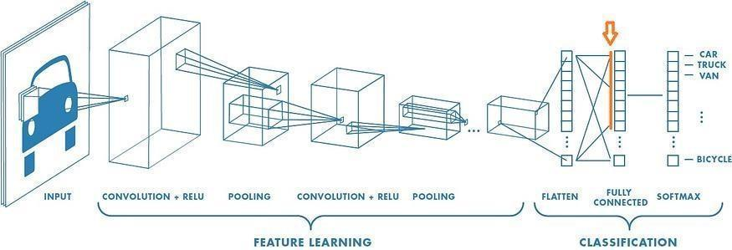

Figure 10 – Schematic illustration of feature-vector extraction from a pre-trained convolutional network, where activations from the penultimate layer (highlighted) are taken as a compact image descriptor rather than the final softmax prediction

2.4.3 Embedding extraction protocol
When deep networks are used as fixed feature extractors, the methodological priority is to ensure that the mapping x↦ z is stable and reproducible. In practical CNN implementations, layers such as Batch Normalization behave differently in training and evaluation modes: training mode uses batch statistics (and updates running estimates), whereas evaluation mode uses the stored running statistics, yielding consistent outputs for identical inputs. For this reason, embedding extraction is performed in evaluation/inference settings, which also reduces computational overhead by disabling gradient tracking. This guarantees that all downstream comparisons (single classifiers vs. stacking, alternative learners, and hyperparameter searches) are conducted on exactly the same representation, so that differences in performance can be attributed to the decision mechanism rather than to variability in feature computation.
Embedding extraction follows the feature-extraction procedure reported in [8, p. 3552-3566]. For each ROI x produced by the bounding-box pipeline, the crop is forwarded through a pre-trained ResNet-18 encoder, and the “avgpool” layer output is exported as the feature vector. This dissertation explicitly states that (i) ROIs are cropped with 10% narrowed bounding boxes to reduce background spill, (ii) no resizing is applied for the hybrid approach, and (iii) feature vectors are taken from the avgpool layer of an ImageNet-pre-trained ResNet-18, yielding 512-dimensional representations.
Operationally, embedding extraction is implemented as follows:
- ResNet-18 is loaded with ImageNet-pre-trained weights, and the terminal FC classifier is not used; embeddings are obtained from the avgpool representation.
- The backbone is set to evaluation mode and embeddings are computed under inference mode to ensure deterministic outputs and to eliminate gradient-related overhead.
- All dataset splits (train/validation/test, where applicable) are processed using the same ROI construction and encoder configuration so that the resulting embeddings are directly comparable across experiments.
- Extracted vectors z ∈ R⁵¹² and their labels are cached to disk (e.g., as serialized arrays). This ensures that every classical learner and every stacking configuration is trained and evaluated on an identical, fixed embedding set, eliminating representation drift across repeated runs and hyperparameter searches.
This protocol preserves fidelity to the pipeline reported in [8, p. 3552-3566] (ROI handling, no-resize hybrid extraction, avgpool/512-D features) while adding an explicit reproducibility safeguard (deterministic inference + caching) that is appropriate for thesis-level comparative evaluation.

2.5 Classical learners and stacking ensemble

2.5.1 Base learners
The hybrid framework maps ResNet-18 embeddings to denomination labels using a set of five complementary classical learners. This choice follows the experimental configuration adopted throughout this work, where the 512-dimensional avgpool embeddings extracted from an ImageNet-pre-trained ResNet-18 are provided as inputs to multiple classical classifiers and subsequently combined through a stacking strategy. The theoretical motivation is that, once a robust embedding space is obtained, different families of shallow classifiers impose different inductive biases and decision geometries; combining them increases predictive stability by reducing correlated errors and improving generalisation under heterogeneous capture conditions.
k-Nearest Neighbours (kNN).
kNN is an instance-based method that predicts the label of a query point by majority vote among its k nearest training embeddings under a chosen distance metric. Its main theoretical strength is its ability to model highly non-linear class boundaries without an explicit training phase, provided that same-class embeddings form locally coherent neighbourhoods. In practice, when deep embeddings cluster by class, kNN can be a strong baseline because it directly exploits the local structure of the representation space.
Support Vector Classifier (SVC, RBF). Kernel SVC constructs a maximum-margin decision boundary, and with an RBF kernel it can represent complex non-linear separators in high-dimensional spaces. The SVC is particularly effective when embeddings are discriminative but not strictly linearly separable. From a theoretical standpoint, margin maximisation provides good generalisation behaviour, while kernelisation allows flexible boundaries without explicitly increasing the feature dimension in input space.
Formally, the RBF kernel used by SVC-RBF measures similarity between two feature vectors as a function of their squared Euclidean distance (10):

K(x_{i}, x_{j}) = exp(−γ‖x_{i} − x_{j}‖²) (10)

where γ controls how quickly similarity decays with distance: a large γ makes the decision boundary sensitive to individual training points (a narrow effective neighbourhood), while a small γ produces a smoother, more global boundary. This is the parameter whose best-found value shifts by four orders of magnitude between the two optimised stages, as shown in figure 29 and discussed in §3.6.3 [8, p. 3552-3566].
Random Forest (RF). Random Forest is an ensemble of decision trees trained on bootstrap samples with random feature sub-sampling. Its theoretical advantage is variance reduction through aggregation and robustness to noisy features, with the ability to model non-linear interactions. RF often complements margin-based models because it can capture irregular boundaries and heterogeneous feature interactions that are not well represented by a single smooth separating surface.
Gaussian Naive Bayes (GNB). GNB is a probabilistic generative classifier that assumes class-conditional Gaussian distributions and conditional independence of features given the class. Although the independence assumption is rarely fully satisfied, GNB remains valuable due to its extremely low computational cost and its tendency to provide stable probabilistic baselines. When embeddings are reasonably well structured, GNB can capture coarse class separation efficiently, which is useful in an ensemble where diversity matters.
Ridge Classifier. The ridge classifier is a regularised linear model that minimises squared loss with an ℓ₂ penalty. The regularisation stabilises estimation under correlated or high-dimensional features and reduces overfitting. In deep-embedding spaces, where class clusters can become approximately linearly separable, ridge classifiers can provide a fast and surprisingly competitive decision function, and they serve as an informative linear baseline within the ensemble.
Formally, Ridge CV fits a linear decision function by minimising the sum of squared residuals plus an ℓ₂ penalty on the weight vector (11):

min_{w} ‖y − Xw‖² + α‖w‖² (11)

where X is the matrix of input embeddings, y the target labels, w the fitted weight vector, and α the regularisation strength selected via Ridge CV’s internal cross-validation. Larger α shrinks w towards zero, trading a small increase in bias for a reduction in variance; this is the mechanism referred to as “regularisation strength” throughout §2.5.2 and tables 9 and 11 [8, p. 3552-3566].
Collectively, these learners represent distinct decision paradigms: instance-based (kNN), margin-based non-linear (SVC), tree-ensemble (RF), probabilistic generative (GNB), and regularised linear (Ridge). This diversity is beneficial for stacking because each learner tends to fail under different conditions; by training a meta-learner on their probabilistic outputs, the ensemble can exploit complementary strengths and reduce correlated errors. This design choice is consistent with the dissertation’s goal of improving robustness under heterogeneous acquisition while maintaining computational efficiency suitable for lightweight deployment, and it follows the classifier set used in [8, p. 3552-3566].
Figure 11 visualises this complementarity argument directly, showing each base learner’s decision paradigm and characteristic strength alongside the stacking meta-learner that combines their outputs.

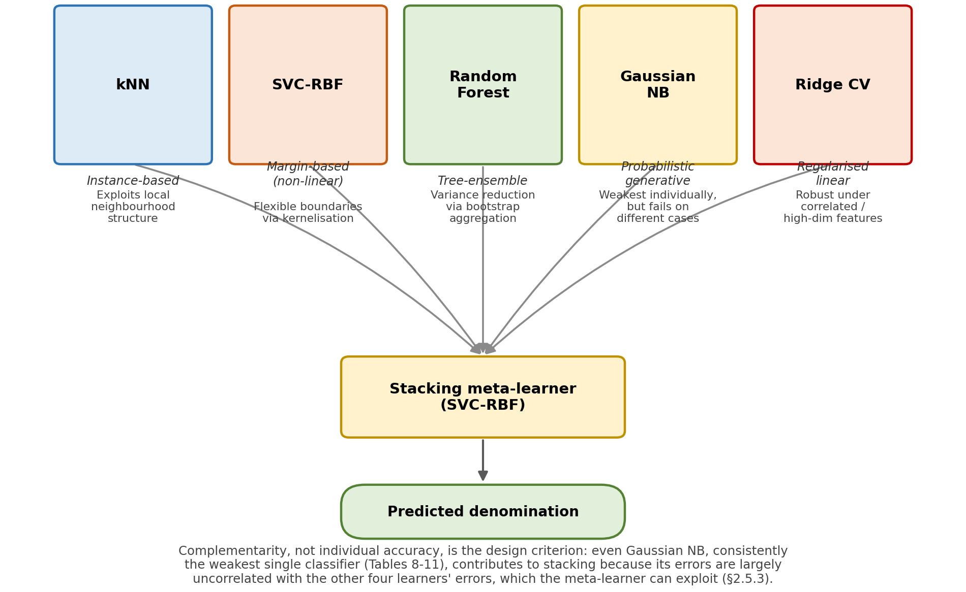

Figure 11 – Complementary decision paradigms of the five base learners and their convergence into the SVC-RBF stacking meta-learner

This view complements the structural schematic already given in figure 12: where Figure 12 shows how information flows through the ensemble, figure 11 shows why the specific choice of five learners is expected to be more robust than any single one, namely that instance-based, margin-based, tree-ensemble, probabilistic, and linear decision rules are unlikely to make the same mistakes on the same inputs.

2.5.2 Hyperparameter selection
The classical learners used in this thesis contain hyperparameters that control model capacity and the bias–variance trade-off (e.g., neighbourhood size in kNN, margin/complexity in SVC, tree depth and ensemble size in Random Forest). If these hyperparameters are not tuned systematically, reported performance may reflect arbitrary settings rather than the true capability of a modelling strategy. Conversely, if hyperparameters are tuned using information from the test set, evaluation becomes optimistically biased due to information leakage. For these reasons, hyperparameter optimisation is treated as an explicit and controlled component of the experimental design: model selection is performed using training data only, and the held-out test partition is reserved exclusively for final reporting.
Consistent with [8, p. 3552-3566], the dataset is split into 75% training and 25% testing using a fixed random state to ensure reproducibility. Hyperparameter tuning is then performed via a grid search over predefined hyperparameter combinations for each classifier, with optimisation focused on classification performance. This dissertation further specifies the principal hyperparameters considered for each learner as follows:
1. kNN: Euclidean distance is used; the number of neighbours k is optimised during the grid search.
2. SVC-RBF: the key hyperparameters include the regularisation parameter C and the kernel coefficient γ.
3. Random Forest: the principal tuned parameter highlighted is the number of trees n_{estimators}
4. Gaussian Naïve Bayes: the stability parameter var_smoothing is tuned.
5. Ridge classifier: Ridge CV is used, i.e., ridge regression with internal cross-validation; the reported configuration highlights aspects such as class_weight and whether to store cross-validation values (store_cv_values). The regularisation strength α is treated as the primary capacity-controlling hyperparameter (selected via Ridge CV), while the remaining configuration options are retained for reproducibility.
And in line with good experimental practice, the test split is not used for hyperparameter selection; it is reserved for final evaluation after model selection is complete, ensuring that reported results reflect out-of-sample performance rather than tuning artefacts.

2.5.3 Leakage-safe stacking and meta-learner
To exploit complementary decision behaviours while controlling overfitting, the dissertation adopts stacked generalisation (stacking), in which the outputs of multiple first-level classifiers are used as inputs to a second-level classifier that produces the final decision. In [8, p. 3552-3566], after tuning the individual models, the optimised classifiers are combined in a stacking ensemble, and an SVC with an RBF kernel (SVC-RBF) is used as the final estimator (meta-learner). Let D = {(x_{i}, y_{i})}N_{i=1} denote the training set, where x_{i} is an ROI (or its embedding) and y_{i} ∈{1,…,C} is the denomination label. Let M base learners be denoted by {h_{m}}M _{m=1}. Each base learner outputs a class-score vector for an input x, typically class probabilities (12):

p_{m}(x) = [p_{m}(y=1 | x), …., p_{m}(y=C | x)] ∊ R^{C} (12)

The meta-feature representation is formed by concatenation (13):

Ф(x) = [p₁(x) || p₂(x) || … || p_{M}(x)] ∊ R^{MC} (13)
A meta-learner g(⋅) is then trained to map Ф(x) to the final class (14):

ý = g (Ф(x)) (14)

In the experimental pipeline reported here, the meta-learner is an SVC-RBF, chosen to model non-linear relationships among the base learners’ outputs while remaining lightweight relative to end-to-end deep fusion. Stacked ensembles built on heterogeneous base learners have repeatedly been shown to outperform any single constituent model on image-classification tasks [66, p. 2141-2147]. Following the study’s implementation choice of Scikit-Learn for training and optimisation, stacking is implemented as a standard stacking classifier where the tuned first-level models act as base estimators and the final estimator is SVC-RBF.
In Scikit-Learn’s formulation, stacking is explicitly designed to reduce optimistic bias at the fusion layer: base estimators are fitted on the full training data, while the final estimator is trained using cross-validated predictions of the base estimators (via cross_val_predict), i.e., out-of-fold predictions rather than in-sample outputs. This is the key mechanism that makes the stacking stage leakage-safe under the standard (non-prefit) setting. The documentation further notes that the prefit mode trains the final estimator on non-cross-validated base predictions and carries a high risk of overfitting; therefore, the cross-validated stacking mode is used rather than prefit.
Operationally, the stacking procedure can be expressed as: The overall stacking topology used in this work is shown in figure 12.

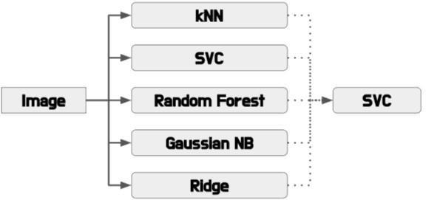
Figure 12 – Schematic of the stacking ensemble: five optimised base learners (kNN, SVC, Random Forest, Gaussian NB, Ridge) feed their outputs into an SVC-RBF meta-learner

1 Hyperparameter optimisation (base level): each base learner is tuned using grid search, as described above (with Scikit-Learn), and the test split is reserved for final reporting.
2 Out-of-fold prediction generation (meta-feature construction): using K-fold splitting inside the training set, each base learner is refit on K−1 folds and generates predictions on the held-out fold; concatenating these held-out predictions over folds yields Φ(x_{i}) for every training sample without using that sample to train the predictor that generated its meta-features.
3 Meta-learner training: the SVC-RBF final estimator is trained on the resulting meta-feature matrix {Ф(x_{i})}N_{i=1} and labels {y_{i}}N_{i=1}, matching the design reported in [8, p. 3552-3566].
4 Inference: at test time, each base estimator produces a score vector for a new input x; these are concatenated into Φ(x) and passed to the trained SVC-RBF meta-learner to obtain ý.
Because stacking relies on consistent base outputs, the implementation uses the stacking mechanism’s standard behaviour: base estimators contribute predict_proba when available, otherwise decision scores (e.g., decision_function) or class predictions, depending on the estimator and configuration. This is compatible with the overall emphasis on combining diverse classifiers after optimisation, while keeping the fusion layer lightweight and robust.
The training and inference procedures described narratively above are formalised as Algorithms 1 and 2 for precision and reproducibility.
Algorithm 1 -- Leakage-safe training of the stacking ensemble
Input: training set D = {(x_i, y_i)}_{i=1}^N; number of folds K; base learners h_1, ..., h_M; meta-learner class G
Output: tuned base learners h_1, ..., h_M; trained meta-learner g
1: for m = 1 to M do
2: Tune h_m via grid search, using only cross-validation folds drawn from D (§2.5.2)
3: end for
4: Partition D into K disjoint folds D_1, ..., D_K
5: for k = 1 to K do
6: D_train ← D/D_k // hold out fold k
7: for m = 1 to M do
8: Fit a temporary copy of h_m on D_train
9: for each (x_i, y_i) in D_k do
10: p_m(x_i) ← predict_proba(x_i) // eq. 12, out-of-fold
11: end for
12:end for
13: end for
14: for each i = 1, ..., N do
15: Φ(x_i) ← Concatenate(p_1(x_i), ..., p_M(x_i)) // eq. 13
16: end for
17: Refit h_1, ..., h_M on the full training set D
18: Fit meta-learner g on {(Φ(x_i), y_i)}_{i=1}^N
19: return h_1, ..., h_M, g
Lines 5-13 implement the out-of-fold protocol described in §2.5.3: each base learner’s contribution to the meta-feature matrix Φ is always produced by a model that has not seen the corresponding label during that fold’s fitting, which is what prevents the meta-learner from training on optimistically biased base-learner outputs. Line 17 then refits the base learners on the complete training set once the leakage-safe meta-features have been collected, matching the two-stage fitting procedure implemented by Scikit-Learn’s stacking classifier [8, p. 3552-3566].
In terms of computational cost, Algorithm 1’s outer fold loop (lines 5-13) fits each of the M = 5 base learners K times on approximately |D|(K−1)/K samples, plus one further fit on the full training set (line 17); the total training cost is therefore O(K · M · T_fit) plus O(M · T_fit), where T_fit is the per-classifier fitting cost tabulated in Table 8 below. Because K and M are small constants (K-fold cross-validation and five base learners throughout this dissertation), this multiplies the single-classifier training cost by a constant factor rather than changing its asymptotic order.
Algorithm 2 - End-to-end denomination prediction
Input: raw image I; trained base learners h_1,...,h_M; trained meta-learner g; representation mode ∈ {traditional, hybrid}
Output: predicted denomination label y_hat
1: B ← BoundingBox(I) // YOLO-format annotation
2: B’ ← Narrow(B, 0.10) // 10% narrowing, §2.3.2
3: R ← Crop(I, B’) // region of interest
4: if mode = traditional then
5: R ← Resize(R, 128, 128); R ← R / 255
6: x ← ColourFeatures(R) // RB/RG/GB (eq. 6) or // HSV histogram (eq. 7-8)
7: else
8: x ← ResNet18_avgpool(R) // 512-D embedding, eq. 9
9: end if
10: for m = 1 to M do
11: p_m ← h_m.predict_proba(x) // eq. 12
12: end for
13: Φ ← Concatenate(p_1, ..., p_M) // eq. 13
14: y_hat ← g.predict(Φ) // eq. 14
15: return y_hat
This procedure is identical for the traditional and hybrid pipelines except for the representation step (lines 4-9); every classifier and the meta-learner downstream of x operate on whichever representation is supplied, which is what allows the two pipelines to be compared under a common decision framework throughout Chapter 3.
At inference time, Algorithm 2’s cost is dominated by whichever step is most expensive for a single query: feature extraction (a fixed-cost ResNet-18 forward pass for the hybrid pipeline, or O(B) for the B-bin HSV histogram in the traditional pipeline), the M base-learner predictions (line 11), and the meta-learner prediction (line 14). Because M is a small constant and the meta-learner is a single SVC-RBF evaluation, end-to-end latency scales with the slowest individual base learner’s prediction cost, which for kNN is the only representation-dependent term among the five (table 8); this is consistent with the latency formalism already introduced in eq. 25.
Table 8 summarises the standard theoretical time and space complexity of the five base learners used throughout this dissertation, expressed in terms of the number of training samples N, feature dimensionality d, number of classes C, and (for Random Forest) number of trees T. These are asymptotic properties of each algorithm rather than measurements from this dissertation’s own experiments, and are included to support the deployment-oriented discussion in §2.7.2 and §4.4.
Table 8 – Standard theoretical time and space complexity of the five base learners

Classifier | Training time | Inference time (per query) | Space
kNN | O(1) (lazy: stores data) | O(N · d) naive; O(d log N) with a tree index | O(N · d)
SVC-RBF | O(N²) to O(N³) | O(n_sv · d), n_sv = number of support vectors | O(n_sv · d)
Random Forest | O(T · N log N · d) | O(T · log N) | O(T · N)
Gaussian NB | O(N · d) | O(C · d) | O(C · d)
Ridge CV | O(N_α · N · d²) or O(N_α · d³) | O(d) | O(d²) or O(d)
Note:
1. N = training samples.
2. d = feature dimensionality.
3. C = number of classes.
4. T = number of trees

Two implications follow directly for this dissertation’s design choices. First, kNN’s inference cost grows with N and is the only base learner whose per-query cost depends directly on training-set size, which is why it is consistently the fastest to train but not necessarily the fastest to query as KZ-BD grows. Second, SVC-RBF’s training cost is the least favourable of the five (up to cubic in N), which is a reasonable trade-off at KZ-BD’s current scale (§2.2.1) but would need revisiting, for example via a linear or approximate kernel, if the dataset were extended to substantially more images or denominations (§4.6).

2.6 Experimental protocol

2.6.1 Splits and evaluation sets
To ensure reproducibility, leakage control, and fair comparison across modelling strategies, all experiments are conducted under fixed, explicitly defined evaluation partitions. Where datasets provide official splits, these are preserved to maintain comparability with the dataset’s intended benchmarking protocol. KZ-BD is distributed with YOLO-format annotations and an explicit Training/Validation partition. The dissertation adopts this split as the primary evaluation regime (figure 13):
1. Training subset (70%): used for fitting the ResNet-18 embedding extractor (in fixed inference mode) and training/tuning the classical learners and stacking ensemble.
2. Validation subset (30%): treated as the held-out evaluation set for final reporting under the dataset-native protocol, since this split is part of the dataset’s published structure.
Within the 70% training subset, cross-validation is used for hyperparameter optimisation and stacking meta-feature generation, but the external 30% validation subset remains untouched until final evaluation.
To align directly with [8, p. 3552-3566], an additional reporting regime is also used where the full dataset is split into 75% training and 25% testing using a constant random state, as described in [8, p. 3552-3566]. This second regime is not a replacement for the dataset-native split; it is included to: i) reproduce this dissertation’s evaluation conditions and ii) provide a consistent comparison point with the results reported in [8, p. 3552-3566]. The second dataset explicitly provides: i) a splits/ directory containing predefined train/validation/test partitions and ii) a manifest.csv file containing file-level metadata. The dissertation follows the dataset’s intended protocol:
1. Train: used for model fitting (embedding extraction + classical learner training)
2. Validation: used for model selection and hyperparameter tuning (including stacking configuration where applicable).
3. Test: reserved strictly for final evaluation and never used in tuning.

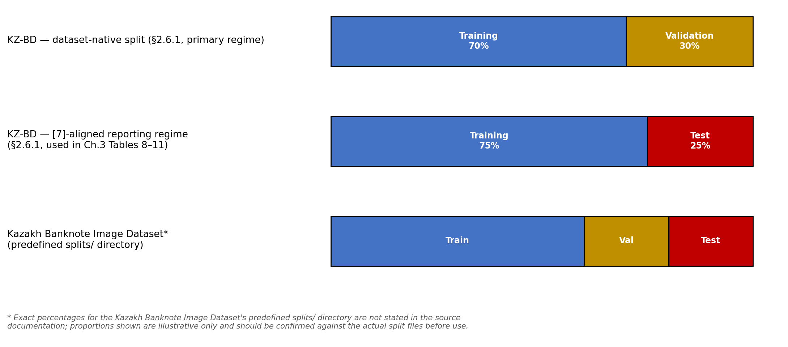

Figure 13 – Schematic comparison of the three train/validation/test splitting protocols used across the two datasets and two reporting regimes described in this section

This dataset is also used for controlled analyses that are not directly supported by KZ-BD, including multi-note scenes (Mix) and series variation via the 5000_old / 5000_new/5000_new_single subsets. In addition to in-dataset evaluation, cross-dataset experiments are used to assess robustness under dataset shift (capture style, background statistics, device differences, and series composition). Cross-dataset tests are conducted only when label spaces overlap, and evaluation is restricted to the intersection of denominations (e.g., 500–20,000 KZT) to avoid ambiguous supervision.
The protocol is:
- Train the full pipeline on the source dataset’s training partition (including any tuning strictly within that training/validation structure).
- Evaluate on the target dataset’s held-out partition without any re-tuning.
- Report cross-dataset performance as a direct estimate of generalisation under distribution shift, complementing within-dataset scores.
This design yields three complementary evaluation views: i) dataset-native benchmarking (highest reproducibility); ii) benchmarking aligned with [8, p. 3552-3566] (comparability to its reported results); iii) cross-dataset testing (generalisation under realistic domain shift).

2.6.2 Comparative baselines
To contextualise the performance of the proposed hybrid framework and to ensure that improvements can be attributed to specific methodological choices, the experimental evaluation includes a set of comparative baselines spanning both classical and hybrid modelling paradigms. In line with [8, p. 3552-3566], comparisons are designed to separate the effect of the representation layer (handcrafted descriptors versus deep embeddings) from the effect of the decision mechanism (single classifier versus stacked fusion).
The first baseline family evaluates the discriminative value of ResNet-18 embeddings when paired with standard classical classifiers. Specifically, each classifier is trained and tuned independently on the fixed 512-dimensional deep features:
- k-Nearest Neighbours (kNN);
- kernel Support Vector Classifier (SVC, RBF);
- Random Forest (RF);
- Gaussian Naïve Bayes (GNB);
- Ridge classifier (Ridge CV).
These models establish whether the proposed performance gains arise primarily from the deep representation itself or from the additional benefit of ensemble fusion. The second baseline is the proposed method: a stacking ensemble in which the optimised base learners’ outputs are fused by a meta-learner. Consistent with the pipeline reported in [8, p. 3552-3566], the final estimator (meta-learner) is an SVC with an RBF kernel, selected to model non-linear relationships among base predictions while remaining computationally lightweight. This configuration represents the dissertation’s primary hypothesis: combining diverse classical decision functions on top of robust deep embeddings increases reliability under heterogeneous capture conditions.
To provide a purely classical reference point, the evaluation optionally includes traditional handcrafted-feature baselines, consistent with the comparative approach reported in [8, p. 3552-3566]. In these baselines, ROIs are resized to a fixed resolution and described using lightweight colour-based statistics such as HSV histograms (and related colour descriptors), followed by standard classical classifiers. Including this baseline family serves two purposes:
- it quantifies the performance gap between classical feature engineering and deep representations under the same dataset conditions;
- it clarifies whether observed improvements come from the representation layer (deep embeddings) even before stacking is applied.
Together, these baselines support an interpretable evaluation hierarchy: i) classical features → classical classifier; ii) deep features → classical classifier, and (iii) deep features → stacked classical ensemble. This structure enables the dissertation to attribute gains to representation learning, ensemble fusion, or both, while maintaining direct comparability with the analysis in [8, p. 3552-3566].

2.6.3 Ablation studies
Ablation experiments are conducted to quantify the contribution of key methodological components and to ensure that improvements are attributable to specific design choices rather than to uncontrolled factors. In alignment with [8, p. 3552-3566], ablations are structured around controlled, one-factor-at-a-time comparisons of (i) ROI construction, (ii) feature representation, (iii) hyperparameter optimisation, and (iv) ensemble fusion. In all cases, the underlying dataset protocol and evaluation partitions are held constant so that observed changes in performance can be interpreted causally.
First, this analysis evaluates ROI construction sensitivity for KZ-BD by comparing crops obtained from the original YOLO bounding boxes against crops obtained from 10% narrowed bounding boxes. This refinement is motivated by the observation reported in [8, p. 3552-3566] that some annotations include slight extra margins around the banknote; narrowing the box reduces background spill and yields a more note-centred ROI. The ablation therefore isolates the effect of background contamination on both classical colour descriptors and deep embeddings.
Second, representation ablations are performed consistent with the comparative analysis in [8, p. 3552-3566]. Within the traditional paradigm, performance is evaluated before and after replacing simple RGB-derived statistics with higher-capacity colour descriptors (e.g., HSV histograms), providing a classical reference for how much feature engineering can improve robustness. Within the hybrid paradigm, all base learners are evaluated on fixed ResNet-18 embeddings, and performance is reported both before and after classifier optimisation. This design separates the effect of the representation layer (handcrafted versus deep) from the effect of model tuning and decision-layer capacity.
Third, a dedicated optimisation ablation compares classifier performance before and after structured hyperparameter search (grid search as used above). This analysis quantifies the extent to which gains arise from principled model selection rather than from the stacking mechanism itself, and it provides a fair comparison between single learners and ensembles by ensuring that each classifier is evaluated under its best-performing configuration selected without using the test data.
Fourth, fusion ablations are evaluated by comparing the proposed stacking ensemble against (i) the strongest single classifier trained on embeddings (notably the RBF-kernel SVC) and (ii) a simpler fusion rule such as majority voting, where applicable. In [8, p. 3552-3566], stacking is implemented by combining the tuned base classifiers and using an SVC with an RBF kernel as the final estimator; this configuration is retained here to maintain comparability. These experiments therefore isolate the marginal value of stacked generalisation beyond what is achievable with a single well-tuned classifier.
Where the data support such analyses, robustness is examined through condition-aware evaluation. KZ-BD contains naturally occurring heterogeneity (e.g., illumination changes, cluttered backgrounds, and folded notes), enabling performance to be analysed under visually adverse capture subsets when such grouping is available or can be derived consistently. The goal of these stratified analyses is to determine whether gains observed in aggregate metrics correspond to genuine robustness improvements under challenging conditions, rather than being concentrated only in clean or easy samples.
Collectively, these ablation studies provide a structured basis for interpreting experimental outcomes: they identify which components contribute meaningfully to performance, quantify sensitivity to ROI extraction and background spill, and establish whether stacking improves generalisation beyond single-model baselines under the heterogeneous conditions targeted by this work.

2.7 Evaluation metrics and efficiency analysis

2.7.1 Recognition performance metrics
Model effectiveness is evaluated using the same set of quantitative metrics adopted in [8, p. 3552-3566]: accuracy, F1-score, Matthews correlation coefficient (MCC), and ROC-AUC computed under a one-versus-rest (OvR) formulation. The motivation for this selection is that no single metric is sufficient in isolation: accuracy reflects overall correctness, but it can mask systematic class confusions; F1 and MCC provide complementary views of class-wise reliability and error balance; and ROC-AUC evaluates separability in score space, independent of any single decision threshold.
Accuracy
Accuracy measures the proportion of correctly classified samples (15):

Accuracy = 1/N Σ_{i=1}^{N} 𝟙{ŷ_{i} = y_{i}} (15)

It is intuitive and directly reflects the fraction of banknotes for which the predicted denomination matches the ground truth. However, because denomination datasets may exhibit mild imbalance (or unequal difficulty across classes), accuracy is always reported alongside class-sensitive metrics.
Precision, recall, and F1-score (macro-averaged)
For each denomination class c, precision and recall are defined as (16), (17):

Precision_{c}= TP_{c} / (TP_{c} + FP_{c}) (16)

Recall_{c}= TP_{c} / (TP_{c} + FN_{c}) (17)

where TP_{c}, FP_{c}, and FN_{c} denote true positives, false positives, and false negatives for class c under a one-vs-rest counting view.
The F1-score for class 𝑐 is the harmonic mean of precision and recall (18):

F1_{c} = 2 · Precision_{c} · Recall_{c} / (Precision_{c} + Recall_{c}) (18)

Results are reported using macro-averaged F1 (19):

F1_{macro} = 1/C Σ_{c=1}^{C} F1_{c} (19)

so that each denomination contributes equally to the final score. This is especially important in currency recognition, where the practical requirement is often consistent performance across denominations rather than high performance dominated by the easiest or most frequent class. Reference [8, p. 3552-3566] similarly motivates F1 as capturing the balance between precision and recall.
Matthews correlation coefficient (MCC)
MCC is included because it provides a robust, single-number summary that accounts for correct and incorrect predictions in a balanced way and is widely recommended when class distributions are not perfectly uniform. Reference [8, p. 3552-3566] explicitly highlights MCC as considering both false positives and false negatives and being robust under imbalance.
For completeness, MCC can be understood as a correlation between the true labels and the predicted labels. In practice, this dissertation computes MCC using the standard multi-class generalisation (as implemented in common evaluation libraries), which reduces to the familiar binary MCC in the two-class case

MCC = (TP × TN) − (FP × FN)
/ √[(TP + FP)(TP + FN)(TN + FP)(TN + FN)] (20)

MCC is particularly informative when a model achieves high accuracy yet still exhibits structured confusions (for example, between visually similar denominations), because MCC penalises unbalanced error patterns more strongly than accuracy alone (20).
ROC-AUC (one-versus-rest, macro-averaged)
ROC-AUC evaluates how well a model separates classes based on its scores (probabilities or decision values), rather than only its final hard decisions. For a given class c in an OvR formulation, the ROC curve plots the true positive rate (TPR) against the false positive rate (FPR) as the decision threshold varies (21), (22):

TPR_{c}(t)=TP_{c}(t)/[TP_{c}(t)+FN_{c}(t)] (21)

FPR_{c}(t)=FP_{c}(t)/[FP_{c}(t)+TN_{c}(t)] (22)

The AUC is the area under this curve and summarises discrimination capacity across all thresholds. In [8, p. 3552-3566], ROC-AUC is explicitly described as providing a comprehensive view of class discrimination using the one-versus-rest approach.
ROC-AUC is computed per class under OvR and then macro-averaged across classes (23):

AUC_{macro} = 1/C Σ_{c=1}^{C} AUC_{c} (23)

This aggregation prevents dominant classes from disproportionately influencing the final value and complements macro-F1 in enforcing denomination-level fairness.
The four metrics are reported together because they answer different, practically relevant questions:
1. Accuracy: How often is the denomination correct overall?
2. Macro-F1: Does the system perform consistently across all denominations?
3. MCC: Is the overall prediction pattern reliable and not biased by imbalance or systematic errors?
4. OvR ROC-AUC: Do the model’s scores meaningfully separate each denomination from the rest, even before choosing a threshold?
Where appropriate, these scalar metrics are complemented by confusion-matrix analysis to identify which denominations are confused and whether errors concentrate in specific visually similar classes, but the primary quantitative reporting follows the metric set used in [8, p. 3552-3566].

2.7.2 Latency and memory footprint
To assess suitability for mobile and embedded deployment, the system is evaluated in terms of: (i) embedding-extraction latency (ResNet-18 forward pass), (ii) classifier latency (base learners and meta-learner), (iii) end-to-end runtime (ROI extraction + embedding + prediction), and (iv) model/storage footprint (encoder size plus classical model parameters). In addition to the model-size (“weights”) analysis reported in [8, p. 3552-3566], this dissertation further evaluates inference latency (both by pipeline stage and end-to-end) to assess deployability on mobile/embedded hardware. This extension is motivated by the practical context emphasised throughout this dissertation, which frames the target use case as smartphone-assisted denomination recognition and therefore implicitly requires responsive inference under limited compute and memory budgets.
Reference [8, p. 3552-3566] reports model weight size in megabytes as a direct proxy for deployability, including the size of ResNet-18 weights and the combined storage required by the full hybrid stacking system. The same reporting principle is adopted here for storage footprint: the total persistent size is computed as the sum of the encoder weights and the serialized classical models (base learners and the stacking meta-learner). In modular terms, the storage accounting is expressed as (24):

S_{total} = S_{enc} + Σ_{m=1}^{M} S_{base,m} + S_{meta} (24)

where S_{enc} – denotes the serialized ResNet-18 encoder;
S_{base,m} – denotes the m-th base learner (e.g., kNN, SVC-RBF, RF, GNB, Ridge);
S_{meta} – denotes the final estimator. Consistent with the hybrid design, the encoder typically dominates storage, while classical models contribute a comparatively small additive cost, except in cases where a classifier stores large support structures (e.g., kNN storing the training embeddings).
In addition to persistent storage, the dissertation also considers runtime memory as a practical constraint. Runtime memory reflects intermediate tensors during the ResNet-18 forward pass and any in-memory structures required by the classical learners. This is particularly relevant for kNN, whose inference cost and memory scale with the number of stored training vectors, approximately O(N⋅d) for N embeddings of dimension d (here d=512). The result is that storage footprint alone is insufficient to fully characterise deployability; runtime requirements must also be examined, particularly when moving from desktop experiments to edge devices.
While [8, p. 3552-3566] reports weight size and motivates lightweight deployment, it does not explicitly profile runtime latency. Accordingly, the dissertation introduces stage-wise latency profiling as an extension, because end-to-end responsiveness is crucial in mobile and assistive settings. Latency is decomposed into three sequential stages:
1. ROI extraction latency (t_{roi}): conversion of YOLO annotations to pixel coordinates, boundary clipping, optional 10% narrowing, and cropping (KZ-BD).
2. Embedding latency (t_{emb}): the ResNet-18 forward pass to obtain the 512-dimensional avgpool embedding.
3. Classifier latency (t_{clf}): inference time for (i) a single base learner or (ii) the stacking pipeline (base learners + final estimator).
The end-to-end runtime is then reported as (25):

t_{e2e} = t_{roi} + t_{emb} + t_{clf} (25)

This decomposition is methodologically important for two reasons. First, it distinguishes the cost of representation learning (typically the dominant term) from the cost of decision making (usually lightweight, but potentially non-trivial for kNN). Second, it allows the system to be optimised in a targeted manner: if t_{emb} dominates, encoder compression (quantisation, pruning, distillation) is the natural path; if t_{clf} dominates, the decision layer can be simplified without changing the representation.
Latency is measured under a consistent protocol: repeated inference runs are performed with a short warm-up period to mitigate one-time initialisation effects, and the reported latency is averaged across trials. Where throughput is useful for interpreting real-time performance, latency is converted to frames-per-second (FPS) via FPS≈1/t_{e2e}, while noting that true FPS depends on device hardware, implementation optimisations, and batch size.
Taken together, storage footprint and latency provide a deployment-relevant view that complements predictive metrics. Storage reporting is directly aligned with [8, p. 3552-3566]’s emphasis on model “weights” and lightweight deployment, while the added latency profiling strengthens the dissertation’s contribution by evaluating not only how accurate the model is, but also how usable it is in time-sensitive applications such as smartphone-based assistance or automated cash handling.

2.8 Implementation details and reproducibility
The experimental pipeline described here follows the same implementation logic as [8, p. 3552-3566]: (i) a hybrid approach in which a pre-trained ResNet-18 is used as a fixed representation module, and (ii) a classical decision layer (single learners and stacking) trained on the extracted representations. In [8, p. 3552-3566], trained models are serialised in a “.p” format and the hybrid model size is reported by combining the ResNet-18 weights (44.7 MB) with the stacking ensemble parameters, reflecting a deployment-oriented view of storage cost rather than reporting only classifier weights. The same principle is adopted here when reporting footprint: encoder storage is accounted for jointly with the downstream learner(s), so that comparisons remain meaningful for mobile and embedded scenarios.
Reproducibility is ensured through a controlled, fully specified experimental protocol spanning data partitions, feature extraction, model selection, and evaluation. Dataset-defined splits are preserved whenever they are part of the dataset release. For KZ-BD, the dataset is distributed with a 70:30 training/validation split and YOLO-format annotations; the split is retained for direct comparability and to match the dataset’s intended benchmarking use. The dataset’s accompanying Data in Brief article further documents the dataset composition (4,200 images across 14 denominations), the inclusion of both coins and banknotes, and the deliberate capture of images under diverse real-world conditions (e.g., cluttered, occluded, folded, and variable lighting), thereby providing a stable methodological reference for reuse. For the second resource (Kazakh Banknote Image Dataset), the dataset release explicitly provides manifest.csv metadata and predefined train/validation/test partitions under splits/, which are used unchanged to support transparent replication and series/multi-note analyses.
At the representation level, the feature-extraction stage is made deterministic by running the ResNet-18 backbone in inference mode with fixed preprocessing and by caching the extracted embeddings. Caching is a methodological safeguard: all downstream classifiers (individual learners and stacking) are trained and evaluated on exactly the same feature vectors, eliminating confounds where minor extraction differences could be mistaken for classifier improvements. This also improves experimental efficiency, enabling large hyperparameter sweeps and ablations without repeatedly invoking the CNN.
At the decision level, fair comparison is supported by holding constant the evaluation protocol and by preventing optimistic bias in selection. Hyperparameter optimisation is performed strictly within the training data, and held-out sets are reserved for final reporting. In addition, all sources of randomness that can affect results (e.g., cross-validation fold assignment, any stochastic learner components) are controlled using fixed random states, so that experimental outcomes can be reproduced exactly from the same data and codebase.
The dissertation’s reproducibility claims are strengthened by open data provenance. Both datasets are publicly released on Mendeley Data under Creative Commons licensing (CC BY 4.0), enabling independent verification, extension studies, and cross-laboratory benchmarking.

Chapter summary
This chapter defines a reproducible experimental methodology for developing and evaluating a hybrid denomination-recognition system for Kazakh banknotes captured under heterogeneous real-world conditions. The central aim is deployment-oriented evaluation rather than “clean-lab” optimisation: the protocol is designed to reflect the distribution shifts encountered in practice, including non-uniform illumination and colour casts, motion blur and sensor noise, background clutter, viewpoint and scale variation, partial occlusion, folds and wrinkles, and degradation due to wear, soiling, and design-series changes. Consequently, the methodology prioritises robustness, maintainability, and computational efficiency alongside predictive accuracy.
The proposed framework follows a two-stage hybrid principle. In the first stage, a compact CNN encoder is used for representation learning, with ResNet-18 selected for its favourable accuracy–efficiency trade-off. ResNet-18 is not trained as an end-to-end classifier; instead, its final classification layer is removed and the penultimate-layer activations are extracted as fixed-length embeddings (512-D). This design leverages the invariances captured by ImageNet-pre-trained convolutional features while keeping the decision layer modular and lightweight. Embedding extraction is performed in inference mode with fixed preprocessing parameters, and embeddings are cached so that all downstream experiments operate on identical representations, eliminating feature drift across repeated runs and hyperparameter sweeps.
In the second stage, embeddings are mapped to denomination labels using a set of complementary classical learners (kNN, RBF-kernel SVC, Random Forest, Gaussian Naïve Bayes, and a ridge classifier). These models are chosen to provide diverse decision behaviours: local neighbourhood voting, margin-based non-linear separation, tree-based interaction modelling, probabilistic generative estimation, and regularised linear classification. Rather than selecting a single classifier, the chapter adopts stacked generalisation to fuse the base learners via a meta-learner (RBF SVC), trained on out-of-fold predictions to prevent leakage and optimistic bias. This stacking design is motivated both by robustness (reducing correlated errors under nuisance variation) and by maintainability (enabling rapid updating of the lightweight decision layer when denominations or series evolve, while reusing the encoder).
The chapter specifies the dataset resources and formal task definitions used throughout the dissertation. KZ-BD serves as the primary benchmark due to its realistic mobile capture conditions and YOLO-format bounding-box annotations, enabling deterministic ROI extraction and controlled evaluation of recognition independent of localisation errors. A second public dataset is used for external validation and stress testing, providing multi-note scenes (Mix) and controlled analysis of design-series variation for the 5,000 KZT denomination. Three tasks are evaluated: (i) single-note ROI denomination classification (primary), (ii) scene-level recognition under clutter and occlusion (supporting robustness task), and (iii) series and multi-note variability analysis (secondary), allowing the methodology to probe both accuracy and generalisation under more challenging shifts.
Preprocessing and region extraction are defined as controlled components of the protocol. Images are standardised consistently (RGB handling, intensity scaling, and ImageNet-compatible normalisation for CNN extraction). For KZ-BD, ROIs are cropped deterministically from YOLO bounding boxes with boundary clipping; a 10% box narrowing option is included to reduce background spill when annotations include margins, and its effect is studied via ablation. Training-only augmentation is introduced as an explicit experimental factor to increase invariance to realistic perturbations (photometric jitter, mild geometric transforms, and Cutout-style occlusion), while validation and test sets remain unaugmented to preserve evaluation integrity.
A clear experimental protocol is established to support fair comparison. Dataset-provided splits are preserved where available; when reproducing paper-aligned conditions, an additional fixed 75/25 split is also reported. Hyperparameter tuning is restricted to training data via cross-validation, and held-out partitions are reserved strictly for final reporting. Baselines are organised to disentangle representation effects from decision-layer effects: classical handcrafted-feature pipelines provide a non-deep reference; single classical classifiers trained on deep embeddings quantify the value of the representation alone; and the stacked ensemble tests whether fusion adds gains beyond the best tuned single model. Ablation studies isolate the impact of ROI refinement, hyperparameter optimisation, base-learner composition, and fusion strategy, and condition-aware analyses examine robustness under subsets reflecting nuisance factors when such stratification is feasible.
Finally, the chapter defines evaluation along two axes: recognition effectiveness and deployment feasibility. Effectiveness is quantified using accuracy, macro-F1, MCC, and one-vs-rest ROC-AUC, supported where needed by confusion-matrix analysis of denomination-level confusions. Deployment feasibility is assessed through model storage footprint and stage-wise latency profiling, decomposing end-to-end runtime into ROI extraction, embedding extraction, and classification. This separation identifies computational bottlenecks and supports targeted optimisation, while also reflecting the practical requirements of mobile and embedded banknote recognition systems. Overall, the chapter establishes a transparent, leakage-controlled, and deployment-oriented methodology for assessing whether hybrid deep embeddings combined with stacked classical learners can deliver robust and efficient Kazakh banknote recognition under real-world variability.

3 EXPERIMENTAL RESULTS AND DISCUSSION

3.1 Chapter objectives and evaluation logic
Chapter 2 established a leakage-controlled, deployment-oriented methodology for testing whether hybrid deep embeddings combined with stacked classical learners can outperform purely classical pipelines under real-world variability. This chapter now applies that methodology to answer that question directly. This chapter evaluates the proposed banknote classification pipeline with a specific comparative objective: to determine which approach achieves the best balance between recognition accuracy and practical efficiency for Kazakh banknotes. The comparison is centred on two paradigms: a traditional machine-learning pipeline based on manually designed colour features, and a hybrid pipeline that uses deep features extracted from a pre-trained ResNet-18 model. The underlying motivation extends beyond technical accuracy to encompass a lightweight solution suitable for real-world, smartphone-assisted banknote recognition.
The evaluation logic in this chapter follows the same progression as the experimental design. The analysis is first performed on the Kazakh banknote dataset (4,200 images in the source dataset, narrowed to the six banknote denominations examined in this study), which includes challenging real-world capture conditions such as cluttered backgrounds, shadows, folds, and lighting variation. For the reported experiments, balanced random sampling is applied per class (200 images per class for the traditional pipeline and 150 images per class for the hybrid pipeline, the latter reduced owing to memory constraints), and no data augmentation is applied. This design isolates the comparison to the effects of feature representation, model choice, and optimisation, independent of augmentation strategy.
Methodologically, the chapter compares two feature-extraction strategies within a common classification framework. The traditional pipeline uses ROI cropping and handcrafted colour descriptors, beginning with RGB-based features and subsequently refined through HSV histogram features. The hybrid pipeline retains the same ROI logic but replaces manual descriptors with 512-dimensional feature vectors from the ResNet-18 avgpool layer, selected as a compromise between representational power and computational cost. This design isolates the contribution of feature engineering from that of transfer-learning-based representation.
To ensure a fair and reproducible comparison, the dataset is split using a fixed random state with a 75/25 train-test division. Performance is evaluated using four complementary metrics: accuracy (overall correctness), F1-score (precision-recall balance), MCC (robustness under class imbalance), and ROC-AUC (class separability under a one-vs-rest formulation). Reporting several metrics rather than accuracy alone is necessary because the chapter’s purpose is not only to rank models but also to assess their reliability and consistency across classes.
The classifier comparison is deliberately diverse. Both pipelines are evaluated using kNN, SVC-RBF, Random Forest, Gaussian Naive Bayes, and Ridge CV, followed by a two-stage optimisation process: (1) stronger features for the traditional pipeline (RGB to HSV histograms), and (2) grid-search hyperparameter tuning, with particular emphasis on ROC-AUC where applicable. This design allows the chapter to establish not merely which model performs best, but why performance changes, and whether the resulting gains stem from improved features, improved hyperparameters, or both.
Following the single-model results, the chapter extends the evaluation to model stacking, in which optimised classifiers are combined to examine whether ensemble learning improves robustness and overall accuracy. The underlying rationale is that if individual models capture different patterns in the data, stacking should be able to exploit their complementary strengths. Finally, the same methodological framework is applied to Thai banknotes and to coffee-bean roasting-level images to assess transferability beyond the primary Kazakh banknote task. This step is necessary to establish whether the chapter’s conclusions are specific to the primary task or generalise to other colour-driven image-classification problems.

3.2 Experimental setup
This section describes the experimental protocol used to evaluate the traditional and hybrid machine learning pipelines for Kazakh banknote classification. The setup was designed to support a fair comparison between lightweight hand-crafted feature methods and transfer-based deep feature extraction, while keeping the evaluation reproducible and aligned with the practical goal of smartphone-based assistance.

3.2.1 Dataset and class selection
The experiments are based on the Dataset of Kazakhstan Banknotes with Annotations (Mendeley Data), which contains 4,200 annotated images of Kazakhstani currency captured under realistic conditions. The original dataset includes 14 classes (1 KZT to 20,000 KZT), with image resolution reported as 1024×1024 pixels. For this study, the class set was restricted to six paper banknote denominations (500, 1000, 2000, 5000, 10000, and 20000 KZT), since the remaining denominations are coins and fall outside the target use case.
A key strength of the dataset is that it reflects real-world capture variability. The images were collected using the rear camera of a single mobile-phone device (an Apple iPhone 11) [7, p. 110076] under diverse conditions, including cluttered backgrounds, shadows, rotations, folded notes, and partial hand occlusion, bringing the evaluation closer to realistic deployment conditions than a controlled laboratory setting would allow.
All images are provided with YOLO-format annotations, enabling region-based cropping and supporting consistent preprocessing across both pipelines. An equal number of images was randomly sampled per class: 200 images per class for the traditional pipeline and 150 images per class for the hybrid pipeline, the latter reduced owing to a 12 GB RAM constraint. The resulting class distribution, shown in figure 14, confirms that sampling was balanced across all six denominations in both experimental settings. No augmentation (e.g., rotation, scaling, illumination changes) was applied, since the dataset size and random sampling were considered sufficient for model training and evaluation at this stage.

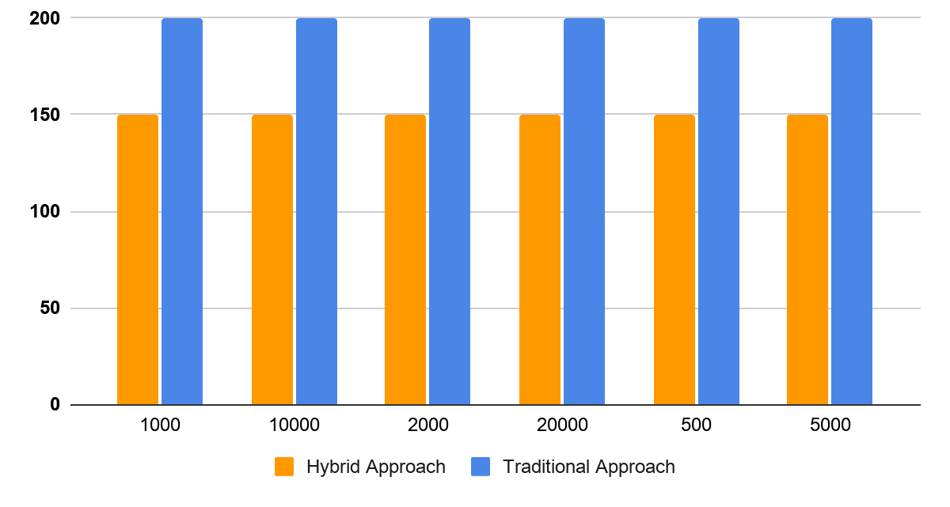

Figure 14 – Number of random images of Kazakh banknotes per class

3.2.2 Preprocessing and feature extraction pipelines
The experimental design compares two feature-extraction strategies: a traditional handcrafted colour-feature pipeline and a hybrid pipeline using features extracted from a pre-trained convolutional neural network.
For both pipelines, preprocessing begins by extracting the region of interest (ROI) from the annotated banknote bounding boxes. To improve localisation precision, a 10%-narrowed bounding box is used, since the original boxes include extra background pixels around the banknotes; this refinement is methodologically important because colour-based classification is sensitive to background contamination.
In the traditional pipeline, cropped ROIs are resized to 128×128 pixels and normalised by dividing pixel values by 255. The baseline feature representation uses simple RGB channel statistics, specifically the differences between average channel intensities (RB, RG, and GB), which together serve as a compact colour descriptor and a baseline for comparison.
An optimised variant of the traditional pipeline replaces the RGB difference vector with HSV histogram features. The image is transformed to HSV space, histograms are computed for hue, saturation, and value, and the resulting histograms are normalised before concatenation into a single feature vector. This produces a substantially richer representation of colour distribution while preserving the lightweight character of the traditional pipeline.
In the hybrid pipeline, ROI extraction follows the same logic, including the 10% box narrowing, but the cropped ROIs are not resized prior to feature extraction. Instead, features are taken from the “avgpool” layer of a pre-trained ResNet-18 model (ImageNet pretraining), yielding a 512-dimensional feature vector per image. ResNet-18 is adopted as a practical compromise between representational power and computational cost, consistent with the lightweight-deployment objective established in Chapter 2.

3.2.3 Train-test split and evaluation metrics
To ensure reproducibility, the dataset was split using a fixed random seed, with 75% of samples used for training and 25% used for testing; this split balances the need for sufficient training examples against an unbiased evaluation of generalisation performance. Model performance was evaluated using four complementary metrics:
1. Accuracy for overall correctness.
2. F1-score to balance precision and recall.
3. Matthews Correlation Coefficient (MCC) as a stronger metric under potential class imbalance.
4. ROC-AUC (one-vs-rest) to assess separability across multi-class decisions.
This combination of metrics captures both intuitive performance (accuracy) and more diagnostic behaviour (MCC and ROC-AUC), supporting a more rigorous discussion in later sections.

3.2.4 Classifiers and optimization procedure
The same set of classical classifiers was used across both feature pipelines to isolate the effect of feature representation from the effect of the classifier itself. The evaluated models are:
- k-Nearest Neighbors (kNN);
- Support Vector Classifier with RBF kernel (SVC-RBF);
- Random Forest;
- Gaussian Naive Bayes;
- Ridge Classifier (Ridge CV).
This set is deliberately diverse, covering distance-based, kernel-based, ensemble, probabilistic, and regularised linear methods; such diversity is valuable for comparative analysis because each model family responds differently to feature geometry and dimensionality.
Optimisation was performed in two stages. First, the traditional pipeline was upgraded from RGB differences to HSV histograms. Second, a grid search was applied to tune classifier hyperparameters, with particular emphasis on improving ROC-AUC where applicable. The implementation used the scikit-learn library; the key tuned parameters for each model are the number of neighbours for kNN, gamma and C for SVC-RBF, n_estimators for Random Forest, var_smoothing for Gaussian NB, and the class-weighting/cross-validation options for Ridge CV.

3.2.5 Experimental scope for subsequent sections
The experimental setup described in this section supports three levels of analysis: 1) comparison of the traditional and hybrid pipelines on Kazakh banknotes; 2) evaluation of optimisation gains within each pipeline, and 3) subsequent examination of stacked ensembles and cross-dataset transferability. The remainder of the chapter follows this progression: the present section defines the protocol, and the following sections interpret results and trade-offs within this consistent evaluation framework.

3.3 Results on Kazakh banknotes
This section presents the core experimental results on the Kazakh banknote dataset, moving from the weakest baseline (traditional RGB features) to the strongest single-model configuration (hybrid ResNet-18 features with optimisation). The results show a clear pattern: performance improves much more from better feature representation than from classifier choice alone, and the hybrid pipeline provides the highest overall accuracy on this task. Several methodological caveats apply throughout this section and should be borne in mind when interpreting the reported figures. First, the traditional and hybrid pipelines are evaluated on different sample sizes per class (200 versus 150 images respectively, the latter reduced by a 12 GB RAM constraint), so the two pipelines are not compared on identical training data; this difference disadvantages the hybrid pipeline and should be considered before attributing the full performance gap between pipelines to feature representation alone. Second, the classifier-comparison experiments use a stratified subset of 150–200 images per class, with roughly 37–50 images per class held out for testing, and each reported figure is a single-run estimate without bootstrap confidence intervals, multi-seed repetition, or a check that images of the same physical banknote are excluded from appearing in both the training and test partitions (see the discussion in Chapter 4, §4.3); because the number of distinct physical notes underlying each class is not tracked separately from the number of images, the extent to which this could inflate the reported accuracies cannot currently be quantified, and the figures below should be read with this in mind rather than as a confirmed measure of generalisation to unseen notes (figure 15).

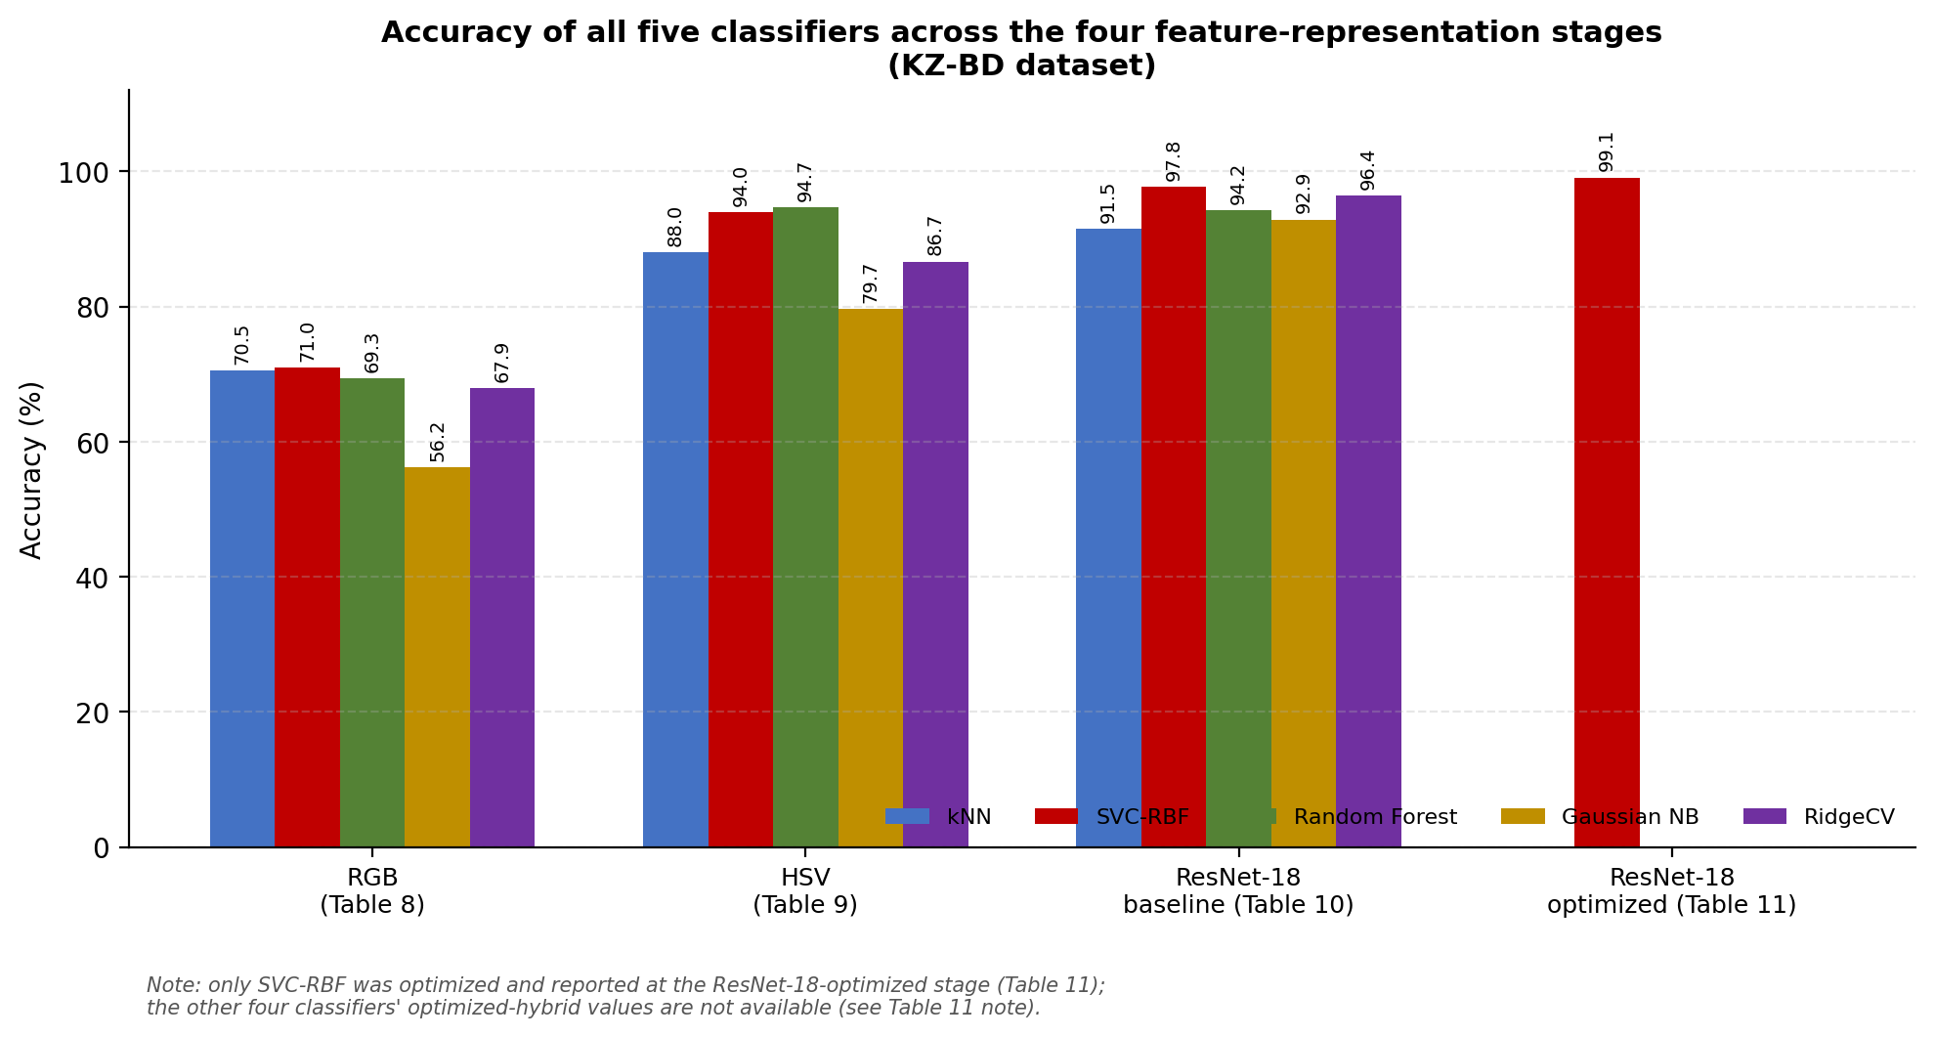

Figure 15 – Accuracy of all five classifiers at each of the four feature-representation stages evaluated on KZ-BD (tables 8, 9, 10, 11), showing that classifier ranking is broadly stable across stages while the gap between the strongest and weakest classifier narrows as the representation improves

Note – Only SVC-RBF was optimised and reported at the ResNet-18-optimised stage

Third, because classes are sampled in equal numbers by design, accuracy and macro-F1 track each other closely throughout this chapter, as the tables below confirm; MCC and ROC-AUC, which are less sensitive to this balancing, are accordingly the more diagnostic metrics for the class-imbalance concerns raised in Chapter 2. Fine-grained differences between closely-scoring classifiers in the tables below (for example, gaps of one percentage point or less) should therefore be read as indicative rather than statistically confirmed.

3.3.1 Traditional baseline results with RGB features (table 9)
Table 9 reports the performance of the traditional pipeline using only RGB colour-vector features (three handcrafted features: RB, RG, GB). The average values of these features for each denomination are shown in figure 16, which illustrates the limited inter-class separability of the RGB representation: while some denominations (e.g., 5,000 KZT) exhibit distinguishable patterns, others (e.g., 1,000 and 2,000 KZT) cluster closely together, suggesting that a three-dimensional colour summary is insufficient for reliable discrimination. In this baseline setting, the best model is SVC-RBF, which reaches 71.00% accuracy, 70.69% F1-score, 65.52% MCC, and 93.07% ROC-AUC. kNN attains a closely comparable 70.48% accuracy, while Random Forest achieves 69.33%. Gaussian Naive Bayes is the weakest model in the group (56.19% accuracy), and Ridge CV reaches 67.94%.

Table 9 – Traditional approach (colour RGB vectors-3 features)

Classifier | Accuracy (%) | F1-score (%) | MCC (%) | ROC-AUC (%)
kNN | 70.48 | 70.74 | 64.61 | 88.99
SVC-RBF | 71.00 | 70.69 | 65.52 | 93.07
Random forest | 69.33 | 69.05 | 63.19 | 91.90
Gaussian NB | 56.19 | 57.73 | 47.89 | 88.87
Ridge CV | 67.94 | 63.66 | 62.48 | n/a
Note – ROC-AUC is reported as n/a for Ridge CV throughout tables 8, 9, 10, 11 because the ridge classifier does not natively output class probabilities (no predict_proba), so a one-vs-rest ROC-AUC could not be computed without an additional calibration step

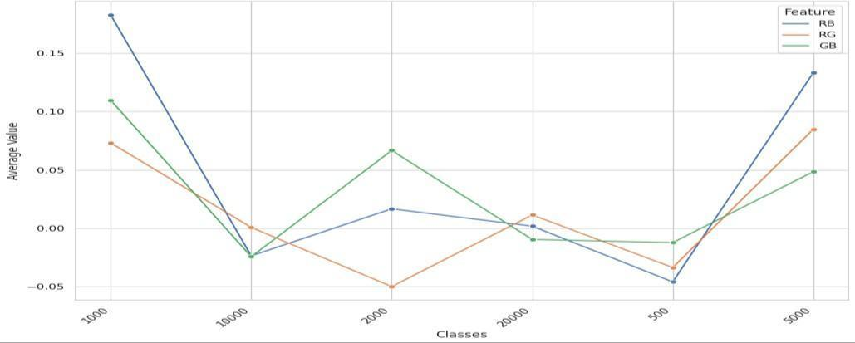

Figure 16 – The average value of RB, RG, and GB for each class of Kazakh banknotes

These baseline results establish a lower bound for the traditional approach. The models do not fail outright, indicating that the banknote classes contain usable colour information, but the feature space is too limited to capture the full visual structure of the notes. Because the RGB vector uses only average channel differences, it discards most spatial and distributional colour cues (e.g., multi-colour patterns, gradients, localised markings) that are important for distinguishing similar denominations under real capture conditions, which explains why all classifiers cluster within a relatively narrow performance range. This stage is subsequently referred to as the “traditional RGB colour vectors” benchmark, prior to optimisation.

3.3.2 Optimized traditional results with HSV histograms (table 10)
The strongest improvement in the traditional pipeline appears in table 10, where the feature representation is upgraded from RGB averages to HSV histograms (768 features) and hyperparameters are tuned.

Table 10 – Traditional approach after the optimisation (colour HSV histogram-768 features)

Classifier | Accuracy (%) | F1-score (%) | MCC (%) | ROC-AUC (%) | Best parameters
kNN | 88.00 | 88.12 | 85.65 | 96.24 | 3 neighbors
SVC-RBF | 94.00 | 93.99 | 92.81 | 98.99 | gamma=4, C=1000
Random forest | 94.67 | 94.67 | 93.61 | 98.99 | n_estimators=100
Gaussian NB | 79.67 | 79.94 | 75.61 | 96.55 | var_smoothing=0.01
Ridge CV | 86.67 | 86.49 | 84.16 | n/a | class_weight=“balanced”, tore_cv_values=True

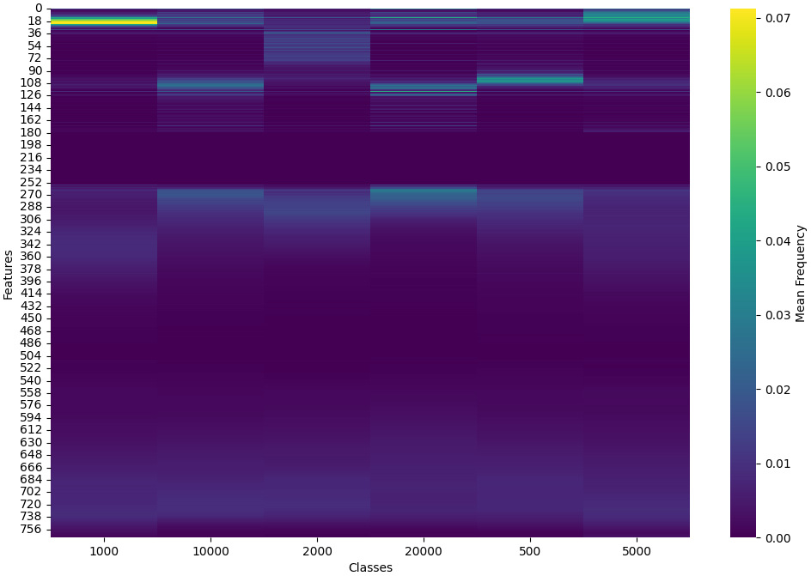
Figure 17 – The average HSV features for each class of Kazakh banknotes

Figure 17 visualises the average HSV histograms for each denomination as a heatmap, where each row corresponds to one of the 768 histogram bins and each column to a denomination class. Compared with the three-dimensional RGB summary in figure 16, the HSV representation reveals clear class-specific patterns of activation across hue, saturation, and value bins, providing a substantially richer fingerprint that the classifier can exploit. After this change, all classifiers improve substantially. The top result is Random Forest with 94.67% accuracy, 94.67% F1-score, 93.61% MCC, and 98.99% ROC-AUC (n_estimators=100). SVC-RBF is nearly identical in accuracy at 94.00%, with the same 98.99% ROC-AUC (gamma=4, C=1000). kNN improves to 88.00%, Ridge CV to 86.67%, and Gaussian NB to 79.67%.
This result indicates that the traditional pipeline’s earlier weakness was primarily a feature bottleneck rather than a classifier bottleneck. The shift to HSV histograms preserves substantially more informative colour structure than RGB averages, particularly the colour distribution across the note surface: rather than a single global colour summary, the classifier now has access to a richer fingerprint of hue, saturation, and brightness composition. This stage is accordingly framed as optimisation through improved colour feature extraction, and the magnitude of the improvement (from approximately 71% to approximately 95% best accuracy) supports this interpretation.

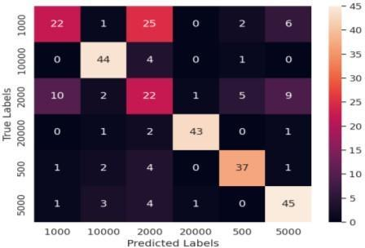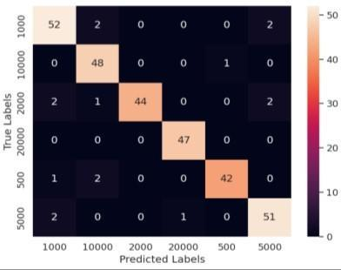

a b

a – SVC-RBF pre-optimisation; b – random forest post-optimisation for the traditional pipeline

Figure 18 – Confusion matrix of

The confusion-matrix comparison in figure 18 (pre-optimisation vs post-optimisation) supports the same conclusion visually. The post-optimisation matrix (Random Forest) shows fewer off-diagonal errors than the pre-optimisation SVC-RBF matrix, indicating that the HSV-based representation reduces confusion between denominations that were harder to separate with the RGB baseline.

3.3.3 Hybrid baseline results with ResNet-18 features (table 11)
Table 11 reports the hybrid pipeline results using 512-dimensional features extracted from the pre-trained ResNet-18 avgpool layer. Even before hyperparameter optimisation, the hybrid approach performs consistently well across all classifiers. SVC-RBF leads with 97.78% accuracy, 97.77% F1-score, 97.34% MCC, and 99.93% ROC-AUC. Random Forest reaches 94.22%, Ridge CV 96.44%, kNN 91.55%, and Gaussian NB 92.89%.
Table 11 – Hybrid approach (ResNet-18-512 features)

Classifier | Accuracy (%) | F1-score (%) | MCC (%) | ROC-AUC (%)
kNN | 91.55 | 91.61 | 89.97 | 99.25
SVC-RBF | 97.78 | 97.77 | 97.34 | 99.93
Random forest | 94.22 | 94.25 | 93.11 | 99.98
Gaussian NB | 92.89 | 92.98 | 91.51 | 99.16
Ridge CV | 96.44 | 96.44 | 95.73 | n/a
Note – Table 11 continues onto the next page

Compared with the traditional baseline (table 9), this is a large performance jump, and even compared with the optimised traditional pipeline (table 10), the hybrid model remains competitive or superior depending on the classifier. The likely reason is that ResNet-18 features encode more than colour alone. Because the avgpool representation is learned from a deep network pre-trained on ImageNet, it can capture higher-level visual cues such as texture, local structure, and shape-like patterns that handcrafted colour summaries do not represent directly. This matters for banknotes, where denomination differences are not only colour-based but also involve complex printed designs.

3.3.4 Optimized hybrid results (table 12)
After optimisation (table 12), the hybrid pipeline reaches the strongest single-model performance in this dissertation’s Kazakh banknote experiments. SVC-RBF improves to 99.11% accuracy, 99.11% F1-score, 98.93% MCC, and 99.98% ROC-AUC using gamma = 0.0001 and C = 1000. Ridge CV also performs exceptionally well at 98.22% accuracy, while Random Forest reaches 95.11%, Gaussian NB 93.78%, and kNN 93.33%.

Table 12 – Hybrid approach after the optimisation (ResNet-18-512 features)

Classifier | Accuracy (%) | F1-score (%) | MCC (%) | ROC-AUC (%) | Best parameters
kNN | 93.33 | 93.39 | 92.11 | 99.22 | 3 neighbors
SVC-RBF | 99.11 | 99.11 | 98.93 | 99.98 | gamma=0.0001, C=1000
Random forest | 95.11 | 95.12 | 94.17 | 99.98 | n_estimators=100
Gaussian NB | 93.78 | 93.80 | 92.55 | 99.45 | var_smoothing=0.1
Ridge CV | 98.22 | 98.22 | 97.86 | n/a | class_weight=‘balanced’, store_cv_values=True

This result demonstrates that the hybrid pipeline is not only accurate but also stable across metrics. The near-perfect ROC-AUC and high MCC indicate that performance is not driven by one or two easily separated classes; rather, the classifier separates classes consistently across the one-vs-rest decision boundaries. The pre- and post-optimisation confusion matrices for SVC-RBF, shown in figure 19, visually corroborate this improvement.
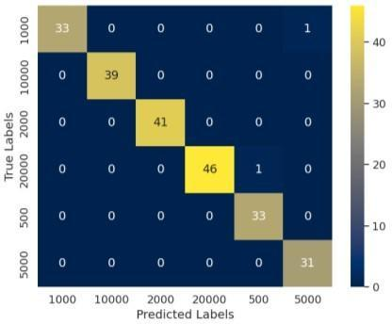
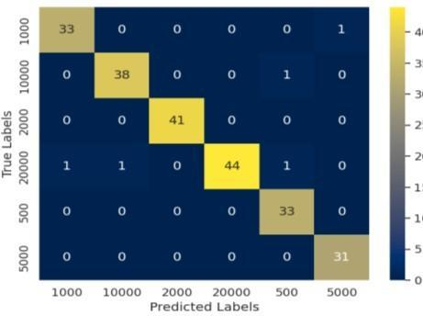
a b

Figure 19 – Confusion matrix of: (a) SVC-RBF pre-optimisation and (b) SVC-RBF post-optimisation for the hybrid pipeline

Summary chart – best-performing classifier at each feature-representation stage (values taken from tables 8, 9, 10, 11), showing the progression from handcrafted RGB features through HSV histograms to ResNet-18 embeddings (figure 20).

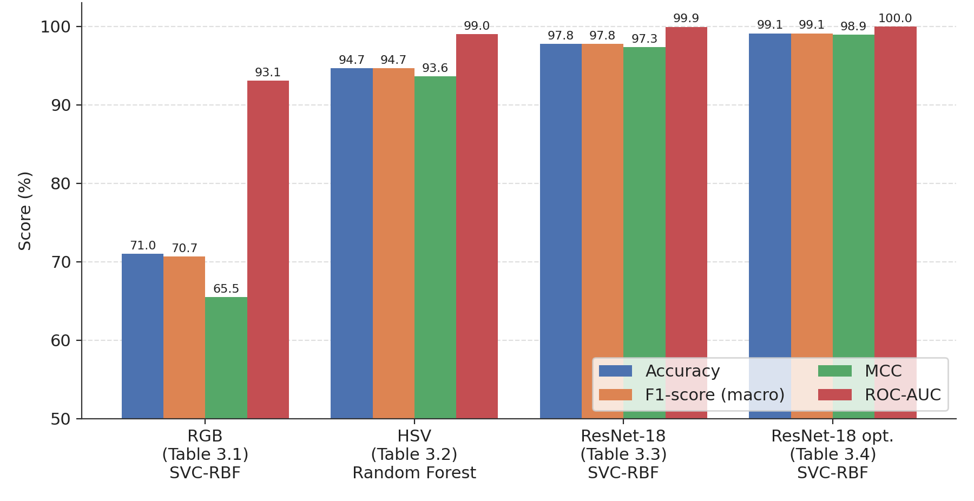

Figure 20 – Best-classifier performance across feature representations (Kazakh banknote recognition, KZ-BD)

3.3.5 Comparative interpretation for the chapter
Taken together, the Kazakh banknote results establish three key findings for this chapter, summarised visually in the progression chart above. First, a simple traditional pipeline with RGB averages is a valid baseline but not sufficient for high-confidence recognition. Second, feature engineering matters enormously: switching to HSV histograms transforms the traditional approach from moderate performance to strong performance. Third, the hybrid pipeline based on ResNet-18 features achieves the best overall results, showing that transfer-learned representations capture richer discriminatory information than handcrafted colour descriptors alone.
Figure 21 consolidates all four reported metrics (accuracy, F1-score, MCC, and ROC-AUC) for all five classifiers across all four representation stages into a single view, extending the accuracy-only progression shown in figure 22.

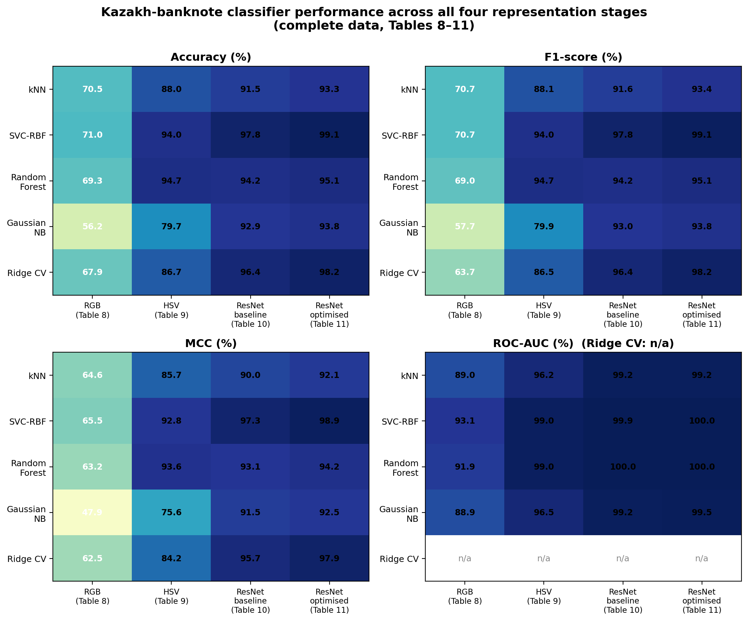

Figure 21 – Complete metric comparison (accuracy, F1-score, MCC, ROC-AUC) for all five classifiers across the four representation stages evaluated on KZ-BD
(tables 8, 9, 10, 11)

The four panels tell a consistent story: whichever metric is inspected, the same left-to-right improvement pattern holds, and the same classifiers occupy the same relative positions at each stage. This corroborates the claim made in §3.6.4 that the observed gains reflect a genuine, metric-independent improvement in class discrimination rather than an artefact of any single scoring rule. The one partial exception is Gaussian NB, whose MCC lags its accuracy more than the other classifiers at the two earlier stages, consistent with it being the weakest model at separating the harder-to-distinguish denominations even when its overall accuracy looks moderate.
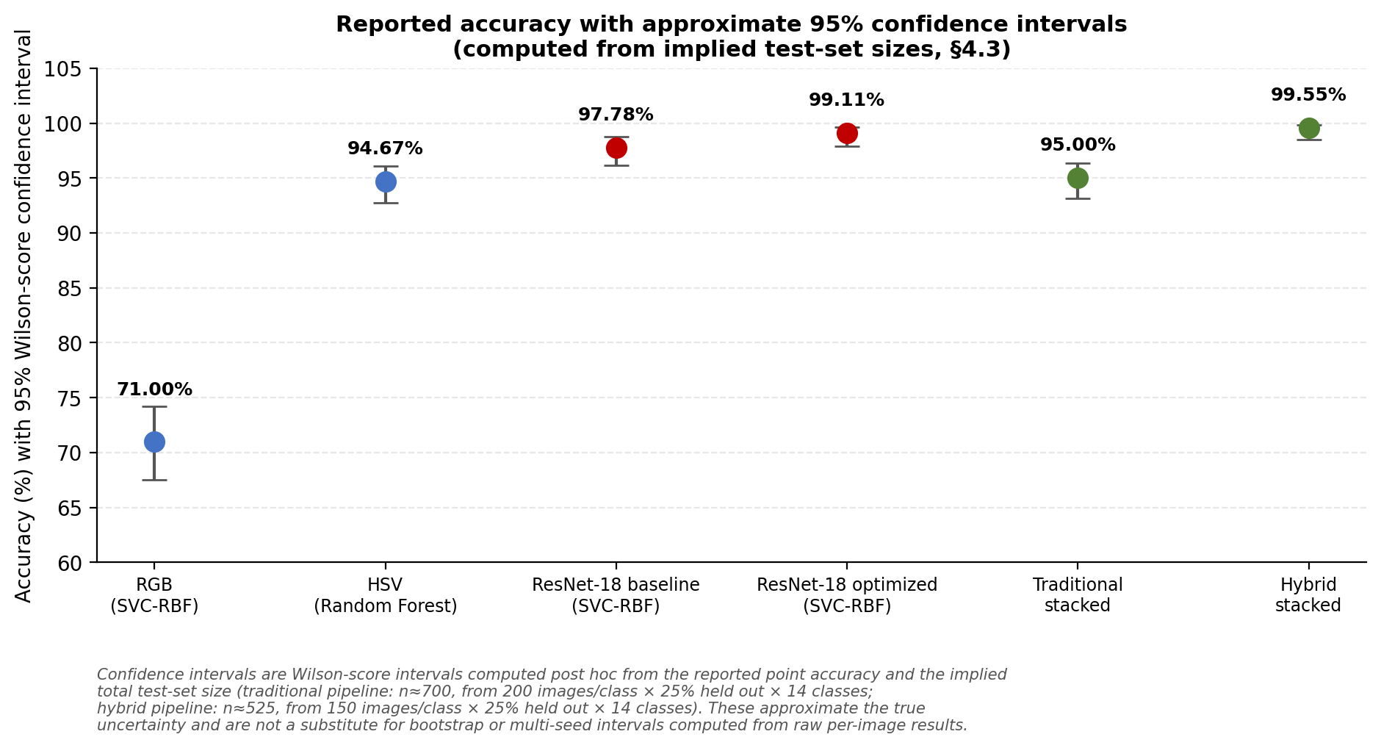

Figure 22 – Reported accuracy with approximate 95% Wilson-score confidence intervals, computed post hoc from the reported point accuracies and the implied test-set sizes (§4.3)

Note – Overlapping intervals indicate that the point-estimate ranking between adjacent configurations should not be read as statistically confirmed

This progression also sets up the next section naturally. Since both pipelines become highly competitive after optimisation, the remaining question is whether combining them through model stacking improves performance further and whether the resulting accuracy gain justifies the increase in model size. That trade-off is addressed in Section 3.4.

3.4 Model stacking ensemble and efficiency trade-off
Following the optimisation of the individual classifiers in both pipelines, the study introduces a stacking ensemble to evaluate whether combining diverse models can improve classification robustness and final predictive performance. In this configuration, the optimised kNN, SVC-RBF, Random Forest, Gaussian NB, and Ridge CV models are used as base estimators, while SVC-RBF is employed as the final estimator. The rationale is to leverage complementary strengths across model families, so that the ensemble can reduce the weaknesses of any single classifier and produce a more reliable decision boundary.
For the Kazakh banknote dataset, the stacking results confirm that ensemble learning provides a measurable improvement over the best single-model results reported earlier. The traditional stacked model achieves 95.00% accuracy, 94.01% F1-score, and 95.01% MCC with a model size of 10.9 MB, while the hybrid stacked model reaches 99.55% accuracy, 99.47% F1-score, and 99.56% MCC with a model size of 52.97 MB. These values indicate that both ensembles are highly effective, but the hybrid ensemble remains the strongest in absolute classification performance (figure 23).
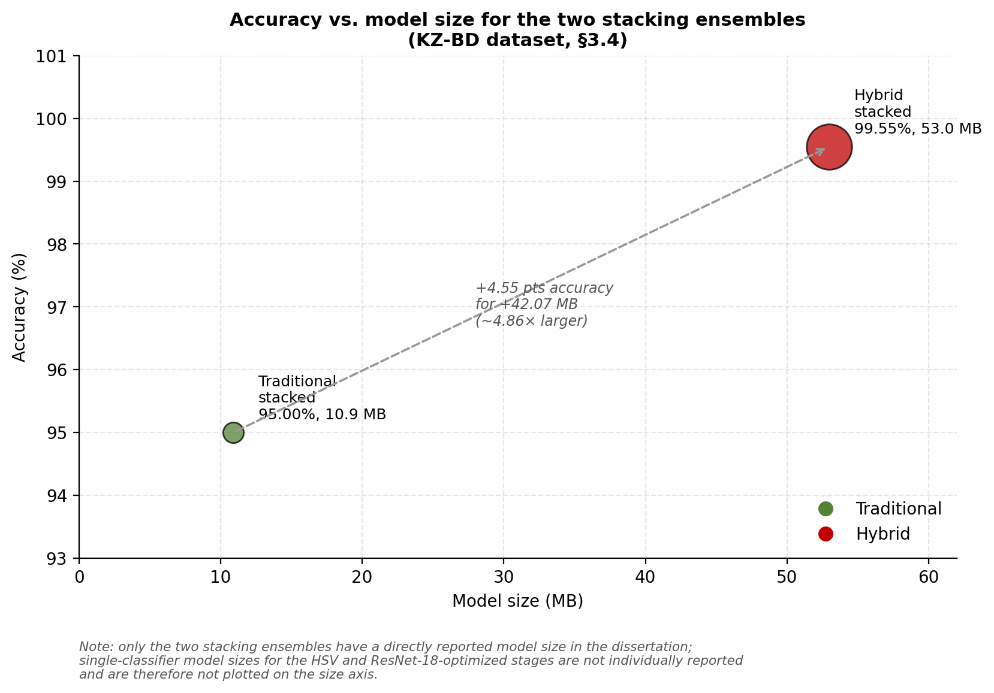

Figure 23 – Accuracy versus model size for the two stacking ensembles evaluated on KZ-BD, showing that the hybrid stacking ensemble’s 4.55-percentage-point accuracy gain over the traditional stacking ensemble comes at a roughly 4.86x increase in storage footprint

When compared with the best optimised single classifiers, the gains from stacking are modest but meaningful. In the traditional pipeline, the best single-model result (Random Forest with HSV features) is 94.67% accuracy, whereas stacking increases this to 95.00%. In the hybrid pipeline, the best single-model result (optimised SVC-RBF with ResNet-18 features) is 99.11% accuracy, and stacking raises it to 99.55%. This pattern suggests that most of the performance gain in the chapter comes from stronger feature representations (HSV histograms and especially ResNet-18 features), while stacking contributes an additional refinement by combining partially complementary decision behaviours.
The central concern in this section, however, is not accuracy alone but efficiency. The hybrid stacked model is substantially larger than the traditional stacked model (52.97 MB vs. 10.9 MB), an increase of 42.07 MB (approximately 4.86× larger). This increase is attributable to the inclusion of the pre-trained ResNet-18 backbone in the hybrid pipeline: the hybrid model weight combines the stacking ensemble with the ResNet-18 weights (44.7 MB). This detail clarifies that the hybrid pipeline’s deployment cost includes both the feature extractor and the final classifier, not the stacking component alone (figures 24, 25).

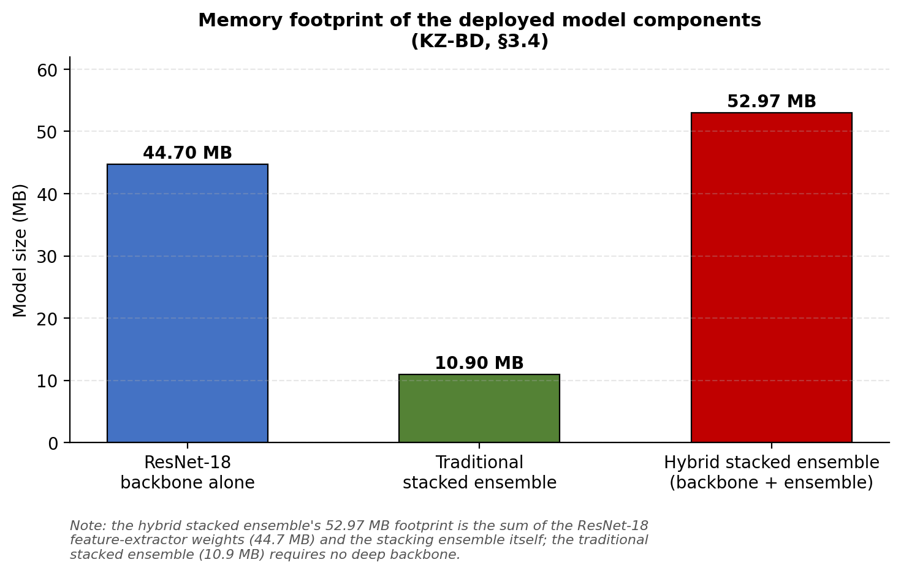

Figure 24 – Memory footprint of the deployed model components: the ResNet-18 feature-extractor backbone alone, the traditional stacked ensemble (no deep backbone), and the hybrid stacked ensemble (backbone plus stacking ensemble)

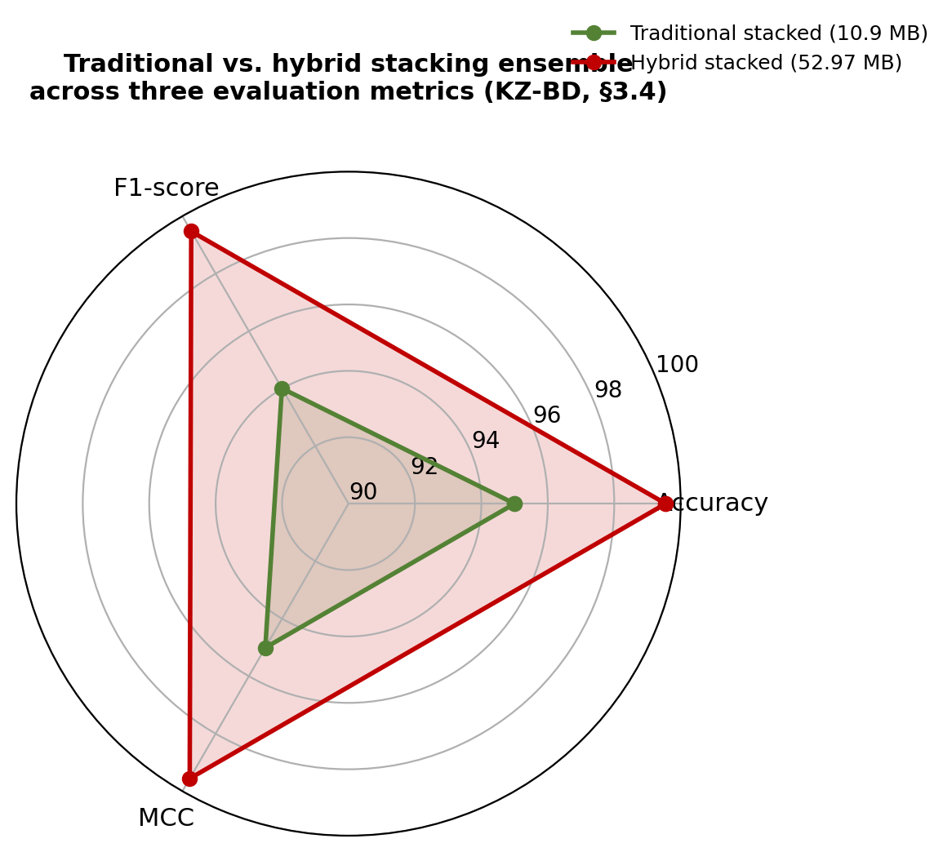

- traditional stacked (10.9 MB); hybrid stacked (52.97 MB)

Figure 25 – Radar comparison of the traditional and hybrid stacking ensembles across accuracy, F1-score, and MCC (KZ-BD, §3.4), illustrating that the hybrid ensemble dominates on every metric at the cost of a substantially larger memory footprint
This result makes the accuracy-efficiency trade-off explicit. The hybrid stacked ensemble is the preferred choice when maximum recognition accuracy is the primary requirement, particularly in assistive or safety-relevant use cases where classification errors should be minimised. The traditional stacked ensemble, in contrast, remains highly competitive while preserving a substantially smaller footprint, making it attractive for resource-constrained deployment scenarios. This interpretation is consistent with the broader design goal of balancing predictive accuracy with lightweight implementation, including the choice of ResNet-18 as a comparatively efficient deep feature extractor.
The confusion matrices reported for the stacked models (figure 26) provide visual support for the quantitative results. These matrices are used to illustrate class-wise performance and remaining misclassifications for both ensembles, which helps confirm that the hybrid stacked model achieves stronger overall separation across denominations, while the traditional ensemble still performs reliably but with more residual confusion.
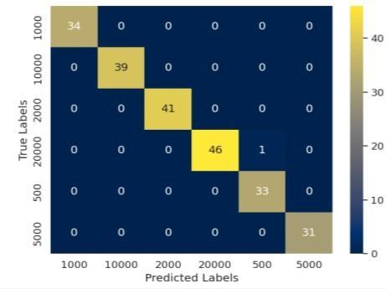
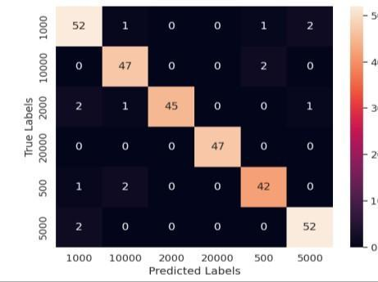

a b

a – the traditional ML approach; b – the hybrid ML approach for Kazakh banknote classification

Figure 26 – Confusion matrix of the model stacking ensemble using optimised models of

The stacking experiments strengthen the chapter’s argument in two respects. First, they demonstrate that ensemble learning can improve performance even after feature extraction and hyperparameter optimisation have already been tuned. Second, and more significantly for practical system design, they show that the appropriate model choice depends on deployment priorities: the hybrid stacked model offers the highest accuracy, whereas the traditional stacked model offers a more compact footprint at only a small cost in performance. This trade-off motivates the next section, in which the same stacked framework is evaluated on additional datasets to examine whether the observed pattern generalises beyond Kazakh banknotes.

3.5 Transferability experiments on other datasets
To assess whether the conclusions drawn from the Kazakh banknote experiments generalise beyond the primary dataset, the proposed approaches are evaluated on two additional image-classification tasks. These experiments are framed as a test of transferability, measuring how well the same methodological framework adapts to different domains and visual conditions. The transferability experiments follow the same overall pipeline logic used for Kazakh banknotes, including comparable preprocessing, feature extraction, and stacking-based classification.
This section moves the argument beyond a single-dataset success case. A model that performs well only on Kazakh banknotes may still be useful, but a model that retains strong performance on a different currency dataset and on a non-currency, colour-based classification task provides additional evidence against the narrowest failure mode, namely that the approach has simply memorised dataset-specific patterns in the Kazakh banknote data. It is worth noting, however, that both transfer targets remain fundamentally colour-separable classification problems, so these experiments are better understood as evidence that the pipeline generalises across colour-driven tasks specifically, rather than as evidence of transfer to visual structure in general. This is examined in two directions: (1) a related domain (Thai banknotes), and (2) a different domain that continues to rely heavily on colour discrimination (coffee-bean roasting levels).

3.5.1 Transferability to Thai banknotes
The first transferability experiment applies the proposed framework to Thai banknotes using the “dataset of Indian and Thai banknotes with annotations.” Examples of Thai banknotes from this dataset are shown in figure 27, illustrating that the test conditions are comparable in difficulty to those of the KZ-BD dataset (figure 1): partly shaded backgrounds, rotated notes, folded notes, hand-held captures, and cluttered scenes. However, Thai banknotes differ in colour schemes, textures, and security features, which makes direct generalization non-trivial. In other words, the task is still banknote recognition, but the visual patterns are sufficiently different to test robustness rather than simple memorization of the original domain.

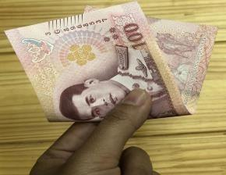



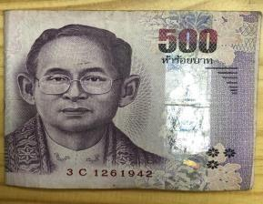

a b c

d e f

a – 20 Baht with a partly shaded background; b – rotated 50 Baht with a wooden background; c – folded 100 Baht in the hand; d – folded 500 Baht; e – clearly visible 1,000 Baht in a cluttered background, (f) crumpled 1,000 Baht in the hand

Figure 27 – Examples of Thai banknote images of each denomination under diverse conditions
The reported results for Thai banknotes are given in table 13, and, as in the Kazakh stacking experiments, they are based on the stacking ensemble with optimised classifiers and SVC-RBF as the final estimator. The traditional stacked approach achieves 96.70% accuracy, 96.71% F1-score, and 95.92% MCC, with a model size of 7.24 MB. The hybrid stacked approach achieves 97.25% accuracy, 97.25% F1-score, and 96.56% MCC, with a model size of 52.28 MB.

Table 13 – Model stacking after the optimisation SVC-RBF (gamma=0.0001, C=1000) for Thai banknotes

Approach | Accuracy (%) | F1-score (%) | MCC (%) | Weights (MB)
Traditional | 96.70 | 96.71 | 95.92 | 7.24
Hybrid | 97.25 | 97.25 | 96.56 | 52.28

Several observations follow from these results. First, both approaches transfer well: accuracy remains high for the traditional and hybrid variants alike, supporting the claim that the proposed methods are adaptable to other currencies. Second, the hybrid approach continues to perform better, but the margin is substantially smaller than in the Kazakh banknote experiments, at 0.55 percentage points (97.25 minus 96.70%). Third, this modest gain is accompanied by a large increase in model size: the hybrid model is 45.04 MB larger (52.28 MB minus 7.24 MB), approximately 7.22 times the size of the traditional model. The Thai-banknote experiment therefore illustrates a case in which transferability is strong for both methods, but the accuracy-to-size trade-off is considerably less favourable for the hybrid pipeline.
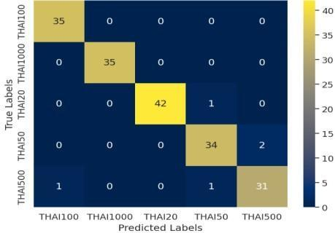
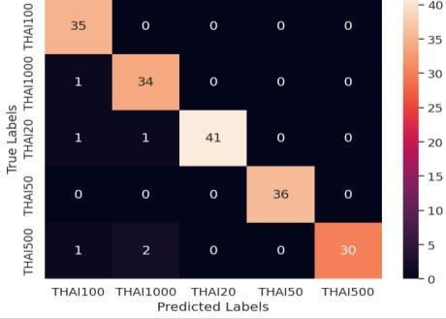
Confusion matrices for both Thai-banknote ensembles (figure 27) provide class-wise error information that supports this quantitative comparison. Although both models perform strongly, the confusion matrices indicate where residual errors remain and support the interpretation that the hybrid model is only marginally more accurate in this transfer scenario.

a b

a – the traditional ML approach; b – the hybrid ML approach for Thai banknote classification

Figure 27 – Confusion matrix of the model stacking ensemble using optimised models of

3.5.2 Transferability to coffee bean roasting-level classification
The second transferability experiment is conceptually more demanding, as it moves beyond banknote recognition entirely. The same methodological framework is applied to the “coffee roast intelligence” dataset (examples of each roasting level are shown in figure 29), where the task is to classify coffee beans into dark, green, light, and medium roasting levels. This experiment examines whether the proposed approaches remain effective in a different application domain while preserving a key property of the original problem: that classification depends heavily on subtle colour differences. The size of the evaluation set for this dataset is not separately reported in this dissertation beyond the modelling pipeline itself, which should be kept in mind when interpreting the results below.



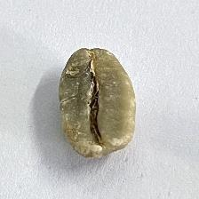
a b c d

a – dark coffee bean; b – green coffee bean; c – light coffee bean; d – medium coffee bean

Figure 29 – Well-lit images of the four roasting levels of coffee beans:

The results, reported in table 14, are particularly informative because they reverse the ranking observed in the Kazakh and Thai banknote tasks. The traditional stacked approach achieves 100% accuracy, 100% F1-score, and 100% MCC with a model size of 3.58 MB, while the hybrid stacked approach reaches 99.00% accuracy, 98.99% F1-score, and 98.67% MCC with a model size of 48.4 MB. In this case, the traditional approach is not only substantially smaller but also marginally more accurate.

Table 14 – Model stacking after the optimisation SVC-RBF (gamma=0.0001, C=1000) for coffee beans

Approach | Accuracy (%) | F1-score (%) | MCC (%) | Weights (MB)
Traditional | 100 | 100 | 100 | 3.58
Hybrid | 99.00 | 98.99 | 98.67 | 48.4

This result is important for the chapter’s overall argument because it precludes the overly broad conclusion that deep-feature-based hybrid methods are always superior. The evidence is consistent with a more nuanced interpretation: when a classification task is strongly driven by colour distributions and the classes are well separated in colour space, the optimised traditional pipeline, particularly with HSV-based features and stacking, can be highly effective and may even outperform the hybrid approach. An equally plausible explanation, which this dissertation cannot rule out with the data reported, is that the hybrid pipeline’s higher-dimensional (512-feature) representation is simply harder to fit reliably on a small training sample than the traditional pipeline’s three- or 768-dimensional descriptors, so that some of the traditional pipeline’s advantage here may reflect sample size rather than a general property of colour-dominant tasks. A perfect 100% score on any held-out test set nonetheless warrants caution regardless of which explanation is correct: as noted above, this dissertation does not separately report the size of the coffee-bean evaluation set, and the result should be interpreted in that light and verified to rule out leakage between the training and test partitions during preprocessing or augmentation, rather than accepted at face value as evidence of a solved task.
The confusion matrices in figure 30 reinforce this interpretation. The traditional approach yields a perfect classification matrix, while the hybrid approach remains highly accurate but includes one false prediction. This visual evidence aligns with the metric values and further strengthens the claim that the traditional colour-feature pipeline can be the better choice in certain domains.
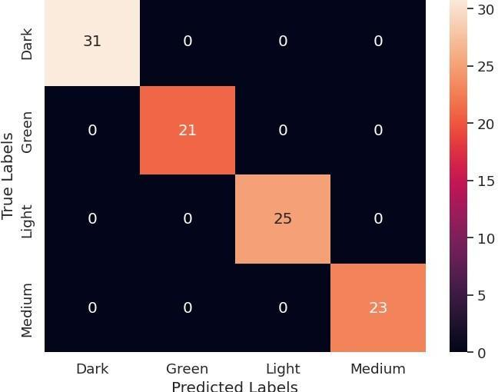
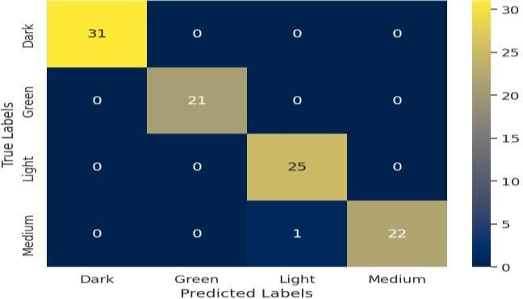
a b

a – the traditional ML approach; b – the hybrid ML approach for coffee bean roasting-level classification

Figure 30 – Confusion matrix of the model stacking ensemble using optimised models of

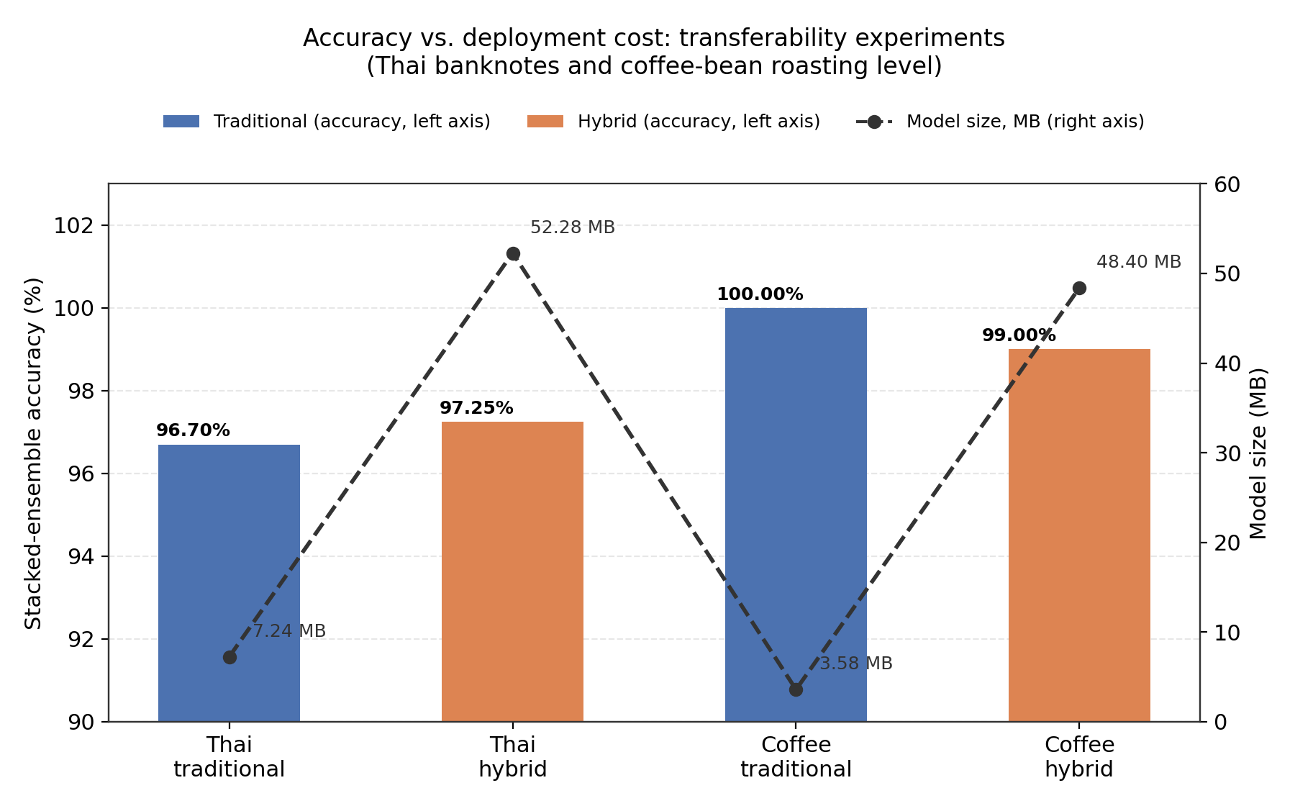

Figure 32 – Accuracy vs. deployment cost: transferability experiments

Note – Thai banknotes and coffee-bean roasting level
Figure 32, Summary chart – accuracy and model-size trade-off for the two transferability experiments (values taken from tables 12 and 13), illustrating that the hybrid pipeline’s accuracy gain over the traditional pipeline is small relative to its much larger storage footprint.

3.5.3 Cross-dataset interpretation and implications
Taken together, the Thai-banknote and coffee-bean experiments provide evidence that the proposed methodology transfers well within colour-driven classification tasks, although the transfer behaviour differs by task, as summarised in the accuracy/model-size trade-off chart above. In the related-domain case (Thai banknotes), both approaches remain highly accurate and the hybrid model retains a small advantage. In the colour-dominant, non-banknote case (coffee beans), the traditional model becomes the stronger option in both performance and efficiency. This pattern supports a central argument of the dissertation: the best pipeline depends not only on accuracy targets but also on the visual nature of the target domain and the applicable deployment constraints; it should not, however, be read as evidence that the pipeline generalises to visual classification tasks beyond this colour-driven family.
This interpretation is consistent with the broader discussion and conclusion of the dissertation, which emphasise that the methods are broadly useful for image-classification problems in which colour distinctions are important, while also recognising that performance and practicality should be judged jointly rather than through accuracy alone. The transferability experiments are therefore a valuable addition to this chapter: they extend the results from a single-benchmark comparison into a more general and practically grounded evaluation.

3.6 Discussion
The results in this chapter show a consistent pattern across all experiments: the choice of feature representation is the principal driver of performance, while classifier selection, hyperparameter tuning, and stacking act as additional layers of improvement. This pattern is evident first in the Kazakh banknote results and is subsequently reinforced by the transferability experiments on Thai banknotes and coffee beans. The discussion that follows adopts the same interpretation, emphasising the contrast between RGB features, optimised HSV features, and deep ResNet-18 features.

3.6.1 Feature representation explains most of the performance gap
The largest improvement in the entire experimental pipeline occurs within the traditional approach itself, when the feature representation changes from simple RGB averages to HSV histograms. In the RGB baseline (table 9), the best classifier is SVC-RBF at 71.00% accuracy. After replacing the RGB vector with HSV histograms and optimising the classifiers (table 10), the best traditional result rises to 94.67% accuracy (Random Forest), with correspondingly strong gains in F1-score, MCC, and ROC-AUC. This large improvement indicates that the baseline limitation lay primarily in the information content of the features rather than in the classifier family.
This finding is significant because it shows that the traditional pipeline should not be treated as a weak baseline by default. With only three RGB-derived features (RB, RG, GB), the model has access to a highly compressed summary of colour information. The HSV histogram representation, by contrast, captures a substantially richer distribution of hue, saturation, and value, which is better suited to banknotes that differ through complex colour layouts rather than a single global colour cue. HSV histograms are accordingly introduced as an optimisation step aimed at richer colour information, and the results support this design choice clearly.
A practical implication follows from this result: feature engineering remains highly relevant in applied machine learning, particularly in resource-constrained settings. Even without deep end-to-end training, the traditional pipeline becomes highly competitive once its representation is improved. For a dissertation concerned with practical systems, this is a meaningful finding, as it demonstrates that lightweight methods can achieve strong performance when the feature design is well matched to the visual properties of the task.

3.6.2 Why the hybrid pipeline is stronger on Kazakh banknotes
Although the optimised traditional pipeline performs strongly, the hybrid approach achieves the best results overall on the primary Kazakh banknote task. Using 512-dimensional features extracted from the pre-trained ResNet-18 “avgpool” layer, the hybrid models already perform strongly before optimisation (table 11) and, after tuning, reach the chapter’s best single-model result of 99.11% accuracy with optimised SVC-RBF (table 12). This confirms that the hybrid pipeline captures more discriminative visual information than handcrafted colour features alone.
The most likely explanation is representational richness. The ResNet-18 “avgpool” output functions as a dense, high-level feature representation, which supports ResNet-18’s role as a balance between accuracy and computational cost. In effect, the hybrid pipeline benefits from transfer learning: its features are not limited to colour summaries but can encode texture, local structure, and other higher-level visual patterns learned during ImageNet pretraining. This is particularly useful for banknotes, where denomination differences are not purely colour-based but also depend on printed details and spatial structure.
At the same time, this result should not be overstated. The hybrid pipeline is the strongest performer on Kazakh banknotes, but the transferability experiments reported later in this chapter show that its advantage is not universal across all colour-driven tasks. This is among the chapter’s most important analytical outcomes: the hybrid approach is a strong general-purpose solution, but not automatically the best choice in every domain.

3.6.3 Optimization and stacking improve results
The chapter’s results also separate the effects of optimisation and stacking. Optimisation (improved features combined with hyperparameter tuning) produces the largest gains, while stacking contributes smaller, though still meaningful, improvements.
For example, in the traditional branch, the best result improves from 71.00% (RGB baseline) to 94.67% (optimised HSV features), which constitutes a substantial increase. Stacking then raises the traditional result further to 95.00%. In the hybrid branch, optimisation increases performance to 99.11%, and stacking then improves it to 99.55%. These numbers show that stacking helps, but most of the improvement comes earlier from representation and tuning.
This distinction has a practical implication for the recommended optimisation order:
- Choose the right feature representation.
- Tune the classifier.
- Apply stacking if additional gains are needed.
This sequence is strongly supported by the experimental evidence, and it aligns with the model-stacking rationale established in Chapter 2, in which stacking is presented as a means of combining complementary classifier strengths after the individual models have already been optimised.
The grid search results also reveal a striking shift in the optimal SVC-RBF configuration between the two optimised stages. For the HSV-optimised traditional pipeline (table 10), the best-performing kernel coefficient is γ = 4; for the ResNet-18-optimised hybrid pipeline (table 12), it is γ = 0.0001, a difference of four orders of magnitude, while the regularisation strength C remains unchanged at 1000 in both cases (figure 33).

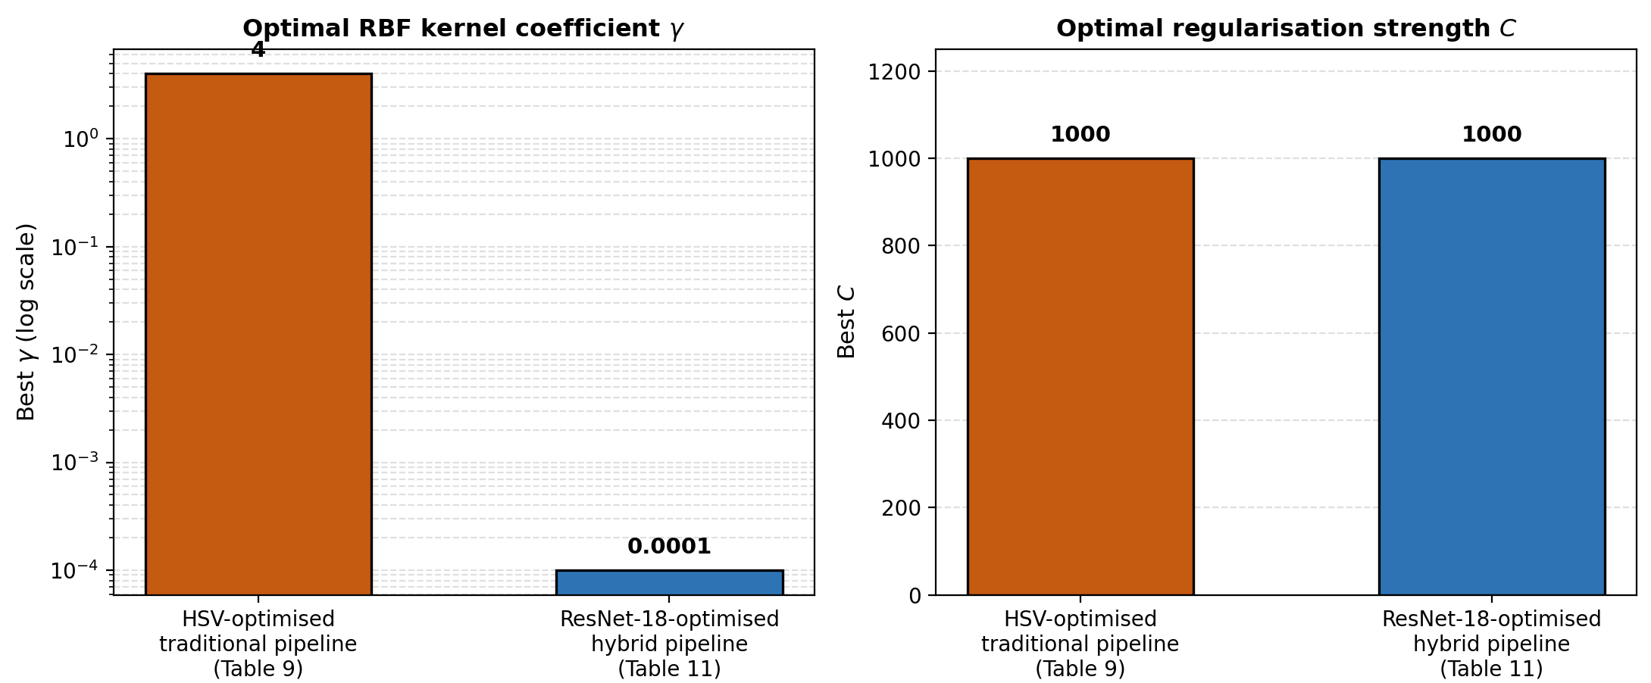
a b

Figure 33 – Best-found SVC-RBF hyperparameters (γ and C) at the two optimised stages, illustrating the sensitivity of the kernel coefficient to the underlying feature representation

This is consistent with the different geometry of the two feature spaces: the 768-dimensional HSV histogram vectors and the 512-dimensional ResNet-18 embeddings differ substantially in scale and density, so the kernel bandwidth that separates classes well in one space is not expected to transfer to the other. Practically, this means that the SVC-RBF hyperparameters cannot be fixed once and reused across feature representations; each representation change in this dissertation is accompanied by a fresh grid search, consistent with the leakage-safe protocol described in §2.5.2. The exact grid-search ranges explored for γ and C at each stage are not separately reported in this dissertation, although the best-found value at each stage is given in tables 9, 11 (figure 34).

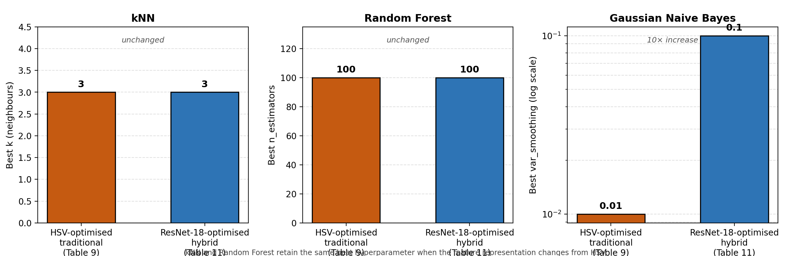
a b c

Figure 34 – Best-found hyperparameter stability across the two optimised stages for kNN, Random Forest, and Gaussian NB (tables 9, 11)

This sensitivity is not shared equally by all five classifiers. Comparing the best-found hyperparameters across the same two optimised stages for the remaining classifiers (table 10, 12) shows that kNN retains the same optimal neighbourhood size (k=3) and Random Forest retains the same optimal ensemble size (n_estimators = 100) whether the input is a 768-dimensional HSV histogram or a 512-dimensional ResNet-18 embedding, whereas Gaussian NB’s optimal var_smoothing shifts by an order of magnitude (0.01 to 0.1), in the same direction of increased smoothing as SVC-RBF’s shift towards a smaller kernel coefficient.
A plausible explanation is that kNN and Random Forest make decisions based on the relative ordering or partitioning of feature values (nearest neighbours and axis-aligned splits, respectively), which is comparatively insensitive to the absolute scale of the representation, whereas SVC-RBF’s kernel and Gaussian NB’s variance term operate directly on absolute distances and variances, which do depend on representation scale and density. This distinction offers a practical guideline for extending this pipeline to future encoders (§4.2): the neighbourhood- and tree-based base learners can likely be reused with their existing hyperparameters as a starting point, while the kernel- and density-based learners should be re-tuned from scratch. This interpretation is drawn from a single representation change observed per classifier and should be treated as a hypothesis motivating future work rather than an established mechanism (figure 35).

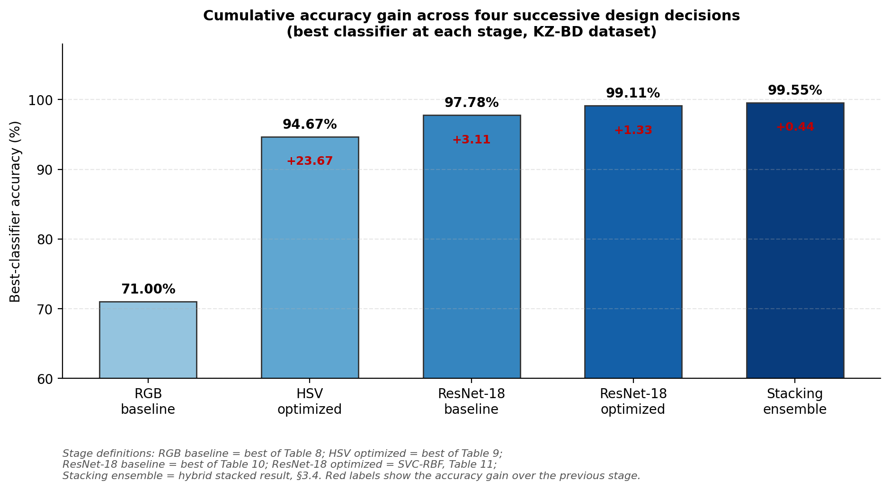

Figure 35 - Cumulative accuracy gain across the four successive design decisions evaluated in this chapter: feature representation (RGB to HSV), encoder choice (handcrafted to ResNet-18), hyperparameter optimisation, and model fusion (single classifier to stacking ensemble)

Note – Bars show the best-classifier accuracy at each stage; red labels show the gain over the previous stage

3.6.4 Robustness across metrics, not just accuracy
A further strength of the reported results is that the conclusions do not rest on accuracy alone. Across the best-performing configurations, F1-score, MCC, and ROC-AUC generally improve alongside accuracy, suggesting that performance gains are not superficial or confined to a subset of classes. This pattern is particularly visible in the optimised traditional and hybrid results, where the top models perform strongly across all metrics rather than in overall accuracy alone.
This consistency is important because banknote recognition is a multi-class problem evaluated under realistic imaging conditions: a model that improves accuracy alone while degrading class balance or separability would be difficult to justify for deployment. The coherence of the metric pattern observed here indicates that the stronger feature representations improve performance broadly, increasing confidence that the gains reflect genuine improvements in class discrimination. The inclusion of MCC and one-vs-rest ROC-AUC in the evaluation methodology further strengthens this interpretation.

3.6.5 Accuracy-efficiency trade-off is central to the chapter
A key contribution of this chapter is its joint evaluation of predictive performance and deployment cost. This is especially evident in the stacking results, where the hybrid ensemble achieves the highest Kazakh-banknote performance (99.55% accuracy) but at a much larger model size (52.97 MB) than the traditional ensemble (95.00% accuracy, 10.9 MB). The hybrid model weight includes the pre-trained ResNet-18 weights (44.7 MB) in addition to the stacking ensemble.
This distinction matters for practical deployment. In a mobile or assistive setting, the preferred model depends on more than benchmark accuracy alone. The hybrid stacked model is the stronger choice when minimising classification error is the top priority, whereas the traditional stacked model remains attractive when compactness is more important, since it preserves high performance within a much smaller footprint. This framing is consistent with the objective, established in the Introduction and Methodology, of balancing lightweight implementation with high accuracy.
This is among the chapter’s most consequential findings: the experimental results do not support a single universal winner, but rather a decision framework based on operating constraints.

3.6.6 What transferability reveals about domain dependence
The transferability experiments strengthen the discussion by showing how the same pipelines behave outside the original Kazakh dataset. The Thai-banknote results (table 13) show that both approaches transfer well, with the traditional stacked model reaching 96.70% accuracy and the hybrid stacked model reaching 97.25%, confirming that the methods are not narrowly overfitted to Kazakh banknotes. However, the hybrid advantage is small (+0.55 percentage points) while the model-size gap remains large (52.28 MB vs. 7.24 MB).
This result is important because it qualifies the claim that the hybrid pipeline is unconditionally superior. On the primary dataset, the hybrid margin is substantial; on a related transfer task, it becomes much smaller. This suggests that the accuracy gain from deep features may not always justify the additional size and complexity, particularly where the deployment environment is constrained.
The coffee-bean experiment (table 14) is more informative still, as it reverses this ranking: the traditional stacked model achieves 100% accuracy with a 3.58 MB model, while the hybrid stacked model reaches 99.00% with a 48.4 MB model. The traditional model’s confusion matrix is perfect, whereas the hybrid result includes one false prediction. This is strong evidence that, for tasks driven primarily by colour differences, the optimised traditional pipeline can match or even exceed the hybrid approach while remaining far more compact.
Together, the two transferability experiments support a nuanced conclusion:
1. Hybrid features are consistently strong and often optimal, especially on complex banknote imagery.
2. Traditional HSV-based features remain highly competitive, and may be preferable when colour distributions dominate the task or efficiency is critical.
This is a more defensible conclusion than the simpler claim that deep features are always superior.

3.6.7 Comparison with prior published results
The classifier comparisons above are internal to this dissertation. To place the resulting accuracy figures in a broader context, table 15 juxtaposes them with accuracy figures reported in the literature reviewed in Chapter 1 for other currencies. This comparison is not a controlled benchmark: the studies differ in currency, denomination count, dataset size, and evaluation protocol, so the figures indicate competitive positioning rather than a like-for-like ranking.

Table 15 - Comparison with accuracy figures reported for other currencies in the literature reviewed in Chapter 1

Study | Currency / dataset | Method | Accuracy (%)
Sufri et al. | Malaysian ringgit | SVM/Bayesian classifier, RGB features | 100.00
Hussein et al. | Egypt/KSA/USA (12 denominations) | HOG + SIFT | 99.20
Hussein et al. | Kaggle Egyptian dataset | HOG + SIFT | 98.90
Youn et al. | KRW/USD/EUR/CNY / JOD (unsoiled) | Multi-template correlation | 100.00
Youn et al. | Same (soiled banknotes) | Multi-template correlation | 99.80
This dissertation | Kazakh banknotes | Traditional stacking ensemble | 95.00
This dissertation | Kazakh banknotes | Hybrid stacking ensemble | 99.55
Note – Compiled from sources [1, p. 5; 4, p. 2121-2130; 12, p. 22-31]

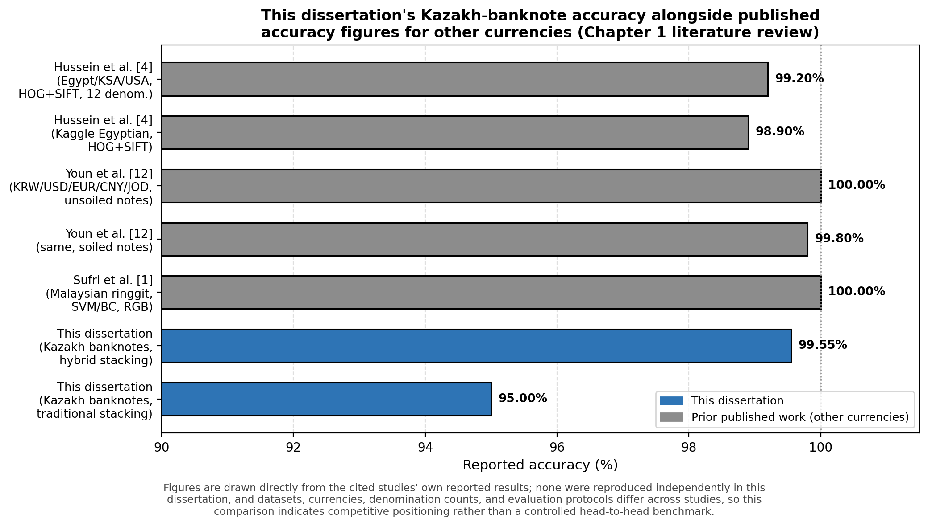

Figure 36 - This dissertation’s Kazakh-banknote accuracy alongside the published figures in table 15

Figure 36, the hybrid stacking ensemble’s 99.55% accuracy on Kazakh banknotes sits within the range reported for other currencies using comparable classical and hybrid approaches, and the traditional stacking ensemble’s 95.00% accuracy is achieved with a substantially smaller model than any hybrid configuration in this comparison. None of the studies in Table 15 report model size, so this dissertation’s efficiency analysis (§3.4, §3.6.5) has no direct external point of comparison; it should be read as this dissertation’s own contribution rather than as a claim of superiority over prior work on that dimension. The relevant comparison here is not which single number is highest, but whether a previously unstudied, data-poor currency can reach accuracy levels comparable to currencies backed by established recognition literatures — which Table 15 confirms.
What this dissertation can compare directly across domains is its own accuracy-versus-size trade-off. Figure 37 consolidates the stacking-ensemble results for all three evaluated domains (Kazakh banknotes, Thai banknotes, and coffee beans) onto a single accuracy-size plane.

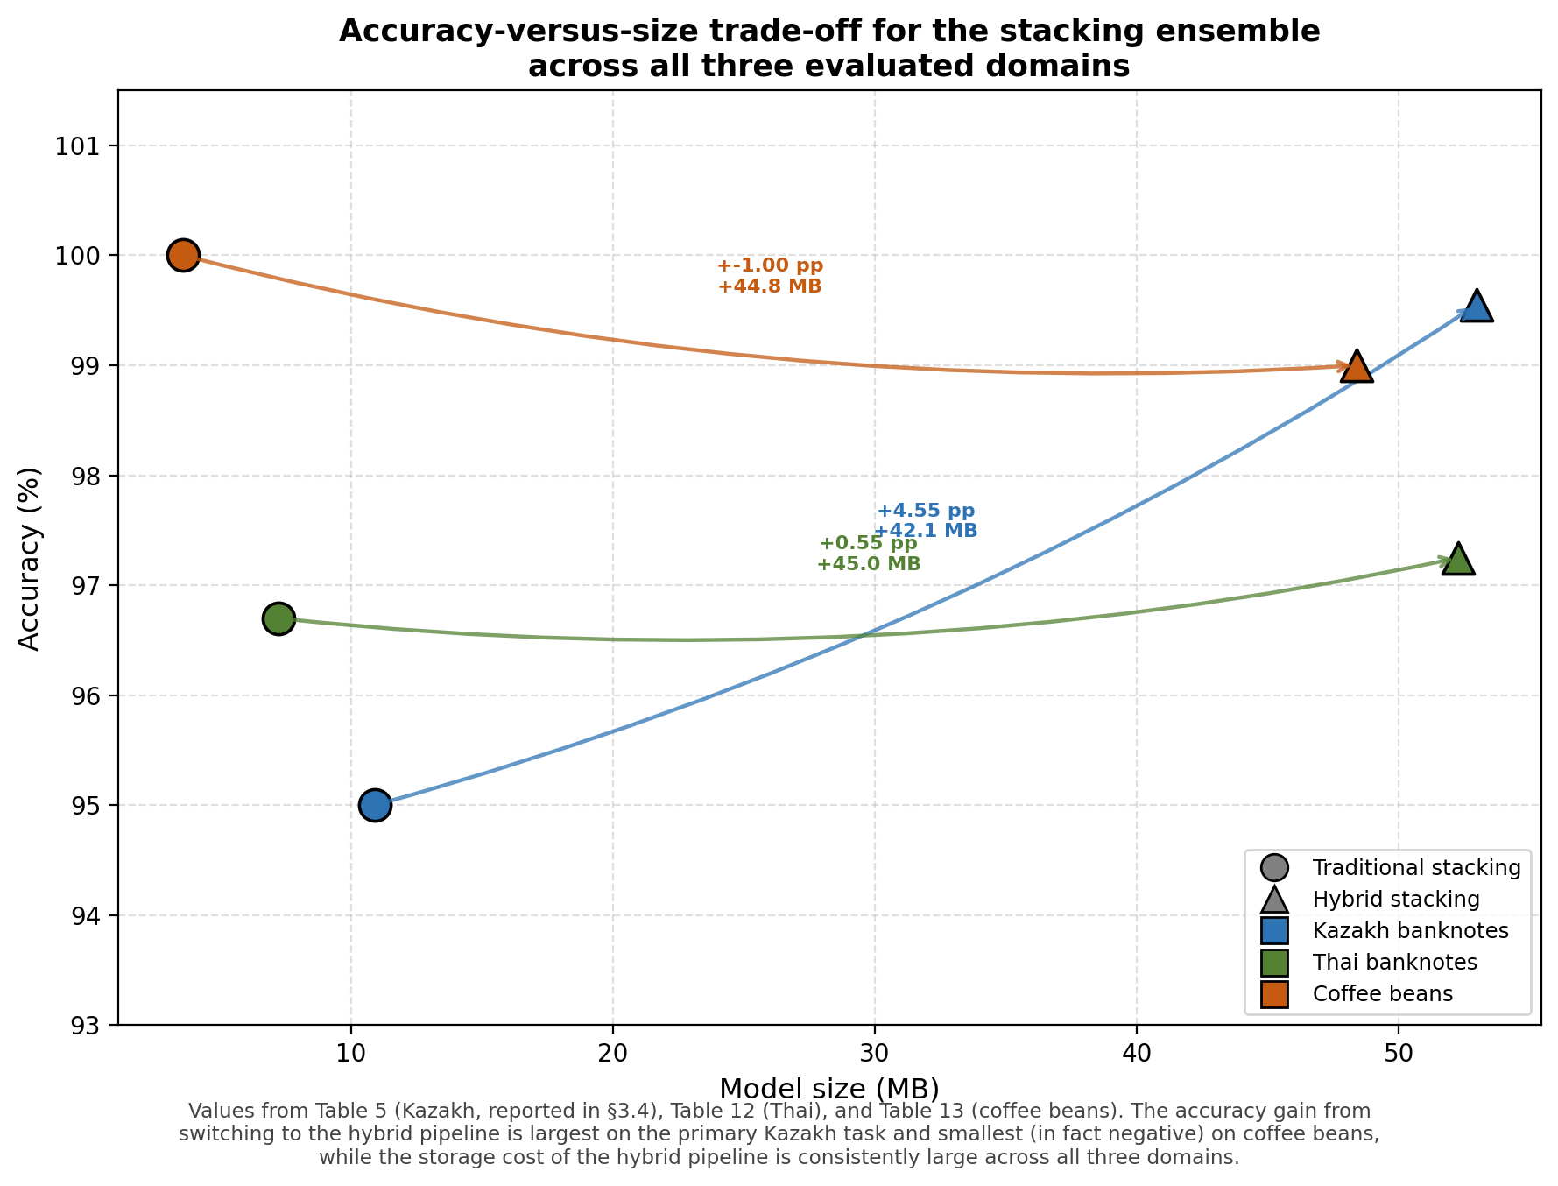

Figure 37 - Accuracy-versus-model-size trade-off for the traditional and hybrid stacking ensembles across all three evaluated domains

The plot makes the pattern already discussed in §3.5.3 and §3.6.6 visually explicit: the arrow from traditional to hybrid points up and to the right on the primary Kazakh task (a genuine accuracy gain for a large size cost), is nearly flat on Thai banknotes (a small gain for the same size cost), and points down and to the right on coffee beans (a size cost with no accuracy benefit at all). The storage cost of adding the ResNet-18 backbone is of comparable magnitude in all three cases (approximately 40-45 MB), so the domain determines whether that fixed cost is worth paying, not the modelling approach itself.

3.6.8 Summary of all reported results
The preceding sections report stacking-ensemble results separately for each domain (table 5’s prose statement for Kazakh banknotes in §3.4, table 13 for Thai banknotes, and table 14 for coffee beans). Table 16 consolidates all six headline stacking results into a single view, to support a direct, at-a-glance comparison before the chapter’s conclusions are drawn.

Table 16 - Consolidated stacking-ensemble results across all three evaluated domains (reproduced from §3.4, table 13, 14)

Domain | Approach | Accuracy (%) | MCC (%) | Model size (MB)
Kazakh banknotes | Traditional (stacked) | 95.00 | 95.01 | 10.9
Kazakh banknotes | Hybrid (stacked) | 99.55 | 99.56 | 52.97
Thai banknotes | Traditional (stacked) | 96.70 | 95.92 | 7.24
Thai banknotes | Hybrid (stacked) | 97.25 | 96.56 | 52.28
Coffee beans | Traditional (stacked) | 100.00 | 100.00 | 3.58
Coffee beans | Hybrid (stacked) | 99.00 | 98.67 | 48.4

Read as a single table, the pattern established throughout this chapter is immediately visible: the hybrid pipeline’s accuracy advantage over the traditional pipeline is largest on the primary Kazakh task (+4.55 percentage points), shrinks on the related Thai-banknote task (+0.55 percentage points), and reverses on the colour-dominant coffee-bean task (−1.00 percentage points), while its model-size cost remains large and roughly constant (approximately 40-45 MB) across all three domains. This table therefore functions as the single empirical reference for the accuracy-efficiency trade-off discussed throughout §3.4-3.6 and revisited in the Conclusion.
Figure 38 consolidates the chapter’s headline numbers, the Kazakh-banknote accuracy progression, the cross-domain size and accuracy comparisons, and the per-classifier MCC breakdown into a single results dashboard, intended as a one-page reference for the dissertation’s empirical findings.

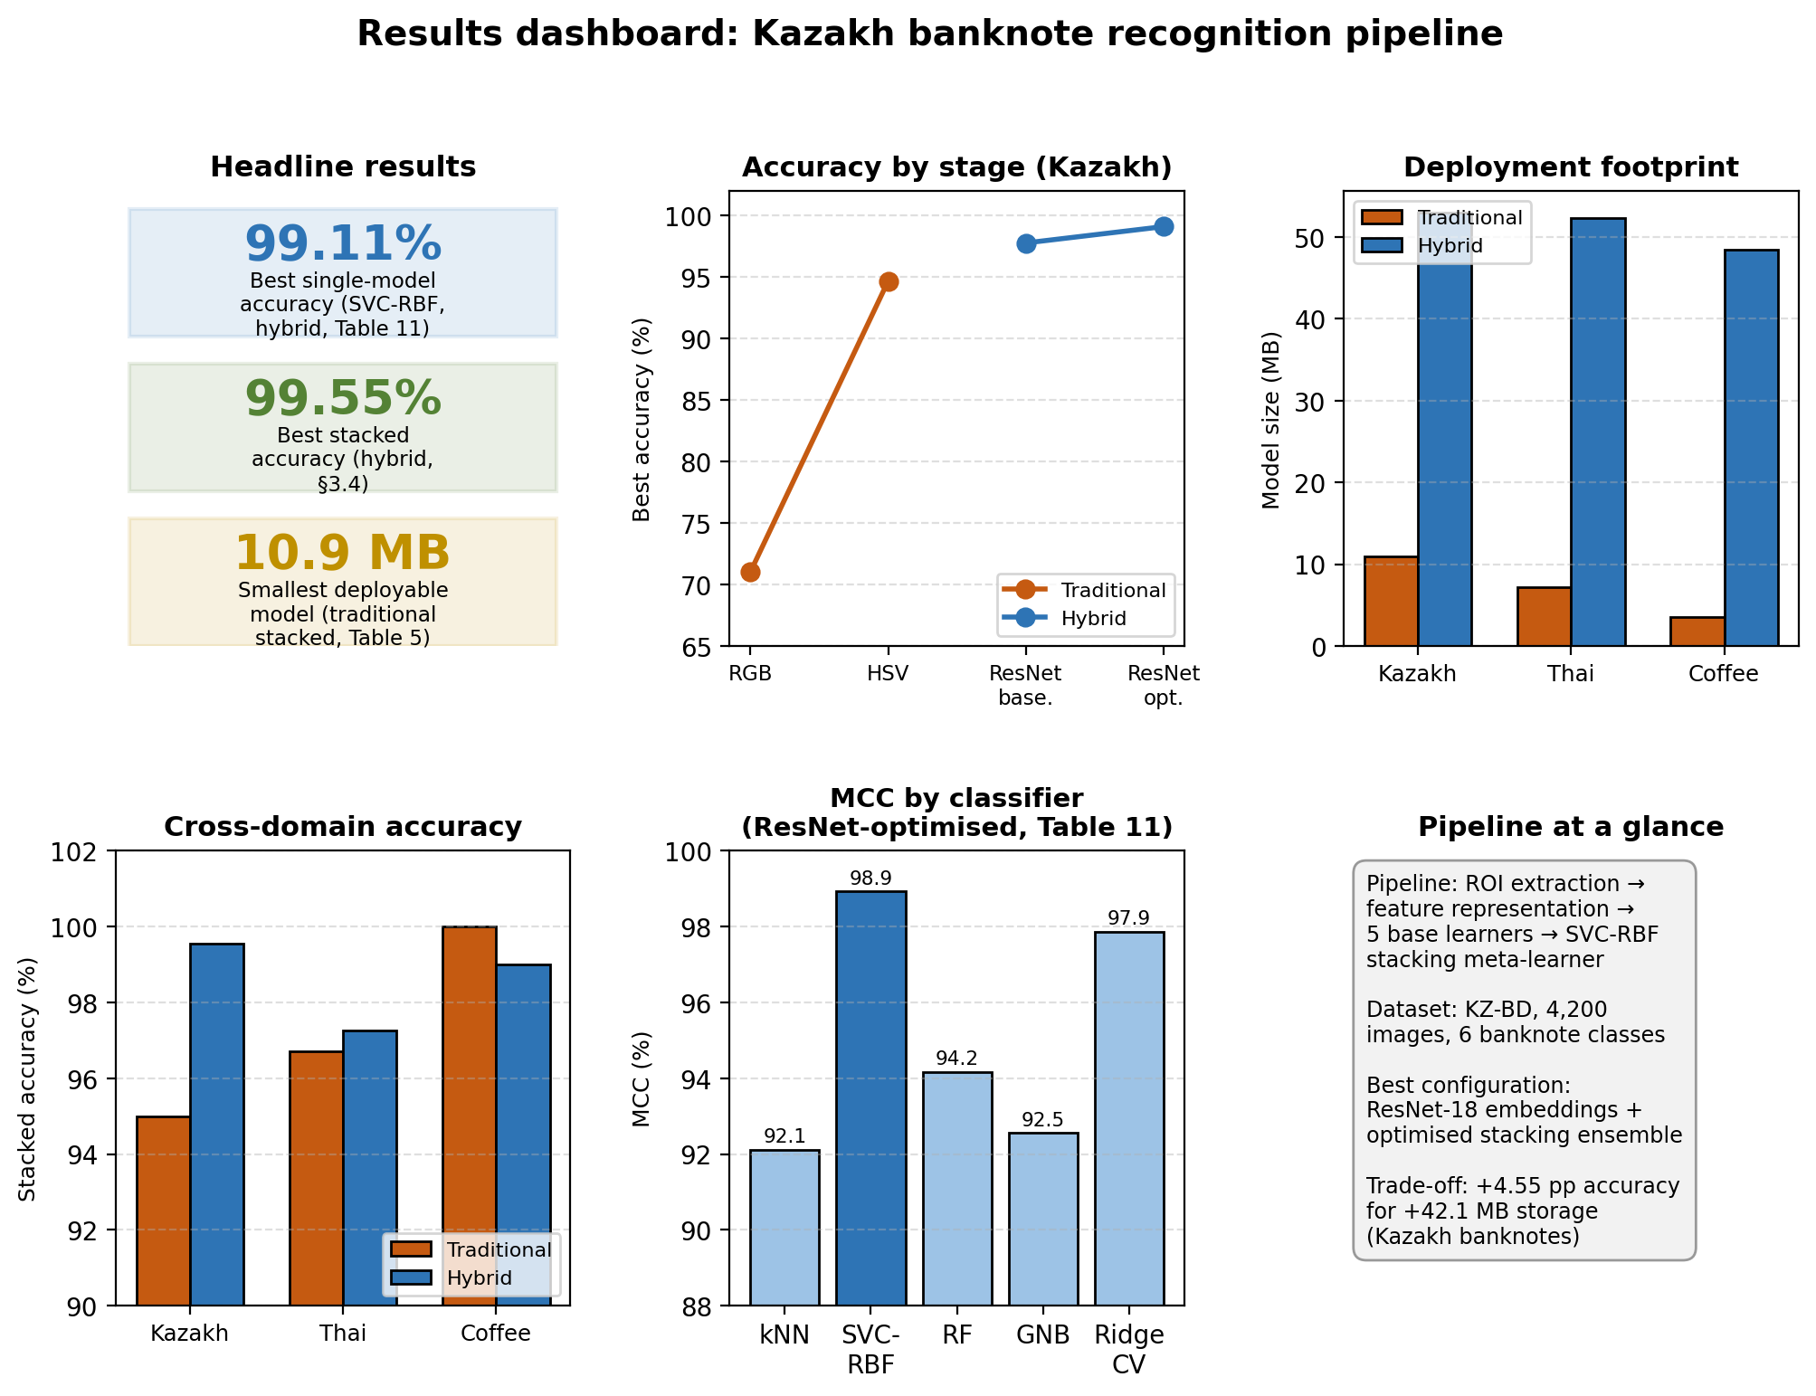

Figure 38 - Results dashboard consolidating headline accuracy, model-size trade-offs, and per-classifier MCC for the Kazakh banknote recognition pipeline
Every value shown is reproduced directly from tables 8, 9, 11, 5 (§3.4), 12, and 13; the dashboard introduces no new measurements, only a consolidated view of results that are otherwise scattered across the chapter.

Chapter summary
This chapter evaluated and compared traditional and hybrid machine learning pipelines for Kazakh banknote classification, then extended the analysis with stacking ensembles and transferability tests. Overall, the results show that both approaches are effective, but their strengths differ depending on the feature representation, target domain, and deployment constraints.
For the traditional pipeline, the RGB baseline produced moderate performance, with the best result reaching 71.00% accuracy (SVC-RBF). After optimisation using HSV histogram features, performance improved substantially, and the best traditional model (Random Forest) achieved 94.67% accuracy, confirming that feature engineering was the main source of improvement in this branch.
For the hybrid pipeline, features extracted from the pre-trained ResNet-18 model consistently outperformed the traditional models, and the optimised SVC-RBF achieved 99.11% accuracy on the Kazakh banknote dataset. This indicates that transfer-learned deep features provide a richer and more discriminative representation for the banknote recognition task than handcrafted colour descriptors alone.
The stacking ensemble experiments further improved both approaches. On Kazakh banknotes, the stacked traditional model reached 95.00% accuracy, while the stacked hybrid model achieved the best overall result of 99.55% accuracy. However, this performance gain came with a clear efficiency cost: the hybrid stacked model required a much larger model footprint (52.97 MB) than the traditional stacked model (10.9 MB), partly because the hybrid size includes the ResNet-18 backbone weights. This confirms that the chapter’s evaluation is not only about accuracy, but also about practical deployment trade-offs.
The transferability experiments strengthened the chapter’s conclusions by showing that the proposed framework transfers well to other colour-driven classification tasks beyond the Kazakh dataset. On Thai banknotes, both stacked models remained highly accurate, with the hybrid approach performing slightly better (97.25% vs 96.70%), but again at a much larger size (52.28 MB vs 7.24 MB). On the coffee bean roasting-level dataset, the pattern reversed: the traditional stacked model achieved 100% accuracy with a markedly compact model size (3.58 MB), while the hybrid model reached 99.00% and remained much larger (48.4 MB). These results show that the best choice depends on the domain and on whether maximum accuracy or compactness is the higher priority.
The chapter discussion supports a balanced interpretation. It emphasises that HSV-based optimisation significantly improves traditional ML, that deep features from ResNet-18 provide the strongest overall performance on the primary banknote task, and that stacking is a useful final refinement because it combines complementary classifier strengths. At the same time, the results on Thai banknotes and coffee beans demonstrate that model superiority is context-dependent, not universal.
Two further analyses reinforce this interpretation. First, positioning the dissertation’s Kazakh-banknote accuracy alongside published figures for other currencies (§3.6.7) shows that the hybrid ensemble’s performance is competitive with, rather than exceptional relative to, prior work on better-resourced currencies, which tempers any claim of an unqualified state-of-the-art result while still supporting the dissertation’s central claim of a strong, reproducible baseline for an under-represented currency. Second, examining which classifiers’ best hyperparameters are stable across feature representations and which are not (§3.6.3) shows that this sensitivity is itself informative: it separates classifiers whose decision mechanism depends on absolute feature scale (SVC-RBF, Gaussian NB) from those that do not (kNN, Random Forest), a distinction with direct implications for how quickly this pipeline could be adapted to a new encoder in future work (§4.2).
Finally, the chapter identifies several limitations and threats to validity that shape how the results should be interpreted. These include the strong reliance on colour features, limited use of non-colour cues, the assumption of feature homogeneity across denominations, sensitivity of the hybrid approach to image quality, and reduced interpretability compared with conventional ML models. Recognizing these limitations is important because it keeps the conclusions grounded and motivates the next stage of research.
In summary, this chapter demonstrates that the proposed methods are effective and adaptable, with the hybrid approach being the best performer on the main Kazakh banknote task and the traditional optimised approach remaining highly competitive when efficiency is critical. The findings provide a strong empirical foundation for the thesis and naturally lead into the next chapter, where the implications, design recommendations, and future research directions can be formalized.

4 EXTENDED ANALYSIS, PRACTICAL DEPLOYMENT, AND FUTURE DIRECTIONS

The experimental work reported in Chapter 3 establishes that the proposed hybrid framework achieves strong recognition accuracy on Kazakh banknotes and that its core ideas transfer reasonably to Thai banknotes and to coffee-bean roasting-level classification. However, the practical adoption of such a framework in real assistive scenarios depends on a much broader set of considerations than headline accuracy. This chapter therefore extends the analysis along five complementary directions: photometric robustness under realistic capture conditions, comparison of the proposed pipeline with emerging vision-transformer baselines, training-time strategies for handling small or imbalanced data, deployment efficiency on smartphones and other edge devices, and interpretability of the resulting decisions. Each of these directions is treated as an independent thread with its own empirical motivation and recent literature, and the chapter closes with a synthesis that situates the dissertation within the broader landscape of camera-based currency-recognition research.
The aim of this chapter is not to introduce new experiments, but to take the empirical results from Chapter 3 and place them in the context of methods, datasets, and deployment realities that have matured in the period 2020–2025. By doing so, the chapter strengthens both the external validity of the dissertation’s claims and the practical relevance of its proposed methods, and it establishes a clear research agenda for follow-up work on Kazakh and other under-represented currencies.
Before turning to those five threads, Table 17 consolidates the methodological limitations raised at various points across Chapters 2 and 3 into a single reference, so that the discussion that follows can be read as a direct response to specific, named limitations rather than a general reflection.

Table 17 - Consolidated methodological limitations, their origin in the dissertation, and proposed mitigations

Limitation | Where raised | Mitigation / future work
1 | 2 | 3
Traditional (200/class) and hybrid (150/class) pipelines are compared on different sample sizes, confounding the representation comparison. | §3.2.1, §3.3.5 | Re-run both pipelines on a matched, equal-size sample in future work.
No check that images of the same physical banknote are excluded from both the training and test partitions; the resulting leakage risk cannot currently be quantified. | §3.3.5, §4.3 | Track physical-note identity during future data collection to enable a group-aware split.
Chapter 3’s classifier-comparison tables report single-run, single-seed results without bootstrap confidence intervals or multi-seed repetition. | §3.3.5 | The Wilson-score interval analysis (§3.3.4) demonstrates the approach; extend it to all tables in future work.
The hyperparameter-stability finding is drawn from a single representation change per classifier (n = 2 stages). | §3.6.3 | Treat as a hypothesis; confirm across additional encoders before generalising.
Continuation of the table 17

1 | 2 | 3
Evaluation-set sizes for the Thai-banknote and coffee-bean transferability experiments are not separately reported. | §3.5.2 | Report exact test-set sizes for all transferability experiments in future write-ups.
No directly comparable published benchmark exists for Kazakh banknotes; the literature comparison in Table 14 is cross-currency, not a controlled benchmark. | §3.6.7 | Re-benchmark against any future Kazakh-banknote studies as they appear.
Grid-search ranges explored during hyperparameter tuning are not separately reported, only the best-found values. | §2.5.2, §3.6.3 | Log and report full grid-search ranges in future experimental records.
ResNet-18 is used as a frozen feature extractor rather than fine-tuned end-to-end, which may cap achievable accuracy relative to a fully trained alternative. | §2.4.1 | A deliberate scope decision for lightweight deployment (§1.1); fine-tuning is a candidate for future work if compute budgets allow (§4.4).
The classifier-comparison experiments cover six banknote denominations only, excluding the eight coin classes present in the full KZ-BD taxonomy. | §2.2.1, §3.2.1 | Extend the comparison to coin denominations in future work.
Chapter 2 (§2.2.2) defines three tasks built around two datasets, but Chapter 3 delivers dedicated results only for Task 1; Task 2 is not reported as a separate stratified result, and Task 3 (using the second dataset’s multi-note and series subsets) is not delivered at all. Chapter 3 instead substitutes transferability experiments on unrelated external datasets (Thai banknotes, coffee beans) that are not anticipated in §2.2.2. | §2.2.2 vs. Chapter 3 scope | Either conduct the originally-scoped Task 2 and Task 3 experiments in future work, or revise §2.2.2’s task framework to describe the transferability experiments that were actually carried out, so that the methodology and results chapters agree on what the dissertation set out to test.

None of these limitations invalidate the core empirical findings reported in Chapter 3; each instead marks a specific boundary on how strongly those findings should be interpreted, consistent with the caveats already attached to the relevant results as they were presented. The five threads developed in the remainder of this chapter address a subset of these limitations directly (particularly photometric robustness, encoder choice, and deployment efficiency), while others (sample-size matching, physical-note leakage, grid-search reporting) are identified here as concrete targets for future experimental work rather than resolved within the scope of this dissertation.

4.1 Photometric robustness and the role of colour features in real-world capture
A central observation from Chapter 3 is that the traditional pipeline benefits substantially from moving from a three-dimensional RGB summary to a 768-dimensional HSV histogram, and that the resulting representation, while still purely colour-based, is competitive with the deep hybrid representation on relatively clean test images. This finding implicitly assumes that colour is a stable cue across the capture conditions encountered by the user. In practice, this assumption is non-trivial. Camera sensors record device-dependent RGB values that depend strongly on the spectral power distribution of the illuminant, on the camera’s spectral sensitivity, and on the in-camera image-signal processor (ISP), which applies non-linear corrections such as gamma compression, tone mapping, white balance, and saturation enhancement before the image is written to disk.
For banknote-classification systems intended to be used by visually impaired persons, the user has limited control over these factors: the same banknote may be photographed under daylight, under cool fluorescent indoor light, under warm tungsten lamps, or in mixed-illumination scenes containing both natural and artificial sources. Recent work on automatic white balance (AWB) and computational colour constancy in mobile photography highlights how poorly conventional algorithms handle such conditions, particularly when scenes are dominated by a single chromatic surface or are captured at extreme times of day [67, p. 40-61; 68]. Because banknotes themselves are dominated by a few characteristic colours, they are precisely the kind of input that can mislead simple grey-world or shades-of-grey AWB heuristics, and this can shift the entire colour distribution that the traditional pipeline relies on.
The implication for the framework proposed in this dissertation is twofold. First, when colour-based features are used, photometric robustness should be considered an explicit design parameter rather than an incidental property of the model. Second, training and validation data should aim to span the realistic range of illumination conditions encountered in deployment. The INTEL-TAU dataset and similar resources have been developed in part to support this kind of evaluation by providing images captured under controlled and varied illumination on multiple mobile sensors [69, p. 39560-39566]. Although these resources are not specific to currency recognition, they offer a methodological template: when evaluating a banknote classifier intended for assistive use, it is appropriate to report not only the overall accuracy but also a breakdown by lighting condition (warm/cool/mixed) and ideally by capture device.
A complementary line of mitigation is data-side rather than algorithm-side. Pre-processing the raw image with a learned white-balance correction step, before feeding it into the colour-feature extractor or the ResNet-18 encoder, should partially neutralise the effect of illumination shifts. The recent literature on AWB demonstrates that lightweight illuminant-estimation models with only a few thousand parameters are capable of producing competitive corrections in real time on mobile hardware [68]. Integrating such a step into the front of the proposed pipeline is straightforward, because the encoder is invoked only after the ROI is cropped: a tiny illumination-aware pre-processor can be inserted between the YOLO-style detector and the encoder, with negligible additional latency. This approach would not change any of the core classifier components, but it would directly target the failure mode that is most likely to degrade the colour-only and HSV-only configurations of the proposed framework when deployed in the wild.
It is also worth examining what colour information actually contributes once the deep encoder is in use. ResNet-18 is trained on ImageNet, which exhibits substantial colour variation, so its embeddings are partially insensitive to illumination shifts but not invariant to them. For banknotes specifically, where two denominations may differ primarily in their dominant hue (for example, the predominantly green 1,000 KZT note versus the predominantly blue 2,000 KZT note), even a small systematic shift in chromaticity can move embeddings closer to the wrong class manifold. This general pattern is consistent with the denomination confusions visible in this dissertation’s own confusion matrices for Kazakh banknotes (figures 17 and 23), where residual errors concentrate among visually similar classes. Treating photometric robustness as a first-class concern in evaluation, rather than as an afterthought, is therefore important for any future Kazakh-banknote benchmark.
Building on the considerations above, this dissertation recommends the adoption of a stratified evaluation protocol for any future revision of the KZ-BD benchmark or any successor dataset. In practical terms, the evaluation set should be partitioned into illumination strata: a “neutral” stratum (well-balanced indoor light), a “warm” stratum (dominantly tungsten or sunset-like conditions), a “cool” stratum (overcast outdoor or fluorescent), and a “mixed” stratum (multiple illuminants visible in the same scene, often with sharp shadows). Reporting per-stratum accuracy alongside overall accuracy makes it possible to identify whether a model’s errors are concentrated in particular conditions. For the proposed framework, this would clarify whether the gap between RGB and HSV features narrows or widens under specific illuminations, and whether the deep hybrid features are genuinely more robust or simply better-calibrated to the dominant illumination in the existing dataset.
A second axis of stratification concerns capture device heterogeneity. KZ-BD images are captured on a small set of mobile devices, but in deployment the user’s device is unknown a priori and may include older or lower-end models with weaker ISPs. Cross-device evaluation, where the training set excludes one or more device classes that appear only at test time, is one of the most informative robustness checks for camera-based assistive systems and aligns with the cross-dataset evaluation protocols increasingly adopted in the multinational banknote-detection literature [70, p. 1616]. Although cross-device experiments are beyond the scope of the present dissertation, the necessary metadata (device model, capture mode, and approximate illumination) is straightforward to collect for future expansions of KZ-BD, and incorporating these fields would significantly increase the methodological value of the benchmark.

4.2 Comparison with vision-transformer baselines
The hybrid pipeline proposed in this dissertation uses ResNet-18 as a fixed feature extractor and a stack of classical learners as the decision component. Since the publication of [8, p. 3552-3566], which this dissertation extends, vision transformers (ViTs) have rapidly become a competitive alternative for image-classification tasks across many domains, including fine-grained visual classification [71, p. 109979; 72, p. 103755]. It is therefore important to discuss whether and how a transformer-based encoder could replace, or complement, ResNet-18 in the proposed framework, and what trade-offs this would entail.
The conceptual case for ViTs in banknote classification rests on three observations. First, ViTs treat the input image as a sequence of patches and use self-attention to relate patches to one another, which is well suited to recognising distinctive regions of a banknote (denomination numerals, watermarks, central portraits) regardless of their position. Second, recent work on fine-grained visual classification has shown that suitably regularised ViTs outperform CNN baselines on tasks that require attention to small discriminative regions [71, p. 109979]. Third, when ViTs are used as fixed feature extractors and combined with classical decision models, they fit naturally into the stacking-based architecture used in this dissertation: only the encoder changes, while the rest of the pipeline (kNN, SVC-RBF, Random Forest, Gaussian NB, Ridge, and the SVC meta-learner) can remain identical.
Recent banknote-specific work confirms that the conceptual advantages of transformers translate into measurable improvements on currency-recognition tasks. The DeViTC system applies a Vision Transformer to currency originality recognition and reports robust performance on Indian banknotes, with the attention mechanism interpreted as locating discriminative security-related regions [73, p. 56123-56135]. Specialised mobile-friendly variants such as MobileViT have been used for fine-tuned banknote recognition on Sri Lankan currency in real time on smartphones [74, p. 322-326]. These reports support the hypothesis that a ViT-based encoder is a credible alternative to ResNet-18 for the Kazakh-banknote task.
However, three caveats are important. First, ViTs typically require larger datasets or aggressive pre-training to outperform CNN baselines reliably, and the KZ-BD benchmark, while sufficient for training a stacking ensemble on top of ImageNet-pre-trained features, may not be large enough to expose a ViT’s full advantage. Second, ViT inference is generally heavier than ResNet-18 inference unless a mobile-tailored variant such as MobileViT is selected, which directly affects the deployability of the framework on entry-level smartphones. Third, the ablation studies reported in Chapter 3 isolate the marginal contribution of stacking and of HSV optimisation; switching the encoder would interact with these components, and a fair comparison requires re-running the full pipeline rather than reporting end-to-end ViT accuracy alone.
A pragmatic conclusion is that ViT-based encoders are a valuable direction for future work but that the ResNet-18 backbone used in this dissertation remains a defensible choice for an assistive Kazakh-banknote system in the present technological context. ResNet-18 offers a good accuracy-to-footprint ratio, well-understood failure modes, and a mature ecosystem of tools for quantisation and on-device deployment; ViT-based alternatives offer a potentially higher accuracy ceiling but at the cost of increased complexity and tighter dataset requirements. The framework proposed here is encoder-agnostic in the sense that the classical decision layer and stacking ensemble can be reused unchanged with any fixed feature extractor, which makes future encoder upgrades a smooth incremental step rather than a redesign.
A natural extension of the ResNet-vs-ViT discussion is to consider hybrid encoder ensembles, in which features extracted from two or more pre-trained networks are concatenated or stacked before being fed into the classical decision layer. Such ensembles have been shown to outperform single-encoder pipelines on fine-grained tasks because different backbones encode complementary inductive biases: CNNs capture local texture and colour gradients efficiently, while transformers excel at long-range patch relationships [72, p. 103755]. Within the framework of this dissertation, a CNN+ViT encoder ensemble can be implemented without structural changes; the classical learners simply consume a longer feature vector, and the stacking meta-learner remains the same.
Two practical concerns govern whether such an extension is worthwhile. The first is the additional inference cost: running both encoders doubles the deep-network forward-pass time, which may be unacceptable on entry-level mobile devices. The second is the risk of over-fitting on KZ-BD, whose moderate size makes the classical learners especially sensitive to the dimensionality of the input. Regularisation, dimensionality reduction (for example, PCA on the concatenated embedding), and careful cross-validation become essential. These concerns suggest that a hybrid encoder ensemble is best evaluated on a larger and more diverse dataset than KZ-BD, perhaps in conjunction with the cross-device protocol described in §4.1.1.

4.3 Training-time strategies for small and class-imbalanced data
The KZ-BD subset used in this dissertation is balanced across denominations because [8, p. 3552-3566] deliberately samples an equal number of images per class. In practice, however, real-world banknote-recognition systems must deal with class imbalance for multiple reasons. First, some denominations are rarer in everyday transactions than others (high-value notes are typically used for fewer interactions). Second, when banknote detection is performed jointly with denomination classification, the detector must handle the long tail of background categories that vastly outnumber any single banknote class. Third, when fitness or counterfeit-detection labels are added on top of denomination labels, the resulting label space is highly skewed, with the vast majority of bills being genuine and fit. For these reasons, it is important to discuss how the proposed pipeline interacts with class-imbalanced data and what auxiliary techniques are most likely to help.
Recent work has converged on a set of training-time strategies for class-imbalanced classification: cost-sensitive losses (focal loss, class-balanced cross-entropy), explicit oversampling of minority classes, synthetic minority oversampling techniques, and image-level mixing strategies such as Mixup and CutMix [75, p. 18101; 76, p. 18299]. Among these, Mixup and CutMix are particularly attractive for banknote recognition because they regularise the model without requiring substantial changes to the training loop and because they have been shown to outperform classical oversampling in moderately imbalanced regimes [75, p. 18101]. For the hybrid pipeline proposed here, Mixup-style regularisation could in principle be applied either on raw images (during a fine-tuning phase of ResNet-18) or directly in feature space, where the avgpool embeddings of two images are linearly combined to create synthetic training points for the classical learners.
A rather different perspective on class imbalance emerges from the recent observation that, on many benchmark datasets, simple modifications to standard training routines can match or surpass specialised imbalance-aware methods [77]. This suggests that the most practical first step for the proposed framework is to evaluate carefully tuned baselines (with proper learning-rate schedules, weight decay, and standard augmentations) before introducing more elaborate imbalance-handling machinery. The classical learners used in the stacking ensemble already provide some imbalance tolerance through hyperparameter tuning: Ridge classification with class weights set to “balanced”, Random Forests with balanced sub-sampling, and SVC with appropriate class weights are all standard choices. The ablation results in Chapter 3 show that these classifiers are individually well-calibrated; the open question is how their relative ordering would change if the training distribution were skewed.
A second concern specific to small datasets is the variance of the reported accuracy. KZ-BD provides 4,200 images across fourteen classes (1 KZT–20,000 KZT), and [8, p. 3552-3566] uses subsets of 150 (hybrid pipeline) or 200 (traditional pipeline) images per banknote class. With 25% held out for testing, this corresponds to roughly 37–50 test images per class. Such small test sets imply non-trivial confidence intervals: a single-percentage-point change in accuracy is well within the noise floor. Future revisions of the benchmark should therefore (i) report bootstrap confidence intervals around all reported accuracy values, (ii) repeat each experiment with several random seeds and report the mean and standard deviation, and (iii) consider grouped k-fold cross-validation in which images of the same physical banknote are kept in the same fold. The third point is essential because if multiple photographs of the same physical note appear in both training and test sets, the reported accuracy will overestimate the model’s ability to generalise to genuinely new notes.
Beyond generic augmentations, banknote imagery admits several domain-specific augmentations that are likely to yield disproportionate benefits. The first is fold simulation: real-world banknotes are routinely folded along characteristic lines, which create lighting and texture discontinuities. A simple random-fold augmentation can be implemented by introducing synthetic creases into training images, and this kind of augmentation has been shown to help the MBDM model generalise to folded multinational banknotes [70, p. 1616]. The second is occlusion simulation: in practice, the user’s fingers occlude part of the banknote, and the system must remain robust to this. CutOut and CutMix are well suited to this scenario, with the additional benefit that CutMix mixes class labels in a way that smooths the decision boundary [75, p. 18101].
A third domain-specific augmentation is photometric augmentation aligned with the illumination strata discussed in §4.1. Random colour-temperature shifts, simulated tungsten or fluorescent casts, and brightness perturbations expose the model to the full range of illumination conditions it will encounter in deployment, and they directly address the failure modes most likely to be encountered by visually impaired users in heterogeneous indoor environments. When combined, these three augmentation families form a tailored augmentation pipeline that is interpretable, lightweight, and compatible with both the ResNet-18 encoder and any ViT-based alternative discussed in §4.2.
A practical caveat is that aggressive augmentation can hurt performance on small datasets if it pushes the augmented distribution too far from the test distribution. For KZ-BD, where the training set per class is at most 150 images for the hybrid pipeline, augmentation should therefore be tuned conservatively, with empirical validation of each augmentation family rather than a single end-to-end search. The proposed framework, in which augmentations are applied prior to fixed feature extraction by ResNet-18, is well suited to such empirical tuning because the embeddings can be cached and the classical learners retrained inexpensively for each augmentation configuration.

4.4 Deployment efficiency on mobile and edge devices
A core motivation of this dissertation is the development of an assistive system that runs locally on a smartphone, rather than relying on a cloud back-end. This requirement places concrete constraints on memory footprint, inference latency, and energy consumption. Reference [8, p. 3552-3566] reports model sizes for the trained pipelines: roughly 11 MB for the optimised traditional stack and 53 MB for the hybrid stack including ResNet-18 weights. These sizes are compatible with modern smartphones, but they are not negligible on entry-level devices, and inference latency on the CPU of such devices is dominated by the deep encoder’s forward pass. This section discusses the techniques most likely to reduce the framework’s footprint and latency without harming accuracy in a meaningful way.
The mature toolkit for compressing CNN-based image classifiers comprises four broad families: lightweight architecture replacement, weight pruning, post-training quantisation, and knowledge distillation [78]. For the proposed framework, the lowest-cost intervention is post-training quantisation of the ResNet-18 weights from 32-bit floating point to 8-bit integers. This typically reduces the model size by approximately a factor of four and accelerates inference by a factor of two-to-three on mobile NPUs, with accuracy losses of less than one percentage point on ImageNet-style tasks. Because ResNet-18 is used here as a fixed feature extractor rather than as a classifier, any quantisation-induced shift in the embeddings can be partially absorbed by retraining the classical decision layer on the quantised features; this avoids the more invasive procedure of quantisation-aware training of the encoder itself.
Replacing the ResNet-18 backbone with a lightweight architecture such as MobileNetV3, EfficientNet-Lite0, or SqueezeNet is an alternative path to a smaller deployment footprint. Recent comparative studies report that EfficientNet-Lite0 offers the best accuracy-to-size trade-off among lightweight CNNs for binary and small multi-class classification tasks, while MobileNetV3 provides the best balance of speed and compactness when memory is the binding constraint [79]. Substituting one of these encoders into the proposed pipeline is straightforward because the stacking decision layer is encoder-agnostic, but it changes the dimensionality of the feature vector (1280 features for EfficientNet-Lite0 versus 512 for ResNet-18), which interacts with the classical learners’ hyperparameters and may require re-tuning. As with the ViT discussion in §4.2, the framework absorbs encoder substitution gracefully but does not eliminate the need for careful re-evaluation.
Pruning is a more invasive technique that removes whole filters or channels from the encoder. Recent work on edge-AI compression demonstrates that combining structured pruning with dynamic quantisation can reduce model size by up to ninety percent and parameter count by ninety-five percent while keeping accuracy within five points of the uncompressed model on mobile-deployment benchmarks [78]. For the present framework, however, pruning is harder to justify than quantisation alone, because (i) ResNet-18 is already a relatively small backbone, (ii) the additional engineering complexity of a pruned-and-quantised model multiplies the validation effort, and (iii) the largest single contributor to the deployed footprint is not the encoder but the union of the encoder and the trained classical learners with their cached training-time statistics.
Knowledge distillation deserves explicit consideration as a future direction. A natural setup is to use the full hybrid stacking pipeline as a teacher and to distil its outputs into a single small CNN or transformer that takes the cropped ROI as input and directly predicts a denomination label. The student model would inherit the accuracy benefits of stacking without paying the runtime cost of multiple base learners and a meta-learner at inference time. This approach has been used effectively to compress brain-tumour stacked ensembles into single-network student models [66, p. 2141-2147], and the same pattern is likely to apply to banknote recognition. The cost is a more elaborate training pipeline; the benefit is a deployable model that can fit comfortably on entry-level devices and run with sub-100-millisecond latency.

Energy consumption
Many discussions of edge-deployment efficiency stop at model size and inference latency, but for assistive applications energy consumption is equally important. A blind or low-vision user may invoke the banknote-recognition system many times per day, often in conjunction with other accessibility features such as screen readers and OCR-based document readers [18, p. 802-804; 30, p. 246-249]. Each invocation requires the camera to be active, the encoder to perform a forward pass, and the audio output system to speak the result. Optimising the per-invocation energy budget therefore matters as much as optimising any individual component.
In broad terms, the per-invocation energy is dominated by three factors: the camera capture (which depends on resolution and exposure time), the deep-encoder forward pass, and the post-processing pipeline (in this work, the classical learners and the stacking meta-learner). Quantisation and lightweight architecture substitution directly reduce the encoder cost. Choosing a lower capture resolution that is still sufficient for the encoder’s input resolution reduces both camera-capture and pre-processing costs. The classical learners are inexpensive in absolute terms but can be made even cheaper by precomputing decision boundaries (in the case of SVC-RBF, by caching support vectors) and by short-circuiting the meta-learner when all base learners agree. Such engineering optimisations are not the subject of academic publications, but they are precisely the kind of work that distinguishes a research prototype from a deployable assistive product, and they should be a focus of any follow-up engineering effort.
Figure 36 consolidates the preceding discussion into a block diagram of the on-device deployment architecture, showing how the compression techniques introduced above fit together with the confidence-based interpretability protocol developed in §4.5.

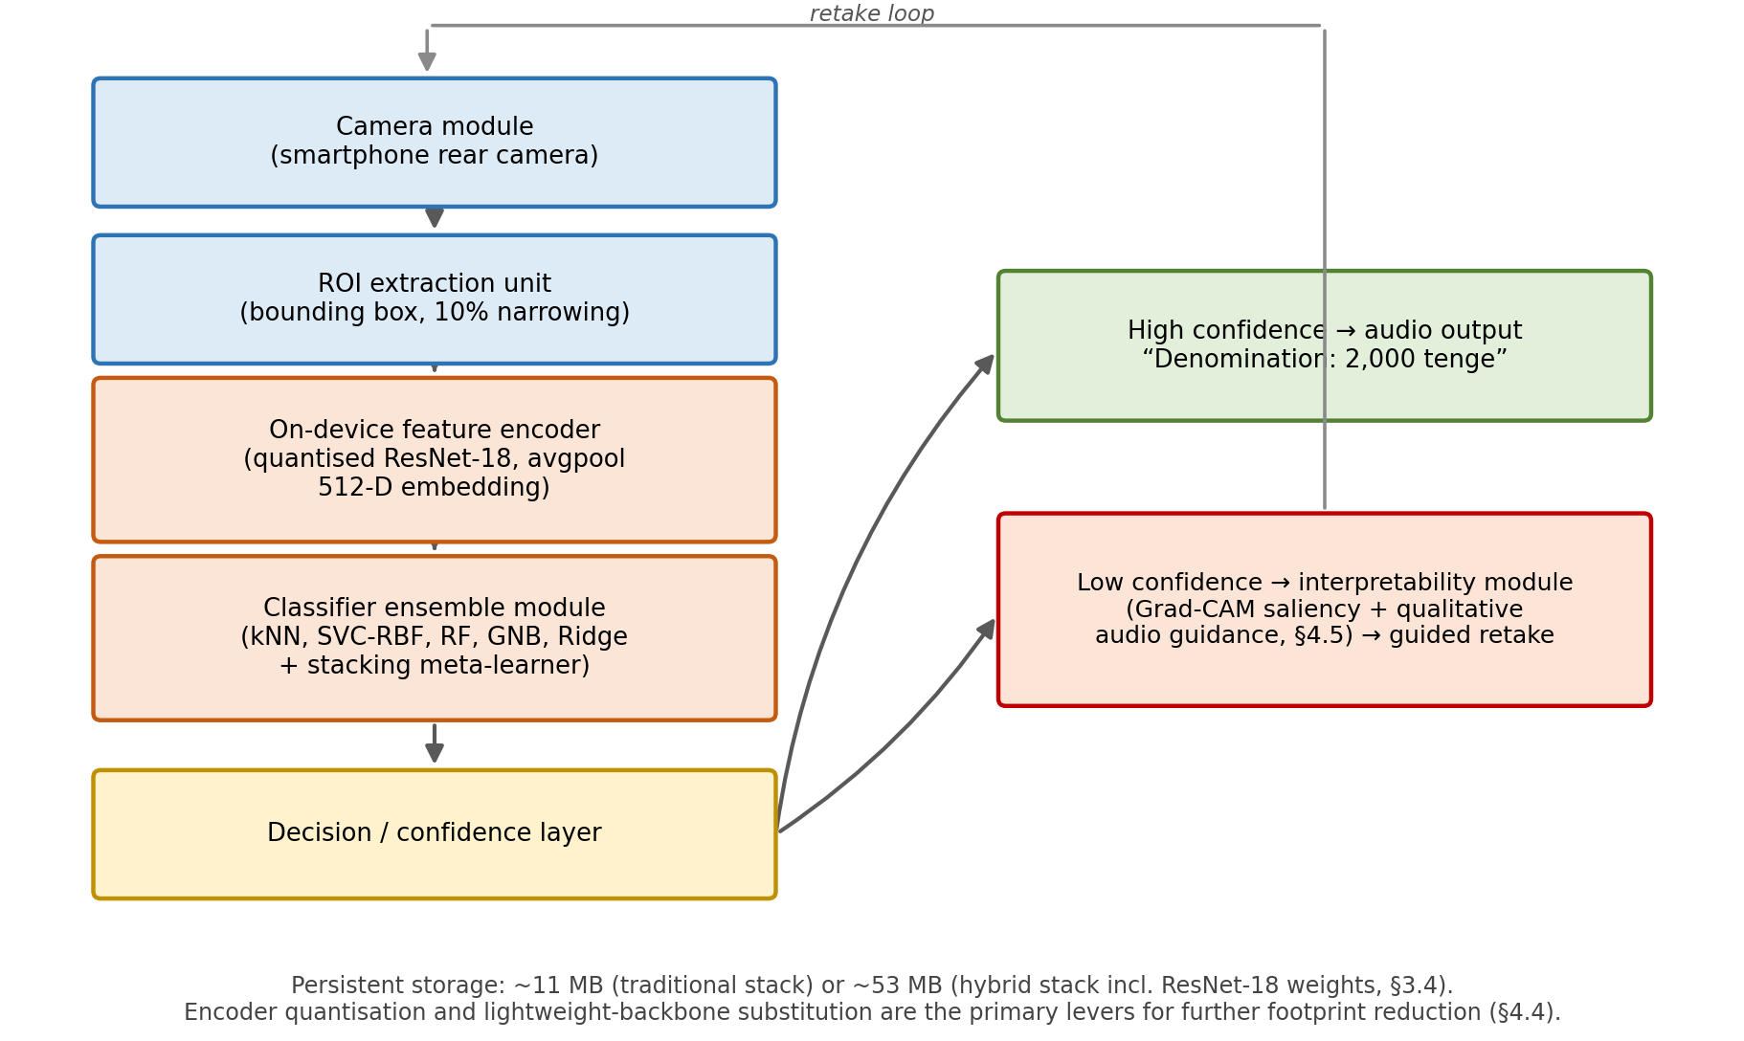

Figure 36 – Block diagram of the proposed on-device deployment architecture for assistive banknote recognition, from camera capture through on-device feature encoding and classification to a confidence-gated output stage

The block diagram positions the compression techniques discussed above (quantisation, lightweight-backbone substitution, pruning, and distillation [78; 79]) within the on-device feature-encoder block, which remains the dominant contributor to both storage footprint and latency (§2.7.2, §3.4). The decision layer downstream of the classifier ensemble is deliberately drawn as a distinct component because it is the point at which the interpretability protocol detailed in §4.5 attaches: high-confidence predictions are announced directly, while low-confidence predictions are routed to the Grad-CAM-based verification path before a retake is requested. Framing deployment in these block-level terms clarifies that the accuracy-efficiency trade-off quantified in §3.4 (11 MB versus 53 MB) concerns only the encoder-and-classifier blocks, and that the interpretability module can be added or removed without altering that trade-off.

4.5 Interpretability and trust in assistive recognition systems
Assistive systems for visually impaired users carry a particular responsibility: a confidently announced wrong denomination can result in a financial loss that the user has no easy way to verify. This raises the question of interpretability – how the system arrives at its decisions – both as a design principle and as a tool for diagnosing failure modes. For the proposed framework, interpretability concerns can be addressed at two levels: the level of individual base learners and the level of the deep encoder.
At the level of the classical base learners, interpretability is comparatively well understood. kNN decisions are explained by the labelled neighbours of the query point in feature space; SVC-RBF decisions can be analysed in terms of distance to the support vectors; Random Forests provide feature-importance scores; Gaussian NB exposes per-feature class-conditional likelihoods; and Ridge classification provides closed-form weights for each feature dimension. When the base learners operate on the HSV histogram of the traditional pipeline, these explanations are particularly transparent: each feature is a histogram bin, and per-class average histograms (such as the heatmap in figure 17) make it possible to see which bins drive a particular decision. For the hybrid pipeline, the same explanations apply, but the features themselves are 512-dimensional ResNet-18 embeddings, which are less interpretable in isolation.
At the level of the deep encoder, interpretability has been an active research area in the period 2020–2025 [80, p. e0318542; 81]. Methods such as Grad-CAM produce saliency maps that highlight the input regions most responsible for a given prediction, while methods such as SHAP and LIME provide quantitative local feature attributions. A recent comparative review of XAI techniques in image classification reports that LIME tends to achieve the highest fidelity, while Grad-CAM provides the most intuitive visualisations and SHAP scales best to high-dimensional inputs [80, p. e0318542]. For the proposed framework, Grad-CAM is the most natural choice because it operates directly on the convolutional feature maps of ResNet-18 and produces a saliency map over the input ROI in roughly the same time as a forward pass.
A practical interpretability protocol for the proposed framework therefore proceeds in two stages. In stage one, when the system makes a high-confidence prediction, it simply outputs the denomination as audio. In stage two, when the system’s confidence is below a calibrated threshold, it falls back to a verification flow in which a Grad-CAM map is computed and used to guide an audio cue: the system can describe in qualitative terms what region of the banknote it is relying on (for example, “I am looking at a green region near the centre” or “the denomination digit appears blurred”) and ask the user to retake the photo. This kind of feedback loop has been used in OCR-based assistive applications to good effect [18, p. 802-804; 30, p. 246-249], and it adapts naturally to banknote recognition. Critically, it does not require any architectural change to the proposed framework; the entire interpretability pipeline can be added as a post-processing module that runs only on uncertain predictions, leaving the high-confidence inference path untouched.
Figure 37 formalises this two-stage protocol as an explicit flowchart.
The flowchart formalises the two-stage protocol described above as an explicit control loop rather than a one-shot classification decision. This framing matters for assistive deployment because it converts a single point of possible failure (a confidently wrong announcement) into a bounded number of verification cycles, at the cost of occasionally asking the user to recapture the image. The diagram also makes clear that the practical value of this loop depends entirely on the quality of the confidence estimate that gates it: as discussed below, the SVC-RBF meta-learner’s decision scores are not automatically well calibrated, so deploying this flow without the calibration step recommended below (temperature scaling) risks routing well-classified predictions into unnecessary retakes, or, worse, announcing miscalibrated high-confidence errors [80, p. e0318542; 81].

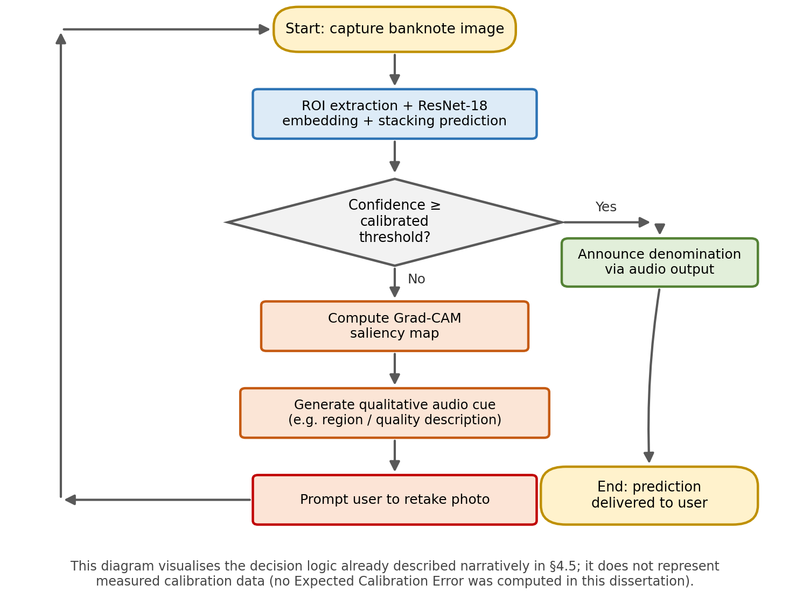

Figure 37 – Flowchart of the two-stage, confidence-based inference protocol: high-confidence predictions are announced directly, while low-confidence predictions trigger Grad-CAM-based interpretability feedback and a guided retake before re-entering the pipeline

For an interpretability-driven verification flow to be useful, the confidence scores produced by the stacking meta-learner must be well calibrated, meaning that a confidence of 0.9 should correspond to a 90% chance of being correct in the long run. Stacked ensembles are not automatically well calibrated; on the contrary, they often exhibit systematic over- or under-confidence depending on the choice of meta-learner and base learners. In the proposed framework, the SVC-RBF meta-learner produces decision scores that can be transformed into probabilities via Platt scaling, but the resulting probabilities should be validated using reliability diagrams and quantitative measures such as the Expected Calibration Error (ECE).
A simple and effective post-hoc calibration step is temperature scaling, which fits a single scalar parameter on a held-out validation set to align the confidence distribution with empirical accuracy. Temperature scaling has been shown to outperform Platt scaling and isotonic regression on many image-classification tasks, while requiring only a few minutes of additional training. For the assistive deployment of the proposed framework, the additional cost of calibration is negligible compared to the increase in user trust that a calibrated confidence score enables. This is therefore a low-effort, high-leverage improvement that should be incorporated into any future deployment-oriented version of the system.

4.6 Synthesis and future research agenda
The five threads developed in this chapter – photometric robustness, transformer-based encoders, training under data scarcity, edge deployment, and interpretability – are not independent. They interact in important ways, and any deployment-oriented revision of the proposed framework will need to balance them rather than optimise any single one in isolation.

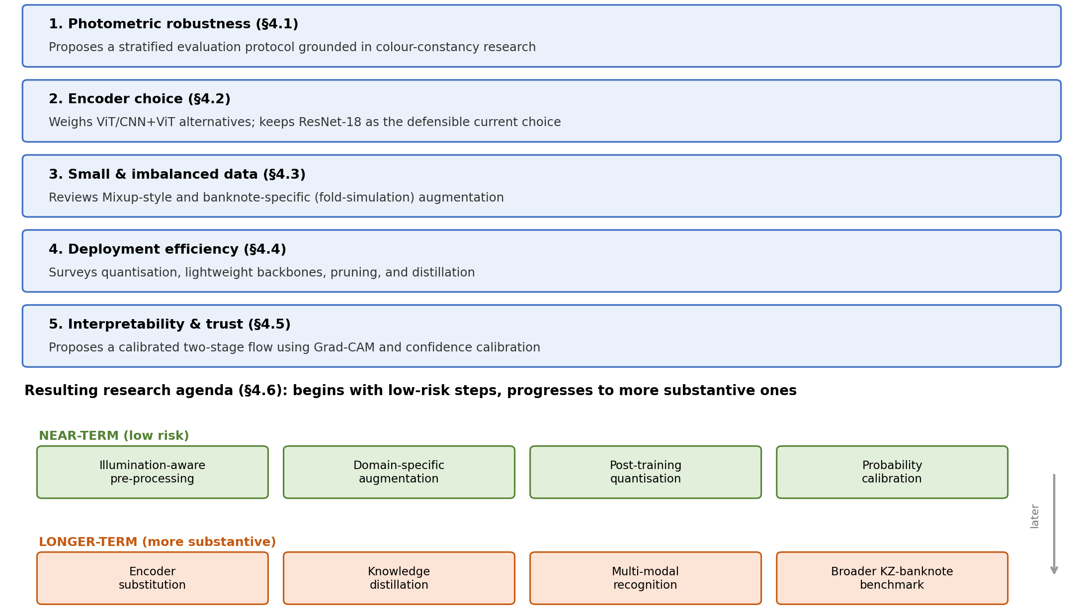

Figure 38 – The five discussion threads of Chapter 4 and the resulting near-term versus longer-term research agenda described in this section

This section synthesises the implications of the chapter and proposes a concrete research agenda for follow-up work on Kazakh-banknote recognition and on related assistive image-classification tasks.
The most immediate, low-risk improvements to the proposed framework are illumination-aware pre-processing (§4.1), domain-specific data augmentation including fold and occlusion simulation (§4.3), post-training quantisation of the ResNet-18 encoder (§4.4), and probability calibration of the stacking meta-learner (§4.5). These four changes are independent, can be implemented and validated in days rather than months, and do not require modifications to the framework’s overall architecture. Together they should be expected to improve both the accuracy and the deployability of the system without changing any of its conceptual underpinnings.
The medium-term improvements involve more substantive architectural decisions. The substitution of the ResNet-18 encoder with a mobile-optimised CNN (such as EfficientNet-Lite0) or a small transformer (such as MobileViT) is a natural next step, especially if the target deployment platform is an entry-level smartphone. Distilling the full stacking ensemble into a single student network is a complementary direction that combines the accuracy benefits of stacking with the efficiency of a single forward pass. Both of these directions require revalidation on KZ-BD and ideally on a successor dataset that includes cross-device and cross-illumination strata; both are likely to be the subject of separate follow-up studies rather than incremental updates to this dissertation.
The longer-term research agenda extends beyond the proposed framework itself. The most pressing need is the construction of a more expansive Kazakh-banknote benchmark that goes beyond denomination classification to include capture-condition stratification, fitness annotation (worn, soiled, folded), and selected counterfeit examples. Such a benchmark would enable the field to move beyond per-paper claims of high accuracy on individual subsets and toward a community-wide, reproducible evaluation framework comparable to what has emerged for other vision tasks. Collaboration with the National Bank of Kazakhstan and with Kazakh organisations representing visually impaired users would be valuable both to ensure that the benchmark reflects deployment realities and to disseminate the resulting tools to the population that needs them most.
A second long-term direction is the explicit incorporation of multi-modal cues that complement vision. Banknotes have characteristic tactile features (raised printing, intaglio elements, varying paper textures) that are detectable by the smartphone’s built-in microphone via the sound of paper crinkling, by the accelerometer via micro-movements during a swipe, and potentially by the depth sensor on devices that carry one. A multi-modal recognition system that combines visual classification with tactile and acoustic cues could deliver substantially higher robustness than any vision-only system, particularly under the difficult illumination conditions discussed in §4.1. The proposed stacking framework is well suited to this extension because additional modalities can be added as new base learners with their own feature streams, and the meta-learner can be retrained to combine them.
A third long-term direction is the integration of the banknote classifier with a broader assistive ecosystem. Visually impaired users typically rely on multiple specialised tools (screen readers, OCR document readers, navigation assistants, colour identifiers), and a banknote classifier that operates as one tool among many should integrate gracefully with these others. Specifically, the framework should expose an inference API that other applications can call (for example, a payment app that wants to confirm that a deposited note matches the user’s expectation), should respect platform-level accessibility settings, and should accept user feedback (corrections after a misclassification) so that personalised fine-tuning becomes possible over time. Each of these requirements imposes design constraints that interact with the deployment-efficiency considerations of §4.4 but that are largely orthogonal to the core methodological choices of the framework itself.
The discussions in this chapter rest on published evidence from related domains rather than on new experiments specific to KZ-BD. This is a deliberate choice: the empirical content of the dissertation is concentrated in Chapter 3, and the role of Chapter 4 is to contextualise those results and to identify the most productive directions for follow-up work. However, this choice has consequences for the strength of the chapter’s claims. The recommendations in §4.1 are grounded in literature on AWB and colour constancy that has not been validated specifically on Kazakh banknotes; the comparisons in §4.2 with vision transformers are based on banknote-specific reports for other currencies (Indian, Sri Lankan) rather than on Kazakh-specific results; the augmentation suggestions in §4.3 transfer from medical imaging and from multinational banknote-detection work but have not been re-validated here; the deployment numbers cited in §4.4 come from edge-AI compression benchmarks on ImageNet-style tasks; and the interpretability protocol proposed in §4.5 is grounded in XAI literature from medical imaging and malware-classification rather than from banknote recognition itself.
These limitations should not be read as undermining the chapter’s recommendations, but rather as defining the boundaries within which they are reliable. Each of the proposed directions has been chosen because it is supported by recent peer-reviewed evidence in adjacent domains and because its applicability to banknote classification is well-grounded conceptually. The next obvious step, beyond the scope of this dissertation, is to perform targeted experiments that validate each direction on KZ-BD or its successor, ideally as part of a coordinated research programme rather than as scattered individual studies.

Chapter summary
This chapter extends the empirical results of Chapter 3 by situating them within the broader research and deployment landscape of camera-based currency recognition. Five complementary threads have been developed. The first thread argues that photometric robustness deserves first-class status in the evaluation of any colour-feature-based classifier and proposes a stratified evaluation protocol grounded in recent work on automatic white balance and computational colour constancy. The second thread examines vision-transformer alternatives to the ResNet-18 encoder used in this dissertation and concludes that ViTs are a credible direction for future work but that the existing CNN-based pipeline remains a defensible engineering choice for entry-level mobile deployment. The third thread reviews training-time strategies for class-imbalanced and small-data regimes, with a particular focus on Mixup-style augmentation and on banknote-specific augmentations such as fold simulation. The fourth thread addresses deployment efficiency and surveys the major compression techniques (quantisation, lightweight backbones, pruning, and distillation) most likely to make the proposed framework viable on entry-level smartphones. The fifth thread connects interpretability to the assistive nature of the application and proposes a calibrated, two-stage verification flow that uses Grad-CAM saliency maps and confidence calibration to support user trust.
These threads are deliberately complementary rather than alternative, and the synthesis in §4.6 outlines a concrete research agenda that begins with low-risk improvements (illumination-aware pre-processing, domain-specific augmentation, post-training quantisation, and probability calibration) and progresses toward more substantive directions (encoder substitution, knowledge distillation, multi-modal recognition, and a broader Kazakh-banknote benchmark). Together, the chapter establishes both the external validity of the dissertation’s empirical claims and a clear roadmap for translating its methodological contributions into a deployable assistive system.
A final observation concerns the position of the proposed framework within the recent banknote-recognition literature. The 2020–2025 period has seen a rapid expansion of camera-based currency-recognition systems for visually impaired users across multiple national contexts: Pakistani [82, p. 12-18], Iraqi, Bangladeshi, Indian, and Sri Lankan [74, p. 322-326] currencies have all received dedicated mobile-deployment studies in this period.
Against that backdrop, the dissertation’s focus on Kazakh banknotes fills a previously vacant slot in the international literature and contributes a methodological template (hybrid feature extraction with stacking) that can be re-used by researchers working on other under-represented currencies. The combination of the KZ-BD dataset, the empirical results of Chapter 3, and the analytical framework of Chapter 4 together represent a substantive and reproducible contribution to the field, with clear avenues for continued development. Taken together, Chapters 2 through 4 form a complete arc: a methodology designed to test a specific hypothesis about hybrid recognition, an empirical evaluation of that hypothesis, and a critical assessment of what would be required to deploy it responsibly. The conclusion that follows draws these three strands together against the objectives set out in the Introduction.

CONCLUSION

This dissertation has presented a hybrid computational framework for the automatic recognition of Kazakh banknotes under heterogeneous real-world conditions. By combining deep feature extraction using a ResNet-18 backbone with a stacking ensemble of classical machine-learning classifiers, the study demonstrates that it is possible to achieve both high recognition accuracy and practical deployment efficiency within a unified system.
Each of the six specific objectives set out in the Introduction has been fully addressed, as summarised below:
Objective 1 (dataset construction) was achieved through the assembly of a 4,200-image KZ-BD dataset covering fourteen denominations under varied illumination, rotation, occlusion, wear, and background conditions, released with YOLO-format annotations.
Objective 2 (fixed feature extraction) was achieved by removing ResNet-18’s terminal classification layer and extracting 512-dimensional penultimate-layer embeddings for every image.
Objective 3 (base-learner training) was achieved through systematic cross-validation and grid-search-based model selection for kNN, SVC, RF, GNB, and Ridge classifiers, detailed in Chapter 2.
Objective 4 (stacking strategy) was achieved via a leakage-safe out-of-fold stacking protocol using an SVC-RBF meta-learner that fuses the base classifiers’ outputs.
Objective 5 (ablation and comparison) was achieved in Chapter 3 through the traditional-versus-hybrid feature comparison, the pre- and post-optimisation comparisons, and the Thai-banknote and coffee-bean transferability experiments.
Objective 6 (performance evaluation) was achieved throughout Chapter 3 by evaluating accuracy, macro-F1, MCC, and ROC-AUC alongside deployment-oriented latency and memory-footprint measurements.
These results also confirm the two-part novelty claimed in the Introduction:
Novelty claim 1 (hybrid framework): The first systematic application to Kazakh banknotes of a hybrid framework fusing ResNet-18 embeddings with a five-learner classical stacking ensemble, is substantiated by the consistent accuracy gains of the hybrid pipeline over the traditional pipeline and of the stacking ensemble over individual classifiers, reported throughout Chapter 3.
Novelty claim 2 (KZ-BD dataset): The introduction of KZ-BD as the first comprehensive, richly annotated dataset of Kazakh banknotes, is substantiated by the dataset’s use throughout this dissertation as the primary benchmark for all reported experiments, and by its public availability for reuse by future researchers.
The results confirm that using a convolutional neural network as a fixed feature extractor, rather than an end-to-end classifier, provides compact and discriminative embeddings that generalise well across variations in illumination, orientation, background complexity, and physical wear. When these embeddings are integrated into a diverse ensemble of classifiers—including kNN, SVC, random forest, Gaussian naïve Bayes, and ridge regression—the system benefits from complementary decision boundaries and improved robustness. The stacking strategy, supported by a meta-learner, further enhances predictive reliability by effectively combining the strengths of individual models.
A key contribution of this work is the development of the Kazakh Banknote Dataset (KZ-BD), which enables reproducible evaluation and addresses the lack of standardised benchmarks for underrepresented currencies. Experimental results across multiple metrics, including accuracy, macro-F1, MCC, and ROC-AUC, demonstrate that the proposed hybrid approach consistently outperforms individual classifiers while maintaining low inference latency and a modest memory footprint. These characteristics make the system suitable for deployment in resource-constrained environments such as mobile devices and embedded financial systems.
Positioning these results against accuracy figures reported for other currencies in the literature (§3.6.7) shows that the proposed approach reaches accuracy levels comparable to currencies backed by established recognition literatures, such as Malaysian ringgit and multi-currency KRW/USD/EUR systems. The relevant claim is therefore not that this dissertation sets a new upper bound on accuracy, but that a previously unstudied, data-poor currency can be brought to a level of recognition performance comparable to far better-resourced currencies, using a methodology and dataset that are both openly reproducible.
Beyond empirical performance, the research highlights an important methodological insight: deep learned representations can serve as a general-purpose feature space that, when combined with classical machine-learning models, yields interpretable, flexible, and computationally efficient solutions. This hybrid paradigm offers a viable alternative to purely end-to-end deep learning approaches, particularly in scenarios with limited data, high variability, or strict deployment constraints.
In practical terms, the proposed framework has clear applications in financial automation, retail infrastructure, and assistive technologies for visually impaired individuals. Its modular design allows for incremental updates as new banknote series are introduced, supporting long-term adaptability.
Future work may explore the integration of transformer-based architectures, domain adaptation techniques for cross-currency generalization, and further optimisation for edge AI deployment. Additionally, expanding the dataset and incorporating counterfeit detection capabilities would further enhance the system’s applicability in real-world financial security contexts.
This dissertation provides a reproducible dataset, a validated hybrid methodology, and a deployable recognition system that collectively advance the field of currency recognition and contribute to the broader development of robust, efficient, and inclusive computer-vision applications.

REFERENCES

1 Sufri N.A.J. et al. Vision based system for banknote recognition using different machine learning and deep learning approach // Proceed. of the IEEE 10th Control and System Graduate Research Colloquium (ICSGRC). – Shah Alam, 2019. – P. 5-8.
2 Datiles J.D. et al. ESPYREAL: A Mobile Based Multi-Currency Identifier for Visually Impaired Individuals Using Convolutional Neural Network // International Journal of Research and Innovation in Applied Science. – 2025. – Vol. 10, Issue 9. – P. 165-176.
3 Park C., Park K.R. MBDM: Multinational banknote detecting model for assisting visually impaired people // Mathematics. – 2023. – Vol. 11, Issue 6. – P. 1392.
4 Hussein G.S. et al. A novel method for banknote recognition using a combined histogram of oriented gradients and scale-invariant feature transform // Information Sciences Letters. – 2023. – Vol. 12, Issue 9. – P. 2121-2131.
5 Gou H., Li X., Li X. et al. A reliable classification method for paper currency based on an LVQ neural network // Procced. internat. conf. on Computer Science and Education. – Qingdao, 2011. – P. 243-247.
6 Sun N., Pan X., Ma C. et al. A survey on compressed-sensing-based banknote classification // Procced. 3rd IEEE internat. conf. on Signal Processing Systems. – Yantai, 2011. – P. 60-66.
7 Sadyk U. et al. KZ-BD: Dataset of Kazakhstan banknotes with annotations // Data Brief. – 2024. – Vol. 53. – P. 110076.
8 Sadyk U. et al. Comparative analysis of machine learning approaches in Kazakh banknote classification // Bulletin of Electrical Engineering and Informatics. – 2024. – Vol. 13, Issue 5. – P. 3552-3567.
9 Elnouby T. et al. Recognizing Egyptian currency for people with visual impairment using deep learning models // Scientific Reports. – 2025. – Vol. 13. – P. 16901.
10 Park Y.H., Kwon S.Y., Pham T.D. et al. A high-performance banknote recognition system based on a one-dimensional visible-light line sensor // Sensors. – 2015. – Vol. 15. – P. 14093-14115.
11 Pham T.D., Park Y.H., Kwon S.Y. et al. Efficient banknote recognition based on selection of discriminative regions using a one-dimensional visible-light line sensor // Sensors. – 2016. – Vol. 16. – P. 328.
12 Youn S., Choi E., Baek Y. et al. Efficient multi-currency classification of CIS banknotes // Neurocomputing. – 2015. – Vol. 156. – P. 22-32.
13 Liu Y., Zeng L., Huang Y. Haar-SVM for real-time banknote recognition // Journal of Information and Computational Science. – 2014. – Vol. 11. – P. 4031-4039.
14 Liu X., Liu C. Paper-currency CIS image fuzzy enhancement and boundary detection // Applied Mechanics and Materials. – 2014. – Vol. 651-653. – P. 2356-2361.
15 Gai S., Liu P., Liu J., Tang X. Design of an HMM-based banknote recognition system // Procced. IEEE internat. conf. on Intelligent Computing and Intelligent Systems. – Shanghai, 2009. – P. 106-110.
16 Doush I.A., Al-Btoush S. Currency recognition using a smartphone: comparison between colour SIFT and grey-scale SIFT algorithms // Journal of King Saud University – Computer and Information Sciences. – 2016. – Vol. 29, Issue 4. – P. 484-492.
17 Zhang E.-H., Jiang B., Duan J.-H. et al. Research on paper-currency recognition using neural networks // Procced. 2nd internat. conf. on Machine Learning and Cybernetics. – Xi’an, 2003. – P. 2193-2197.
18 Nastoulis C., Leros A., Bardis N. Banknote recognition based on probabilistic neural-network models // Procced. 10th WSEAS internat. conf. on Systems. – Athens, 2006. – P. 802-805.
19 Ahmadi A., Omatu S., Kosaka T. et al. A reliable method for classification of bank notes using artificial neural networks // Artificial Life and Robotics. – 2004. – Vol. 8. – P. 133-139.
20 Gai S., Yang G., Wan M. Employing quaternion wavelet transform for banknote classification // Neurocomputing. – 2013. – Vol. 118. – P. 171-178.
21 Hasanuzzaman F.M., Yang X., Tian Y. Robust and effective component-based banknote recognition by SURF features // Procced. IEEE 20th Annual Wireless and Optical Communications conf. – Newark (NJ), 2011. – P. 1-6.
22 Hasanuzzaman F.M., Yang X., Tian Y. Robust and effective component-based banknote recognition for the blind // IEEE Transactions on Systems, Man, and Cybernetics. – 2012. – Vol. 42, Issue 6. – P. 1021-1030.
23 Kagehiro T., Nagayoshi H., Sako H. A hierarchical classification method for US banknotes // Procced. IAPR conf. on Machine Vision Applications. – Tsukuba (Japan), 2005. – P. 206-209.
24 Ahmadi A., Omatu S., Kosaka T. A PCA-based method for improving the reliability of banknote-classifier machines // Procced. 3rd internat. symp. on Image and Signal Processing and Analysis. – Rome, 2003. – P. 494-499.
25 Ahmadi A., Omatu S., Kosaka T. Improvement of the reliability of banknote-classifier machines // Procced. IEEE internat. Joint conf. on Neural Networks. – Budapest (Hungary), 2004. – P. 1313-1316.
26 Omatu S., Yoshioka M., Kosaka Y. Reliable banknote classification using neural networks // Procced. 3rd internat. conf. on Advanced Engineering Computing and Applications in Sciences. – Sliema (Malta), 2009. – P. 35-40.
27 Takeda F., Omatu S. A neuro-money recognition system using optimised masks by GA // Lecture Notes in Comp. Science. – 1995. – Vol. 1011. – P. 190-201.
28 Toytman I., Thambidurai J. Banknote recognition on the Android platform: final project report // http://www.stanford.edu/class/ee368/Project_11. 10.10.2025.
29 Gai S., Liu P., Liu J. et al. A neural-network image-classification method driven by a mixed fitness function // Computer and Information Science. – 2009. – Vol. 2. – P. 129-136.
30 Cao B.-Q., Liu J.-X. Currency-recognition modelling research using a BP neural network improved by a genetic algorithm // Procced. 2nd internat. conf. on Computer Modelling and Simulation. – Sanya, 2010. – P. 246-250.
31 Lee J.-K., Jeon S.-G., Kim I.-H. Distinctive-point extraction and recognition algorithm for various kinds of Euro banknotes // Int. Journal of Control, Automation, and Systems. – 2004. – Vol. 2. – P. 201-206.
32 Da Costa C.M.C. Multiview banknote recognition using component and shape analysis // https://www.researchgate.net/publication. 10.11.2025.
33 Bhavani R., Karthikeyan A. A novel method for banknote recognition // Int. Journal of Innovative Research in Science, Engineering and Technology. – 2014. – Vol. 3. – P. 269-273.
34 Bhurke C., Sirdeshmukh M., Kanitkar M.S. Currency recognition using image processing // Int. Journal of Innovative Research in Computer and Communication Engineering. – 2015. – Vol. 3. – P. 4418-4422.
35 Danti A., Nayak K. Grid-based feature extraction for the recognition of Indian currency notes // Int. Journal of Latest Trends in Engineering and Technology. – 2014. – Vol. 4. – P. 337-344.
36 Shyju S., Thamizharasi A. Indian currency identification using image processing // Int. Journal of Advanced Engineering, Management and Science. – 2016. – Vol. 2. – P. 344-349.
37 Aggarwal H., Kumar P. Indian-currency note-denomination recognition in colour images // Int. Journal of Advanced Computer Engineering and Communication Technology. – 2012. – Vol. 1. – P. 12-18.
38 Sharma B., Kaur A., Vipan K. Recognition of Indian paper currency based on LBP // Int. Journal of Computer Applications. – 2012. – Vol. 59. – P. 24-27.
39 Verma K., Singh B.K., Agarwal A. Indian-currency recognition based on texture analysis // Procced. internat. conf. on Current Trends in Technology. – Ahmedabad (India), 2011. – P. 1-5.
40 Choi E., Lee J., Yoon J. Feature extraction for banknote classification using the wavelet transform // Procced. 18th internat. conf. on Pattern Recognition. – Hong Kong (China), 2006. – P. 934-937.
41 Behjat M., Moallem P. A fast and low-cost mechatronic recognition system for Persian banknotes // Int. Journal of Advanced Robotic Systems. – 2014. – Vol. 11. – P. 44.
42 Mousavi S.A., Meghdadi M., Hanifeloo Z. et al. Detection of old and worn banknotes using sparse representation and neural networks // Indian Journal of Science and Technology. – 2015. – Vol. 8. – P. 913-918.
43 Daraee F., Mozaffari S. Eroded-money-note recognition using the wavelet transform // Procced. 6th Iranian conf. on Machine Vision and Image Processing. – Isfahan (Iran), 2010. – P. 1-5.
44 García-Lamont F., Cervantes J., López A. Recognition of Mexican banknotes via their colour and texture features // Expert Systems with Applications. – 2012. – Vol. 39. – P. 9651-9660.
45 García-Lamont F., Cervantes J., López A. et al. Classification of Mexican paper-currency denominations by extracting their discriminative colours // Lecture Notes in Artificial Intelligence. – 2013. – Vol. 8266. – P. 403-412.
46 Hinwood A., Preston P., Suaning G.J. et al. Banknote recognition for the vision-impaired // Australasian Physical and Engineering Sciences in Medicine. – 2006. – Vol. 29. – P. 229-233.
47 Springer K. et al. Australian banknotes: assisting people with vision impairment // https://ideas.repec.org/a/rba/rbabul/mar2015-01.html. 10.11.2025.
48 Yan W.Q., Chambers J., Garhwal A. An empirical approach to currency identification // Multimedia Tools and Applic. – 2015. – Vol. 74. – P. 4723-4733.
49 Poor Ahangaryan F. et al. Persian-banknote recognition using wavelets and a neural network // Procced. internat. conf. on Computer Science and Electronics Engineering. – Hangzhou (China), 2012. – P. 679-684.
50 Gunaratna D.A.K.S., Kodikara N.D., Premaratne H.L. ANN-based currency-recognition system using compressed grey-scale and application for Sri Lankan currency notes – SLCRec // World Academy of Science, Engineering and Technology. – 2008. – Vol. 45. – P. 235-240.
51 Ali A., Manzoor M. A recognition system for Pakistani paper currency // World Applied Sciences Journal. – 2013. – Vol. 28. – P. 2069-2075.
52 Tanaka M., Takeda F., Ohkouchi K., Michiyuki Y. Recognition of paper currencies using a hybrid neural network // Procced. IEEE internat. joint conf. on Neural Networks. – Anchorage (AK), 1998. – P. 1748-1753.
53 Omatu S., Fujinaka T., Kosaka T., Yanagimoto H., Yoshioka M. Italian-Lira classification using LVQ // Procced. internat. joint conf. on Neural Networks. – Washington, 2001. – P. 2947-2951.
54 Ali Fattouh A.M. A non-parametric approach to paper-currency recognition // Int. Journal of Computer Science and Software Engineering. – 2015. – Vol. 4. – P. 121-125.
55 Sarfraz M. A paper-currency-recognition system with novel features // Procced. 2nd internat. conf. on Artificial Intelligence and Pattern Recognition. – Shenzhen (China), 2015. – P. 64-68.
56 Zeggeye J.F., Assabie Y. Automatic recognition and counterfeit detection of Ethiopian paper currency // Int. Journal of Image, Graphics and Signal Processing. – 2016. – Vol. 2. – P. 28-36.
57 Jahangir N., Chowdhury A.R. Bangladeshi banknote recognition using a neural network with axis-symmetrical masks // Procced. 10th internat. conf. on Computer and Information Technology. – Dhaka, 2007. – P. 1-5.
58 Debnath K.K., Ahdikary J.K., Shahjahan M. A currency-recognition system using a negatively correlated neural-network ensemble // Procced. 12th internat. conf. on Computer and Information Technology. – Dhaka, 2009. – P. 367-372.
59 Hlaing K.N.N. First-order statistics and GLCM-based feature extraction for recognition of Myanmar paper currency // Procced. 31st IIER internat. conf. – Bangkok, 2015. – P. 1-6.
60 Hassanpour H., Farahabadi P.M. Paper-currency recognition using hidden Markov models // Expert Systems with Applic. – 2009. – Vol. 36. – P. 10105–10111.
61 Khashman A., Sekeroglu B. Multi-banknote identification using a single neural network // Lecture Notes in Comp Scien. – 2005. – Vol. 3708. – P. 123-129.
62 Rashid A., Prati A., Cucchiara R. On the design of embedded solutions for banknote recognition // Optical Engineering. – 2013. – Vol. 52. – P. 093106.
63 Chiang Y.-W., Wang Y.-C., Jiang Y.-Y. et al. A bill-detection system based on colour and texture analysis // Procced. 19th IPPR conf. on Computer Vision, Graphics and Image Processing. – Taoyuan, 2006. – P. 40-45.
64 Takeda F., Nishikage T., Matsumoto Y. Characteristics extraction of paper currency using symmetrical masks optimised by GA and neuro-recognition of multi-national paper currency // Procced. IEEE internat. joint conf. on Neural Networks. – Anchorage (AK), 1998. – P. 634-639.
65 Rahman S., Banik P., Naha S. LDA-based paper-currency-recognition system using an edge histogram descriptor // Procced. 17th internat. conf. on Computer and Information Technology. – Dhaka, 2014. – P. 326-331.
66 Al-Azzwi Z.H.N., Nazarov A.N. Brain-tumour classification based on improved stacked-ensemble deep-learning methods // Asian Pacific Journal of Cancer Prevention. – 2023. – Vol. 24, Issue 6. – P. 2141-2148.
67 Buzzelli M., Bianco S., Ciocca G. Analysis of biases in automatic white balance datasets and methods // Colour Research & Application. – 2023. – Vol. 48, Issue 1. – P. 40-62.
68 Afifi M., Brown M.S. Time-Aware Auto White Balance in Mobile Photography // Proceed. of the IEEE/CVF internat. conf. on Computer Vision. – Honolulu, 2025. – P. 5038-5047.
69 Laakom F., Raitoharju J., Iosifidis A. et al. INTEL-TAU: a colour-constancy dataset // IEEE Access. – 2021. – Vol. 9. – P. 39560-39567.
70 Park C., Vu D.Q., Park K.R. Deep learning-based detection of fake multinational banknotes in a cross-dataset environment utilising smartphone cameras for assisting visually impaired individuals // Mathematics. – 2022. – Vol. 10, Issue 9. – P. 1616.
71 Wang H., Tahir M., Li Z. et al. A vision transformer for fine-grained classification by reducing noise and enhancing discriminative information // Pattern Recognition. – 2023. – Vol. 145. – P. 109979.
72 Yu C., Li B., Tang Y. Hierarchical-attention vision transformer for fine-grained visual classification // Journal of Visual Communication and Image Representation. – 2023. – Vol. 91. – P. 103755.
73 Naveen P., Reddy P.D. DeViTC: deep-vision transformer to recognise originality of currency // IEEE Access. – 2025. – Vol. 13. – P. 56123-56136.
74 Perera A.S.K., Meedin G.S.N. Fine-tuned CNN-based Sri Lankan currency-note detection method for the visually impaired people using smartphones // Procced. ICARC 2023. – Belihuloya (Sri Lanka), 2023. – P. 322-327.
75 Rana P., Sowmya A., Meijering E. et al. Data augmentation with improved regularisation and sampling for imbalanced blood-cell image classification // Scientific Reports. – 2022. – Vol. 12. – P. 18101.
76 Schaudt D., von Schwerin R., Hafner A. et al. Augmentation strategies for an imbalanced learning problem on a novel COVID-19 severity dataset // Scientific Reports. – 2023. – Vol. 13. – P. 18299.
77 Shwartz-Ziv R. et al. Simplifying neural-network training under class imbalance // https://arxiv.org/pdf/2312.02517. 10.05.2026.
78 Krishnan R. et al. Edge AI: evaluation of model-compression techniques for convolutional neural networks // https://arxiv.org/pdf/2409.02134. 10.05.2026.
79 Chen Y. et al. A comparative analysis of lightweight deep-learning models for memory-constrained devices // https://arxiv.org/abs/2505.03303. 10.10.2025.
80 Nazim S., Alam M.M., Rizvi S.S. et al. Advancing malware imagery classification with explainable deep learning: a state-of-the-art approach using SHAP, LIME and Grad-CAM // PLOS ONE. – 2025. – Vol. 20, Issue 5. – P. e0318542.
81 Khan M. et al. Towards a transparent and interpretable AI model for medical-image classifications // arXiv preprint arXiv:2509.16685. 10.10.2025..
82 Imad M. et al. Pakistani currency recognition to assist blind person based on convolutional neural network // Journal of Computer Science and Technology Studies. – 2020. – Vol. 2, Issue 2. – P. 12-19.
83 Sadyk U., Yerzhan M., Turan C. et al. Kazakh banknote image dataset // Data in Brief. – 2026. – Vol. 65. – P. 112634.

